Spinal Cord_module

1. Part 01

1.1 Pre-Work Slides for Spinal Cord
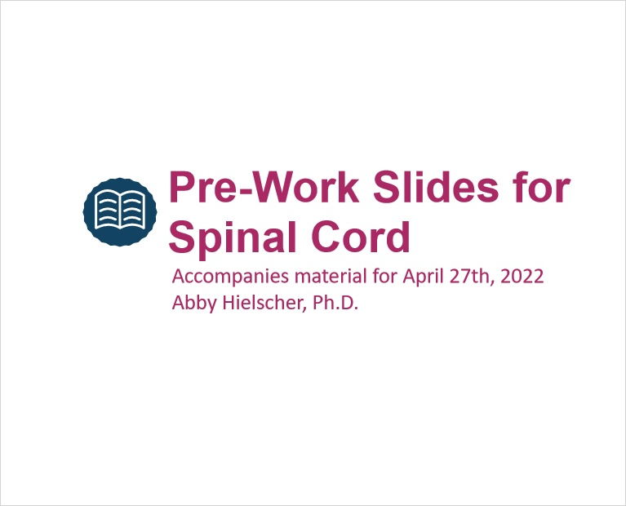

1.2 Overview
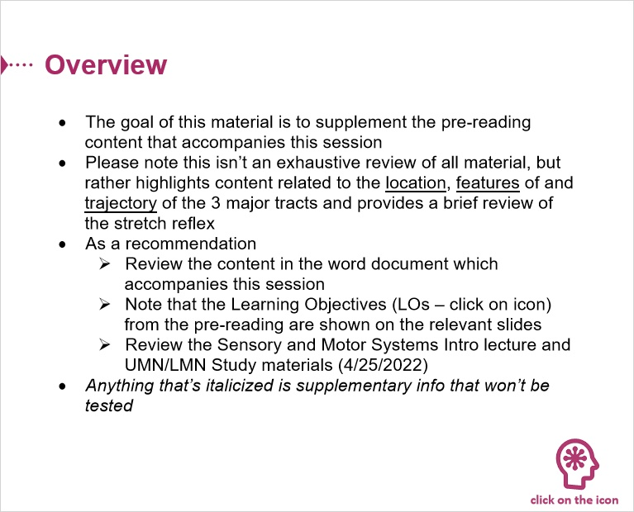

Learning Objectives (Slide Layer)
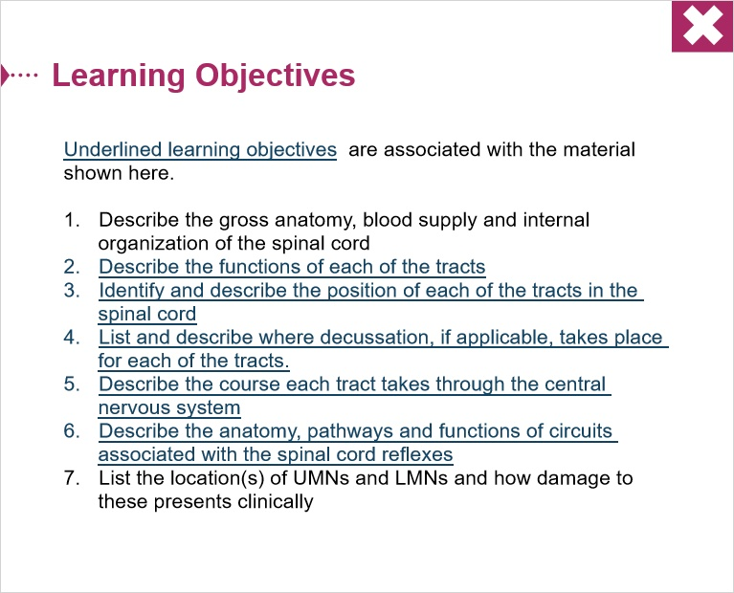

1.3 Exercise 1 - Instructions
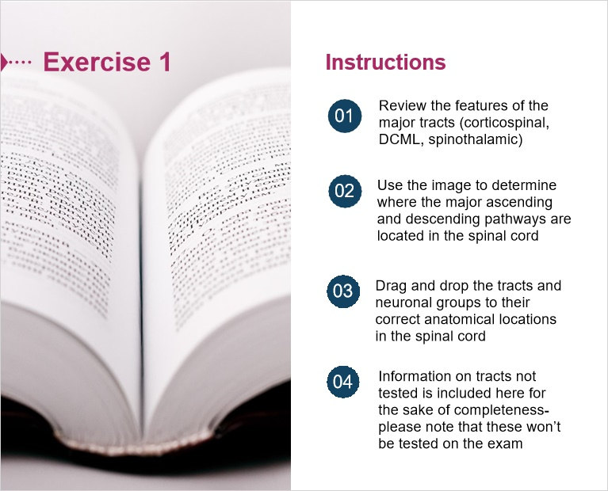
Notes:

1.4 Spinal Cord_Nerve Organization
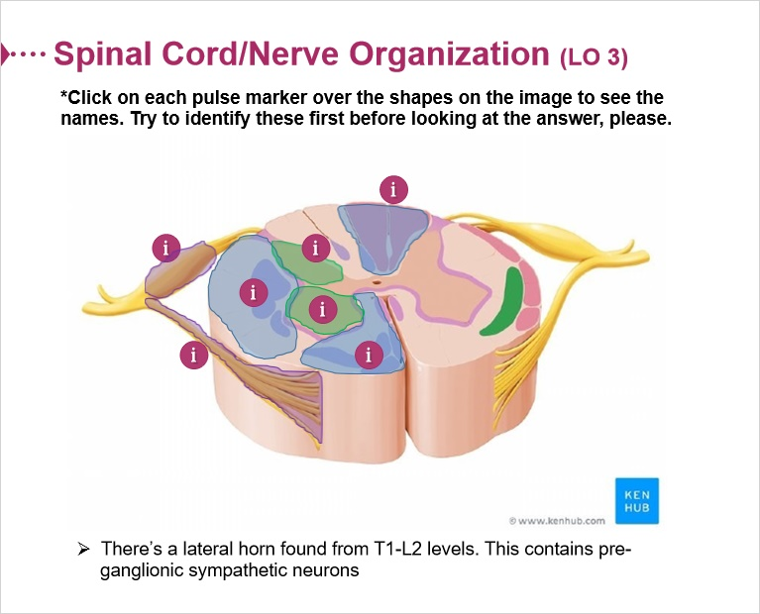

1.5 Knowledge Check 01_Tracts_Nuclear groups
(Drag and Drop, 10 points, unlimited attempts permitted)
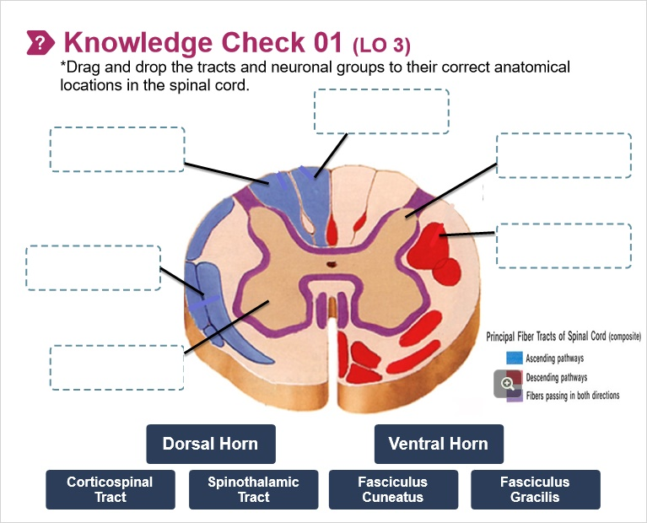
Drag Item | Drop Target
Ventral Horn | Ventral Horn
Spinothalamic Tract | Spinothalamic tract
Fasciculus Cuneatus | Fasciculus Cuneatus
Fasciculus Gracilis | Fasciculus Gracilis
Dorsal Horn | Dorsal Horn
Corticospinal  Tract | Corticospinal Tract

Drag and drop properties
Return item to start point if dropped outside the correct drop target
Snap dropped items to drop target (Snap to center)
Allow only one item in each drop target
Delay item drop states until interaction is submitted

Feedback when correct:
That's right! You selected the correct response.
Feedback when incorrect:
You did not select the correct response.

Correct (Slide Layer)
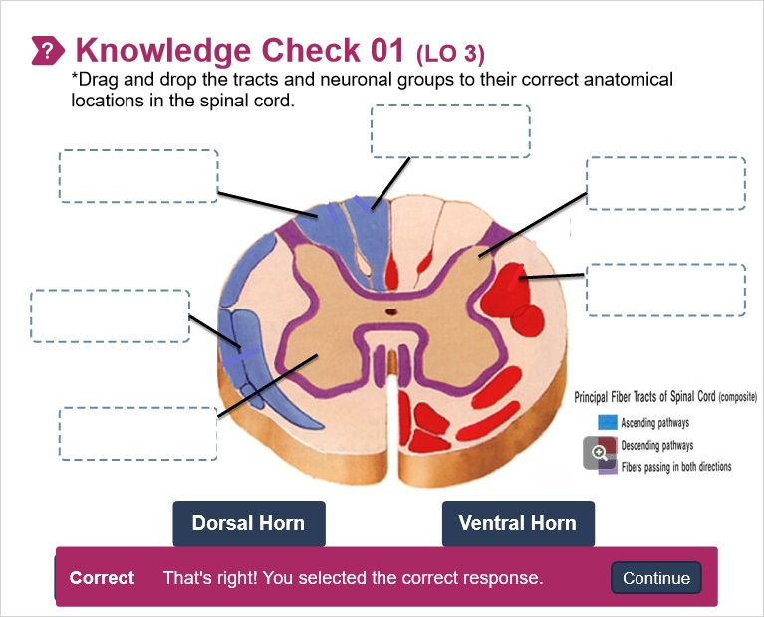

Incorrect (Slide Layer)
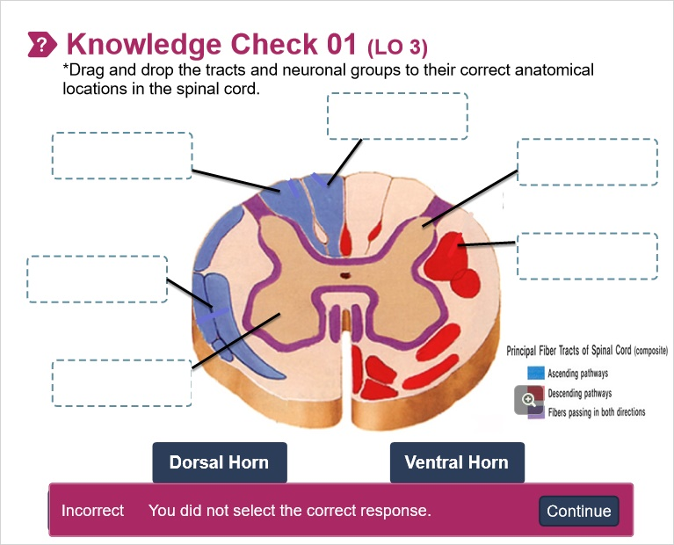

Try Again (Slide Layer)
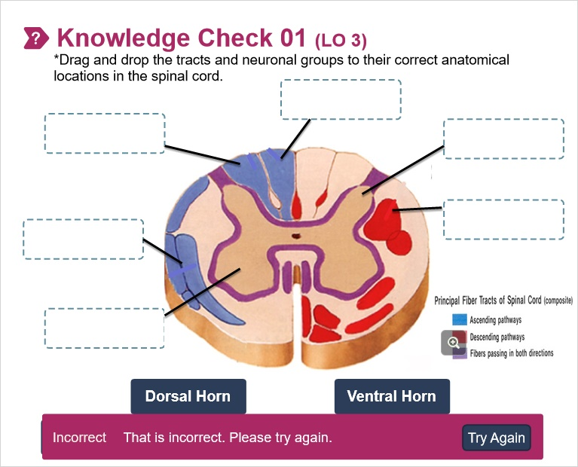

1.6 Supplementary Info on Vestibulospinal Tracts
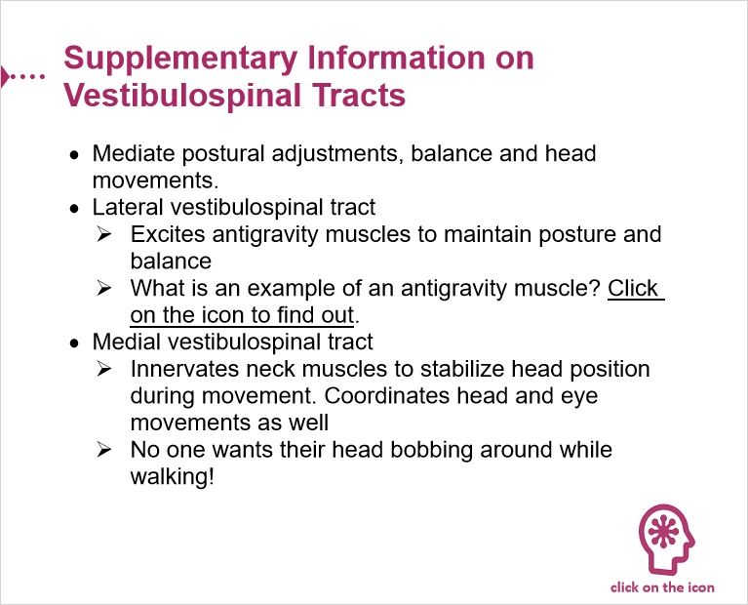

Antigravity (Slide Layer)
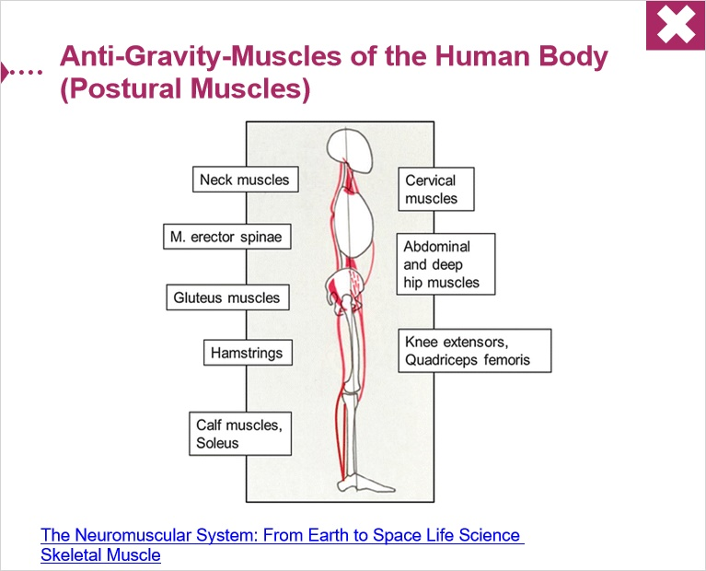

1.7 Major Tracts
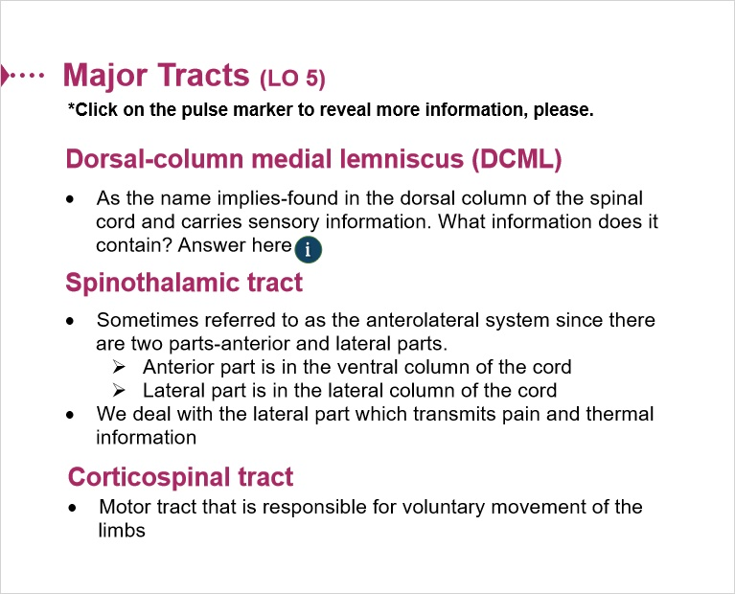

1.8 Other descending_ascending tracts
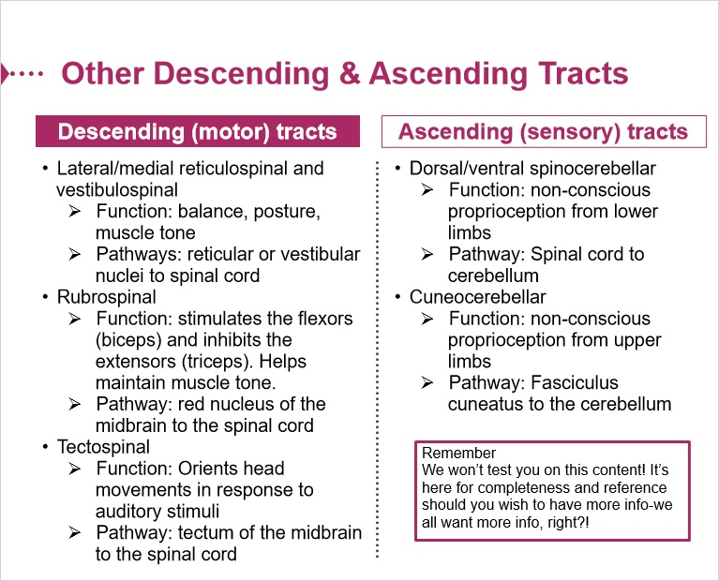

1.9 The Descending Pathways are Organized
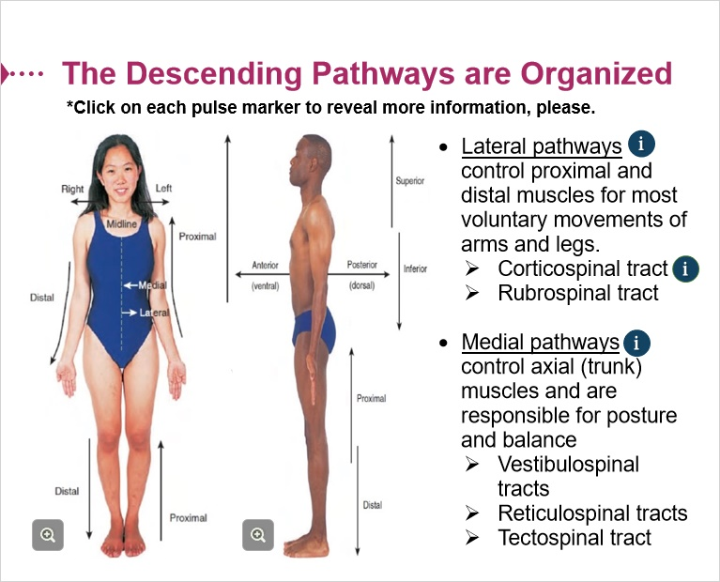

1.10 Supplementary Info on Reticulospinal Tracts
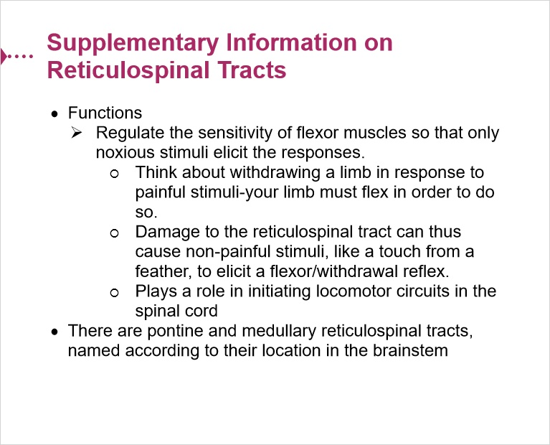

2. Part 02

2.1 Exercise 2 - Instructions
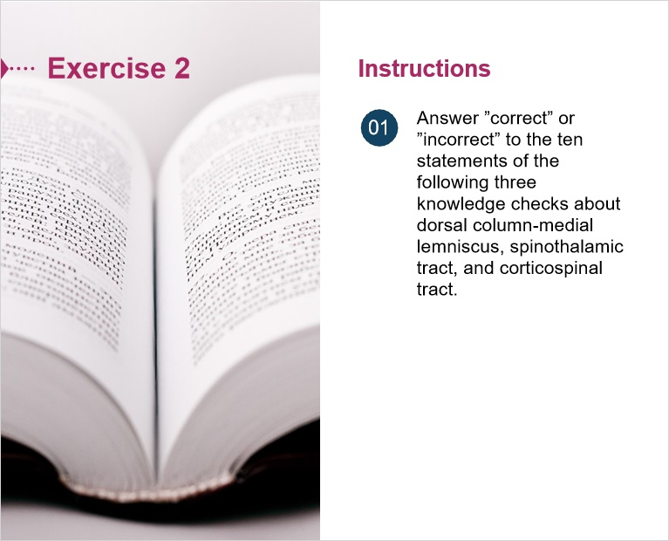

2.2 Knowledge Check 02_ Dorsal Column-Medial Lemniscus
(Multiple Choice, 10 points, 1 attempt permitted)
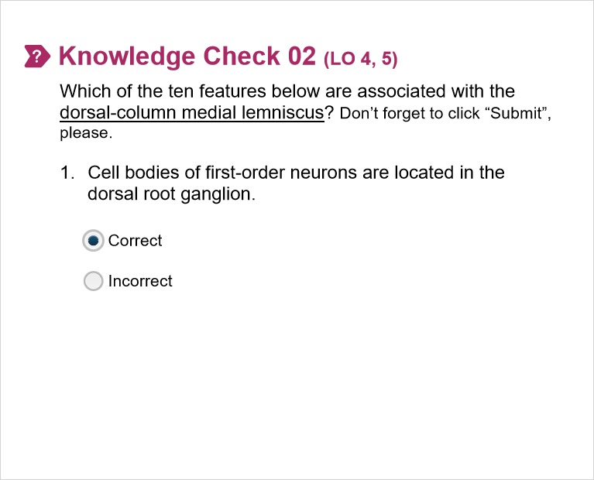
Correct | Choice
X | Correct
 | Incorrect

Feedback when correct:
The cell bodies of the first order neurons of the DCML are located in the dorsal root ganglion. Recall that these are located in the intervertebral foramen of the vertebral column.
Feedback when incorrect:
The cell bodies of the first order neurons of the DCML are located in the dorsal root ganglion. Recall that these are located in the intervertebral foramen of the vertebral column.

Notes:

Good job! (Slide Layer)
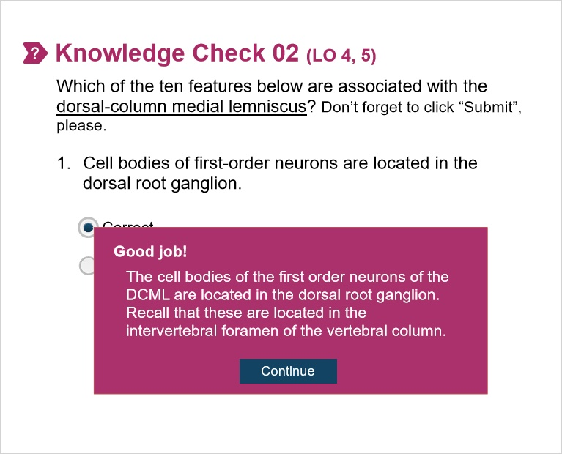

Sorry! (Slide Layer)
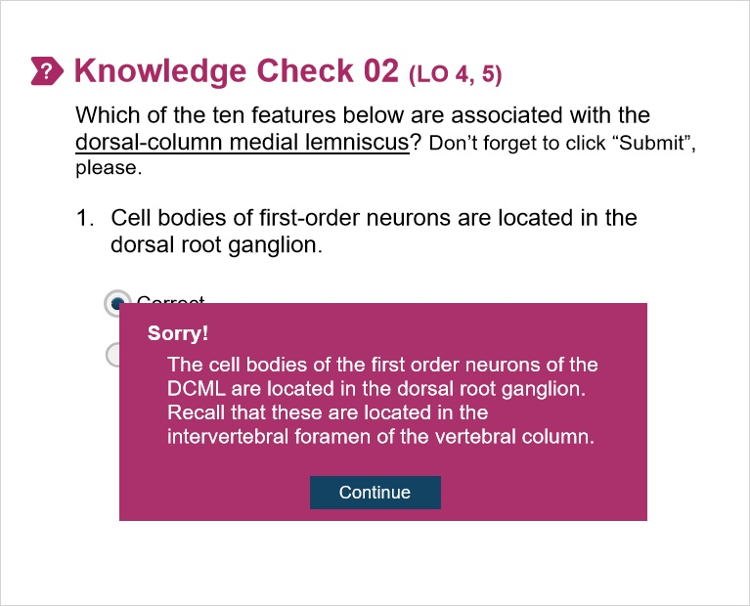

2.3 Knowledge Check 02.02
(Multiple Choice, 10 points, 1 attempt permitted)
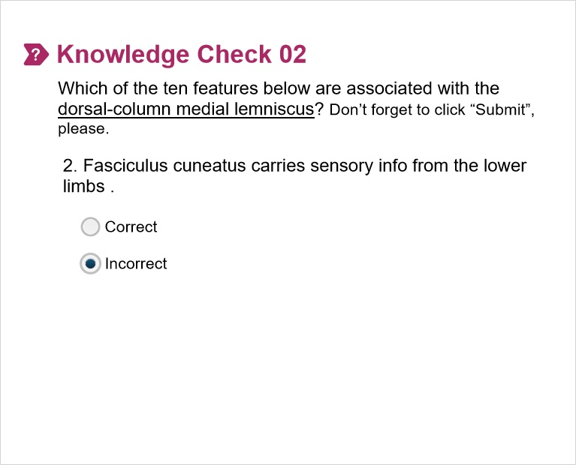
Correct | Choice
 | Correct
X | Incorrect

Feedback when correct:
The fasciculus cuneatus carries sensory information for the upper limbs. The fasciculus gracilis carries sensory information for the lower limb.
Feedback when incorrect:
The fasciculus cuneatus carries sensory information for the upper limbs. The fasciculus gracilis carries sensory information for the lower limb.

Good job! (Slide Layer)
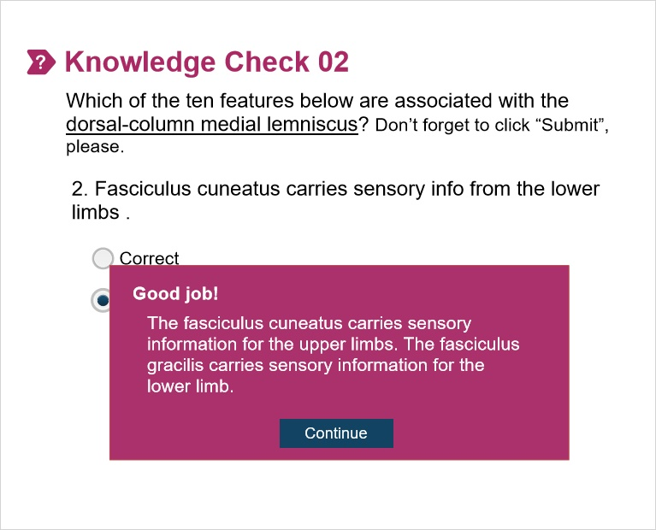

Sorry! (Slide Layer)
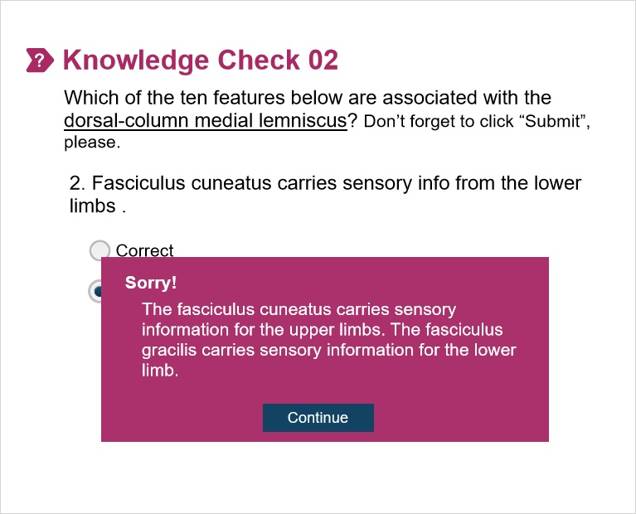

2.4 Knowledge Check 02.03
(Multiple Choice, 10 points, 1 attempt permitted)
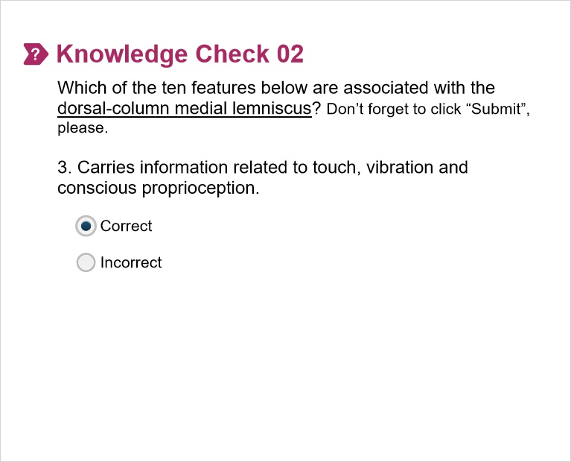
Correct | Choice
X | Correct
 | Incorrect

Feedback when correct:
The DCML carries information related to touch, vibration, pressure and conscious proprioception-the knowledge of where your limb is in space.
Feedback when incorrect:
The DCML carries information related to touch, vibration, pressure and conscious proprioception-the knowledge of where your limb is in space.

Good job! (Slide Layer)


Sorry! (Slide Layer)


2.5 Knowledge Check 02.04
(Multiple Choice, 10 points, 1 attempt permitted)
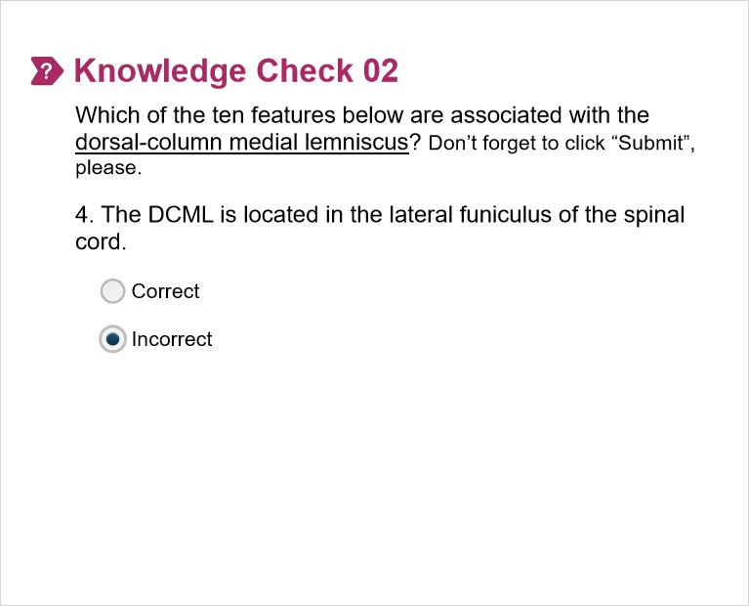
Correct | Choice
 | Correct
X | Incorrect

Feedback when correct:
The DCML (fasciculi cuneatus and gracilis) is located in the dorsal column of the spinal cord.
Feedback when incorrect:
The DCML (fasciculi cuneatus and gracilis) is located in the dorsal column of the spinal cord.

Good job! (Slide Layer)
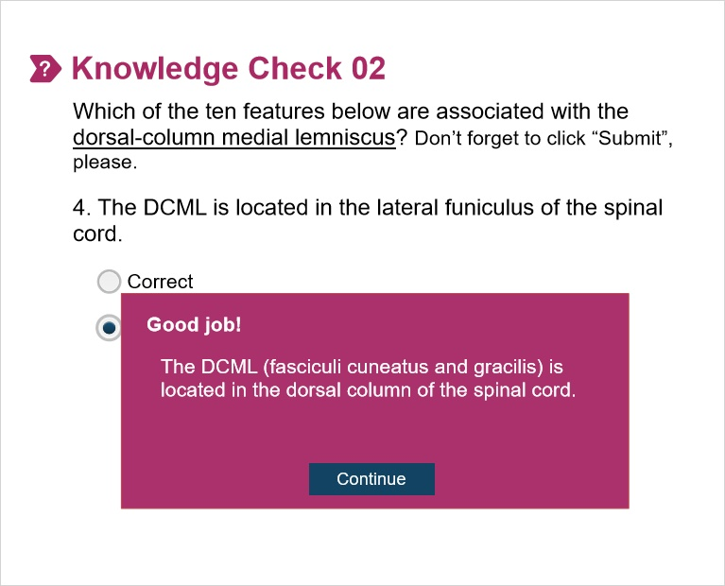

Sorry! (Slide Layer)
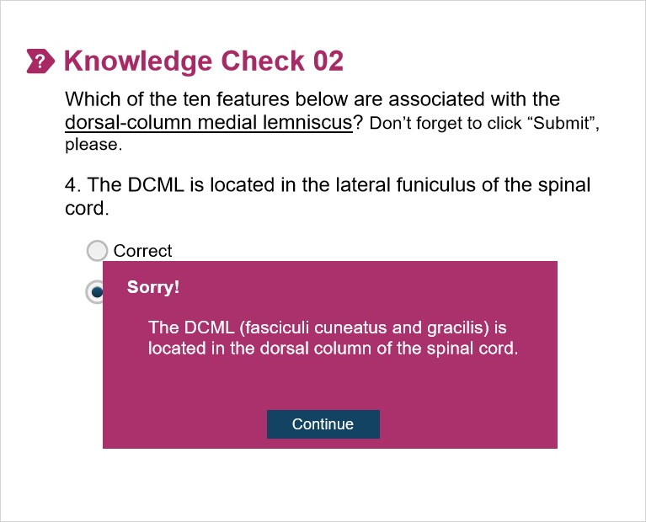

2.6 Knowledge Check 02.05
(Multiple Choice, 10 points, 1 attempt permitted)
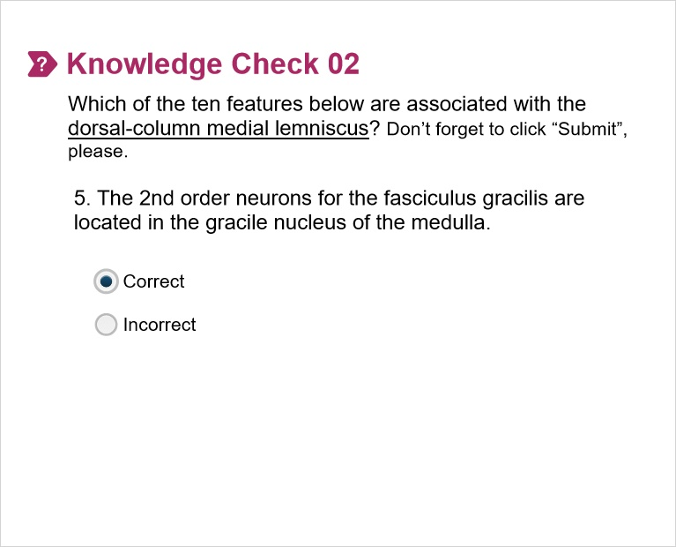
Correct | Choice
X | Correct
 | Incorrect

Feedback when correct:
The 2nd order neurons for the fasciculus gracilis are located in the gracile nucleus while the 2nd order neurons for the fasciculus cuneatus are located in the cuneate nucleus of the medulla.
Feedback when incorrect:
The 2nd order neurons for the fasciculus gracilis are located in the gracile nucleus while the 2nd order neurons for the fasciculus cuneatus are located in the cuneate nucleus of the medulla.

Good job! (Slide Layer)
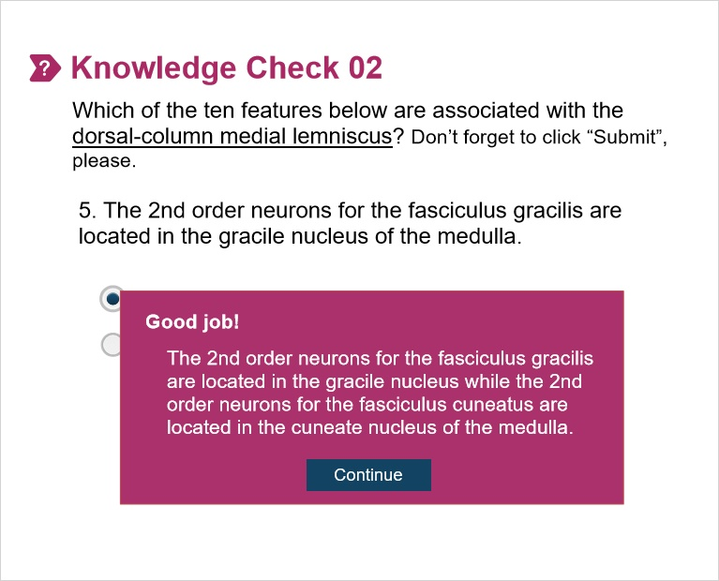

Sorry! (Slide Layer)
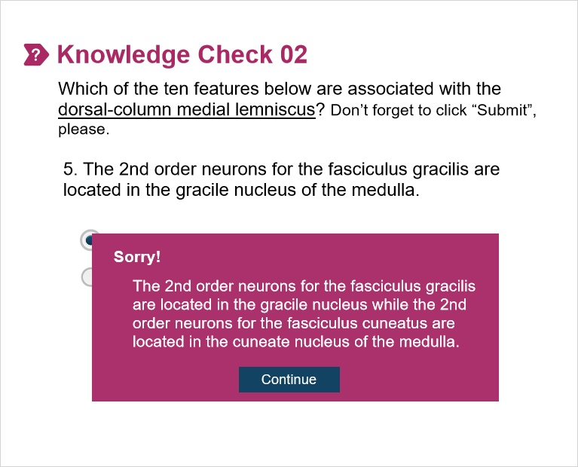

2.7 Knowledge Check 02.06
(Multiple Choice, 10 points, 1 attempt permitted)
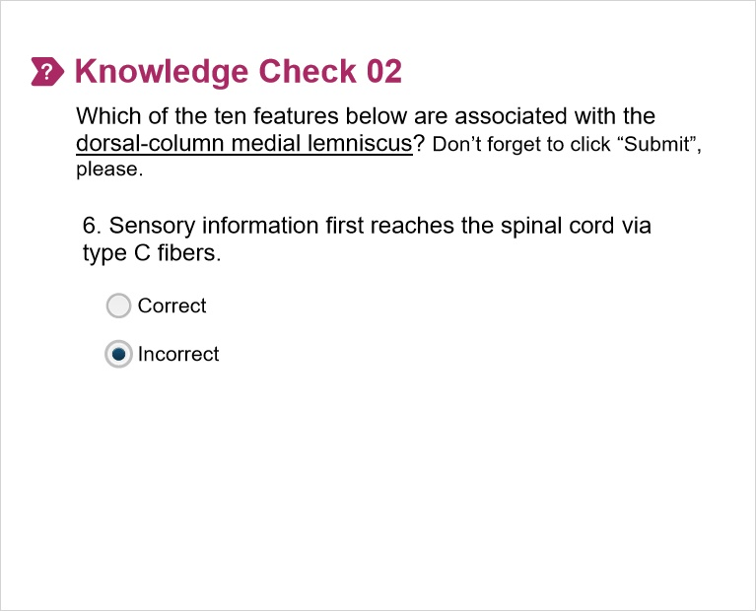
Correct | Choice
 | Correct
X | Incorrect

Feedback when correct:
Sensory information that travels in the DCML doesn’t reach the cord via type C fibers as these carry information related to the sensation of painful stimuli. They are carried in Aβ fibers.
Feedback when incorrect:
Sensory information that travels in the DCML doesn’t reach the cord via type C fibers as these carry information related to the sensation of painful stimuli. They are carried in Aβ fibers.

Good job! (Slide Layer)
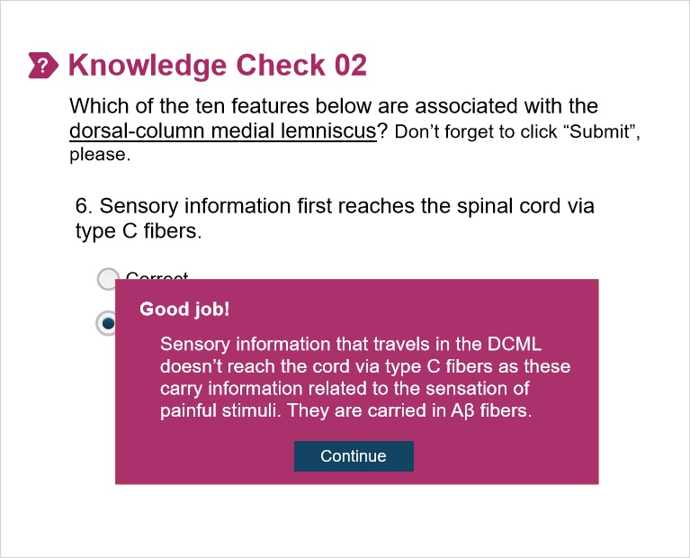

Sorry! (Slide Layer)
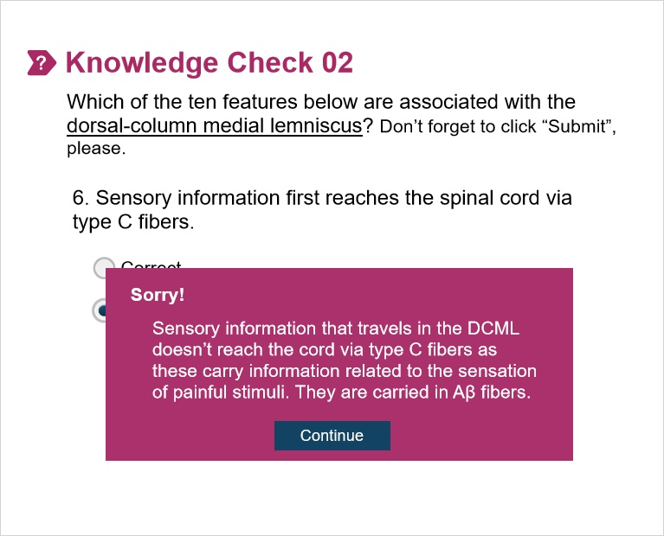

2.8 Knowledge Check 02.07
(Multiple Choice, 10 points, 1 attempt permitted)
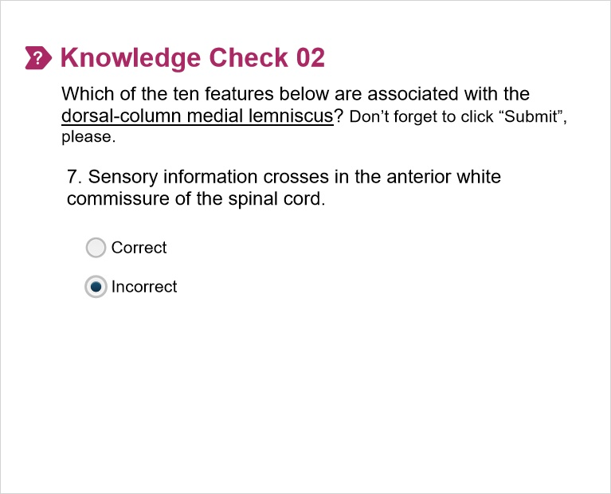
Correct | Choice
 | Correct
X | Incorrect

Feedback when correct:
Sensory info in the DCML doesn’t cross until fibers synapse in gracile or cuneate nuclei of the medulla.
Feedback when incorrect:
Sensory info in the DCML doesn’t cross until fibers synapse in gracile or cuneate nuclei of the medulla.

Good job! (Slide Layer)
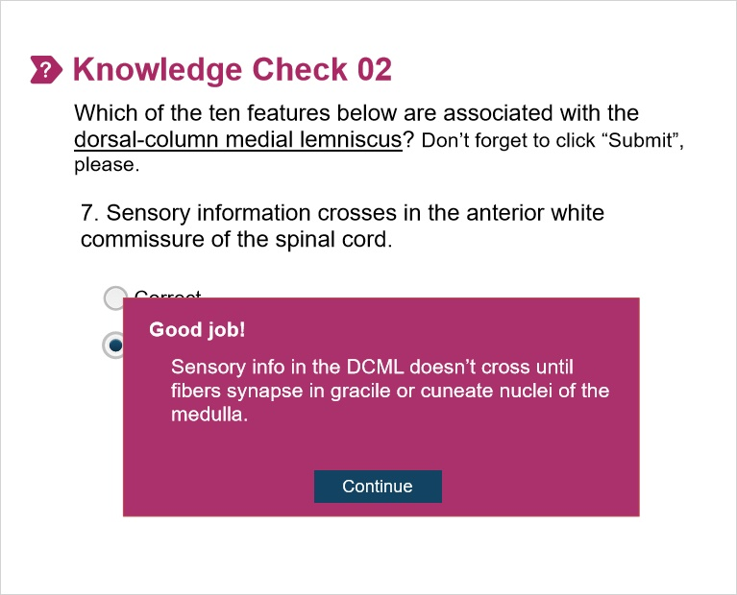

Sorry! (Slide Layer)
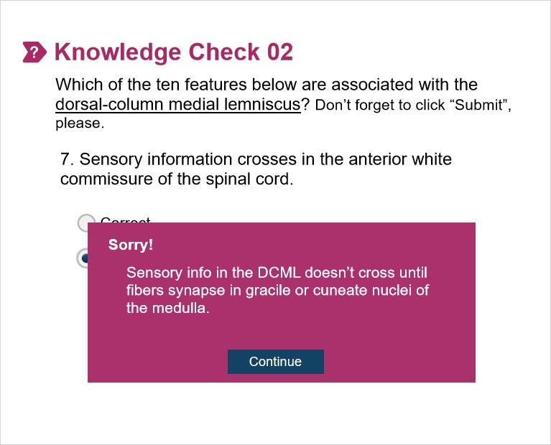

2.9 Knowledge Check 02.08
(Multiple Choice, 10 points, 1 attempt permitted)
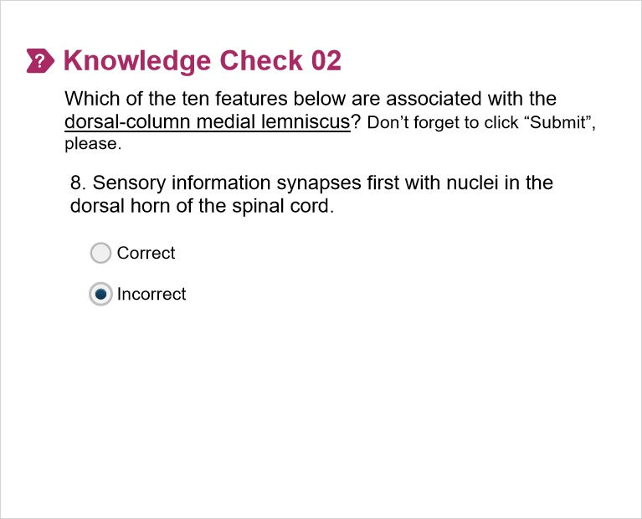
Correct | Choice
 | Correct
X | Incorrect

Feedback when correct:
Sensory info in the DCML doesn’t synapse in the spinal cord. The first location of synapse takes place in the medulla in the cuneate and gracile nuclei.
Feedback when incorrect:
Sensory info in the DCML doesn’t synapse in the spinal cord. The first location of synapse takes place in the medulla in the cuneate and gracile nuclei.

Good job! (Slide Layer)
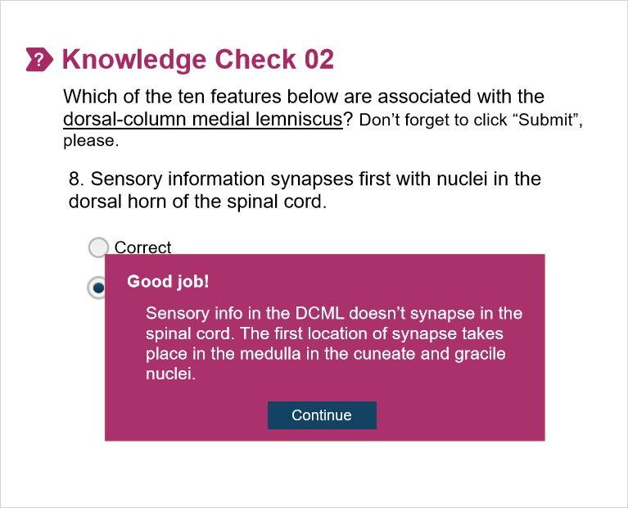

Sorry! (Slide Layer)
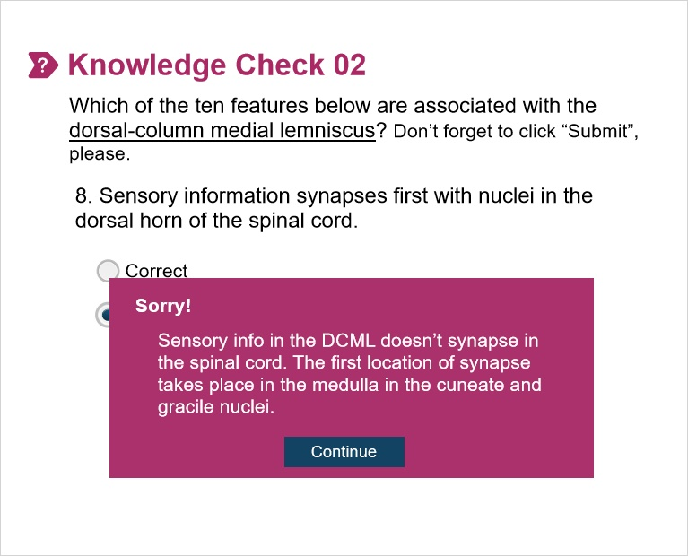

2.10 Knowledge Check 02.09
(Multiple Choice, 10 points, 1 attempt permitted)
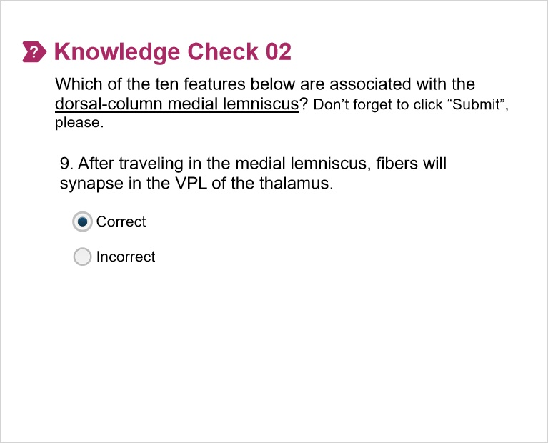
Correct | Choice
X | Correct
 | Incorrect

Feedback when correct:
After traveling in the medial lemniscus, fibers will synapse in the VLP of the thalamus before continuing to the appropriate cortical location in the post-central gyrus. Recall that cortical areas are somatotopically mapped with certain regions of the body represented in distinct areas.
Feedback when incorrect:
After traveling in the medial lemniscus, fibers will synapse in the VLP of the thalamus before continuing to the appropriate cortical location in the post-central gyrus. Recall that cortical areas are somatotopically mapped with certain regions of the body represented in distinct areas.

Good job! (Slide Layer)
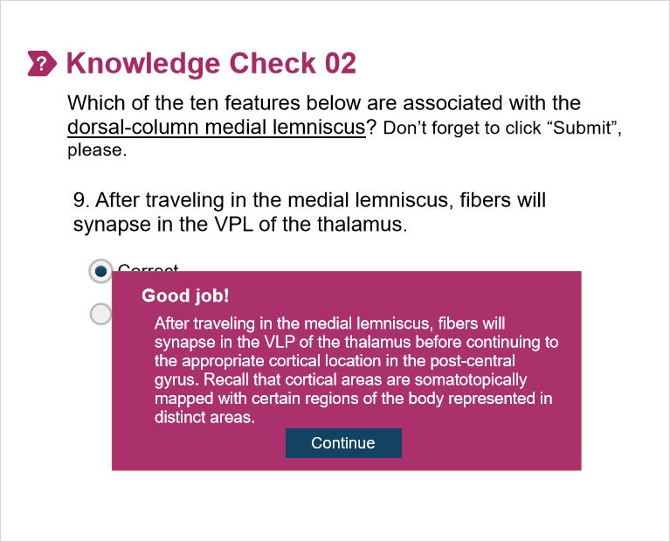

Sorry! (Slide Layer)
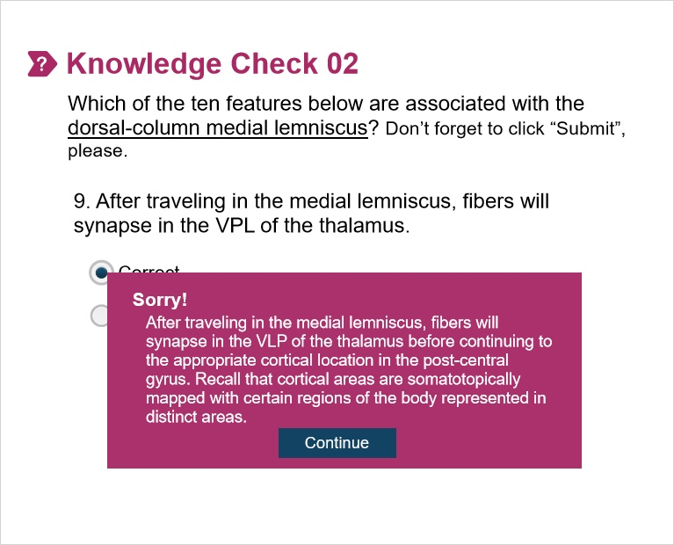

2.11 Knowledge Check 02.10
(Multiple Choice, 10 points, 1 attempt permitted)
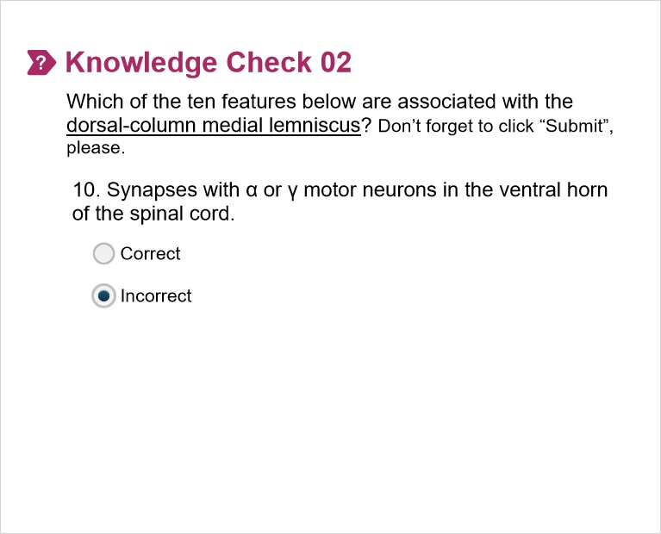
Correct | Choice
 | Correct
X | Incorrect

Feedback when correct:
Sensory information doesn’t synapse with α or γ motor neurons. Motor information synapses with these neurons.
Feedback when incorrect:
Sensory information doesn’t synapse with α or γ motor neurons. Motor information synapses with these neurons.

Good job! (Slide Layer)
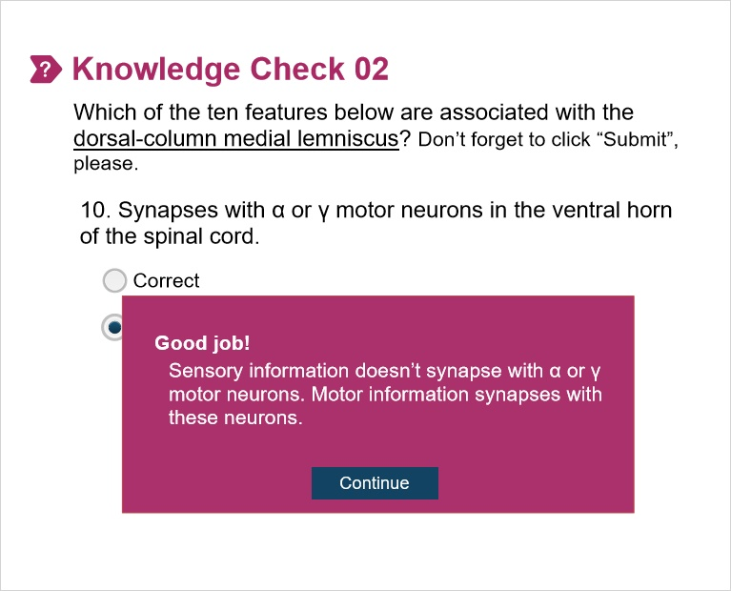

Sorry! (Slide Layer)
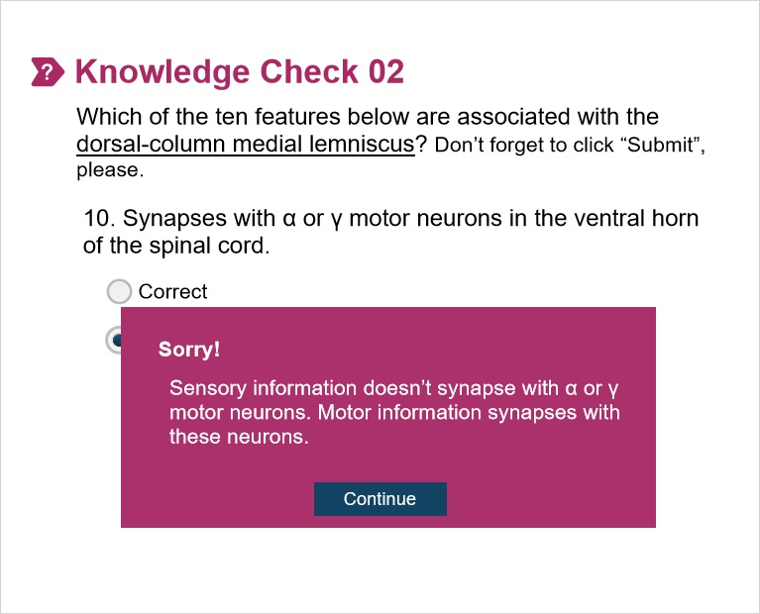

3. Part 03

3.1 Spinothalamic Tract_Quick Note
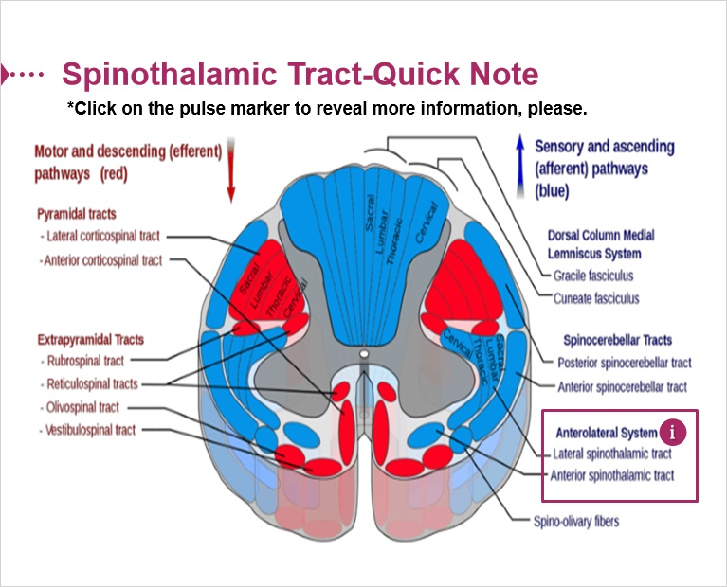

3.2 Knowledge Check_Spinohtalamic Tract
(Multiple Choice, 10 points, 1 attempt permitted)
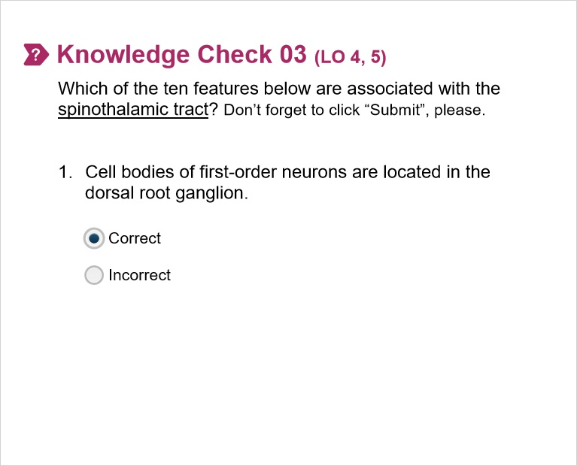
Correct | Choice
X | Correct
 | Incorrect

Feedback when correct:
The cell bodies of the spinothalamic tract are located in the dorsal root ganglion. Recall that there are central processes which transmit sensory info toward the spinal cord and peripheral processes which transmit sensory info from receptors (e.g., tactile) or noxious (e.g., painful) stimuli.
Feedback when incorrect:
The cell bodies of the spinothalamic tract are located in the dorsal root ganglion. Recall that there are central processes which transmit sensory info toward the spinal cord and peripheral processes which transmit sensory info from receptors (e.g., tactile) or noxious (e.g., painful) stimuli.

Good job! (Slide Layer)
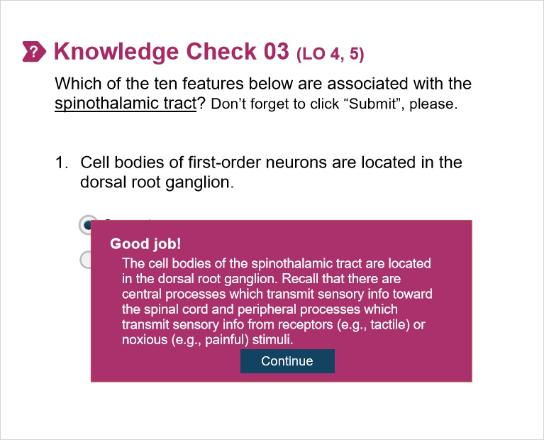

Sorry! (Slide Layer)
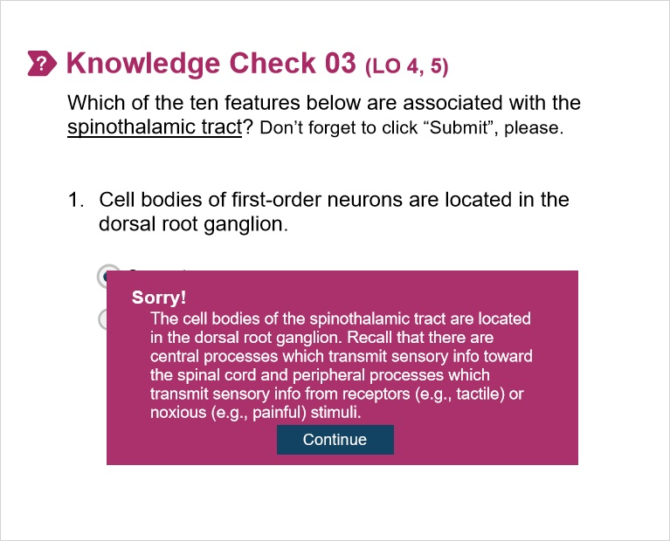

3.3 Knowledge Check 03.02
(Multiple Choice, 10 points, 1 attempt permitted)
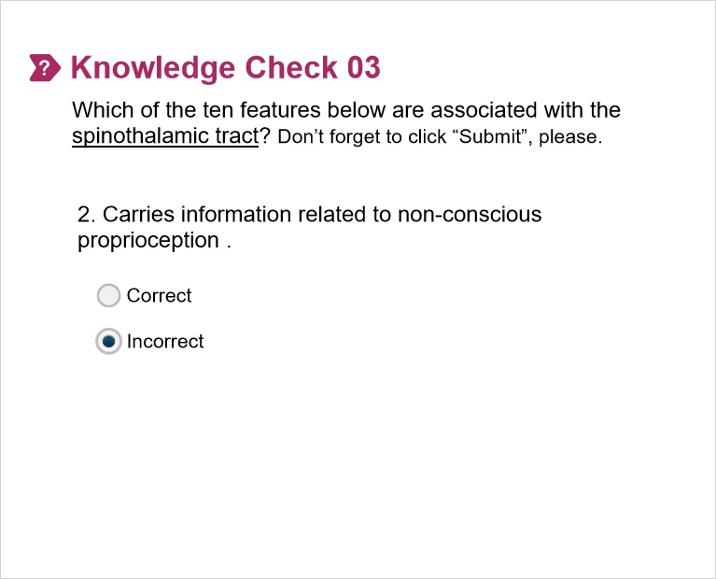
Correct | Choice
 | Correct
X | Incorrect

Feedback when correct:
The spinocerebellar pathways carry information related to non-conscious proprioception such as muscle length, stretch, and tension .
Feedback when incorrect:
The spinocerebellar pathways carry information related to non-conscious proprioception such as muscle length, stretch, and tension .

Good job! (Slide Layer)


Sorry! (Slide Layer)


3.4 Knowledge Check 03.03
(Multiple Choice, 10 points, 1 attempt permitted)
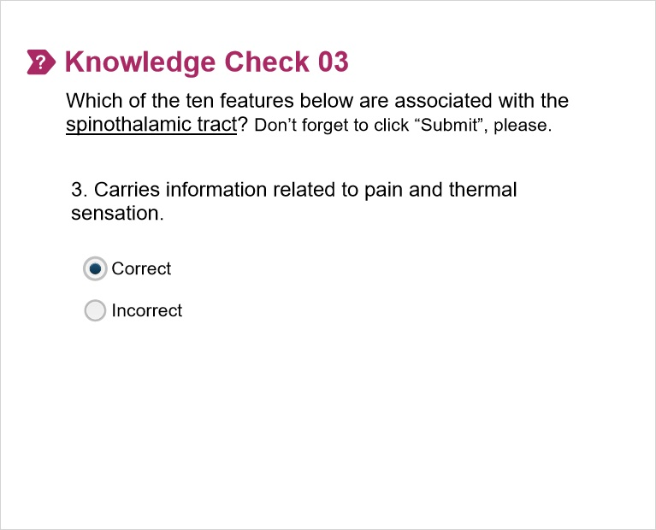
Correct | Choice
X | Correct
 | Incorrect

Feedback when correct:
The spinothalamic tract carries information related to the sensation of painful or thermal stimuli. Pain stimuli are characterized as mechanical (pinching), thermal (hot stove), and chemical (tissue injury).
Feedback when incorrect:
The spinothalamic tract carries information related to the sensation of painful or thermal stimuli. Pain stimuli are characterized as mechanical (pinching), thermal (hot stove), and chemical (tissue injury).

Good job! (Slide Layer)


Sorry! (Slide Layer)


3.5 Knowledge Check 03.04
(Multiple Choice, 10 points, 1 attempt permitted)
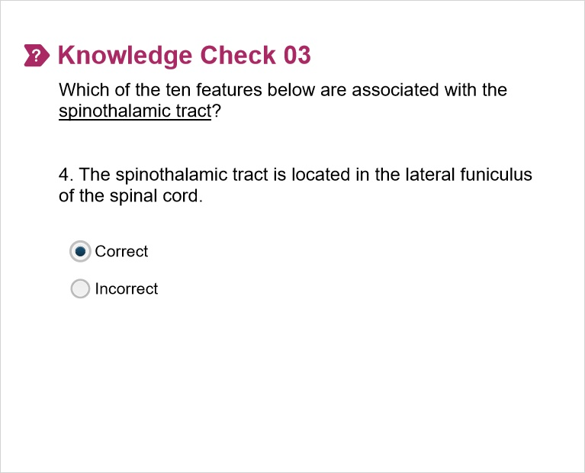
Correct | Choice
X | Correct
 | Incorrect

Feedback when correct:
The spinothalamic tract is located in the lateral funiculus (column) of the spinal cord.
Feedback when incorrect:
The spinothalamic tract is located in the lateral funiculus (column) of the spinal cord.

Good job! (Slide Layer)
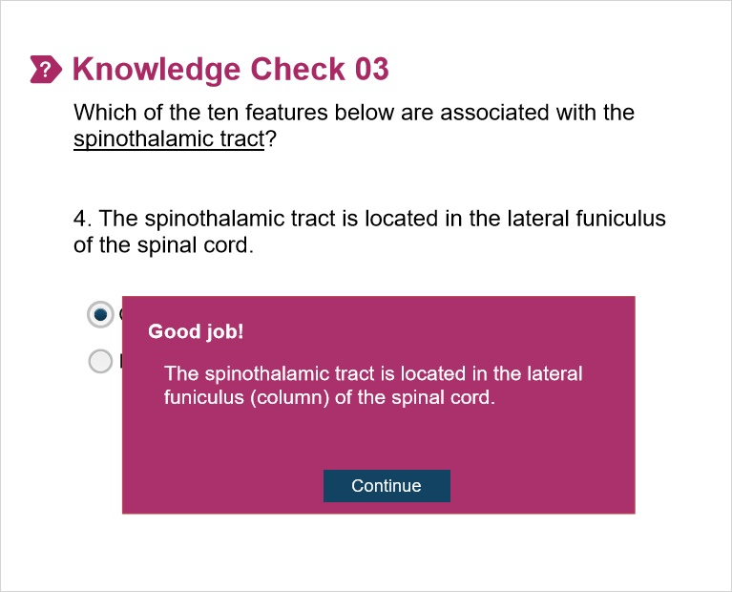

Sorry! (Slide Layer)
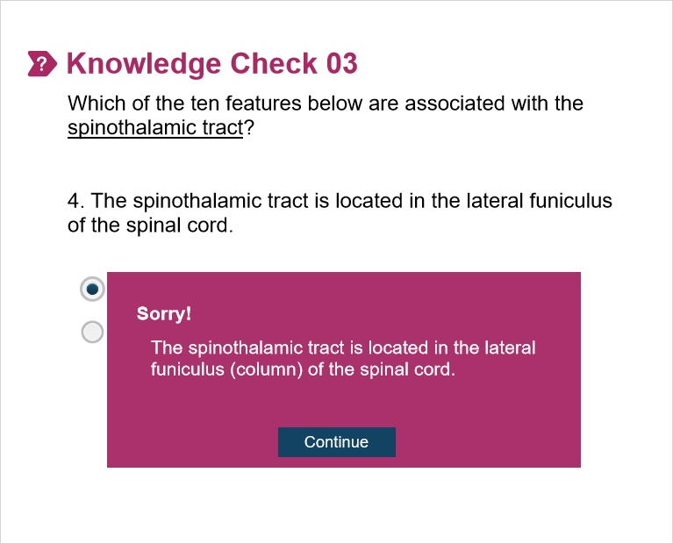

3.6 Knowledge Check 03.05
(Multiple Choice, 10 points, 1 attempt permitted)
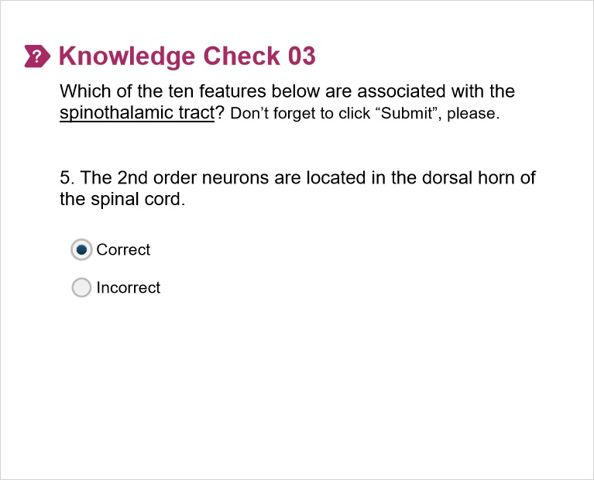
Correct | Choice
X | Correct
 | Incorrect

Feedback when correct:
The 2nd order neurons of the spinal cord are located in the dorsal horn of the spinal cord. Synapses can take place in the substantia gelatinosa and marginal zone.
Feedback when incorrect:
The 2nd order neurons of the spinal cord are located in the dorsal horn of the spinal cord. Synapses can take place in the substantia gelatinosa and marginal zone.

Good job! (Slide Layer)
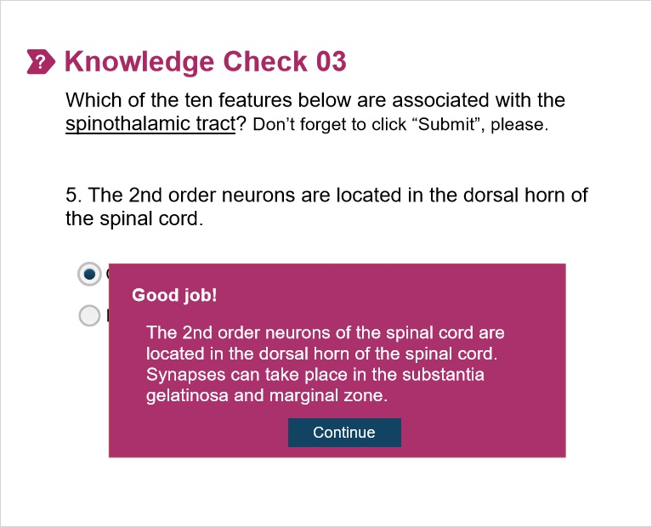

Sorry! (Slide Layer)
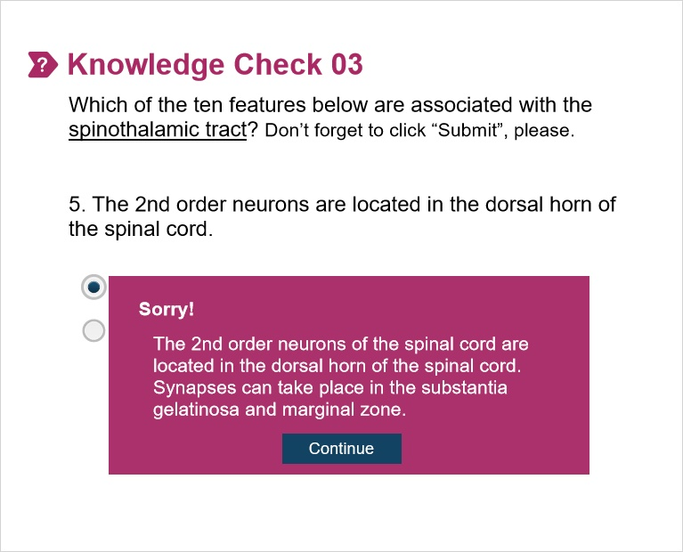

3.7 Knowledge Check 03.06
(Multiple Choice, 10 points, 1 attempt permitted)
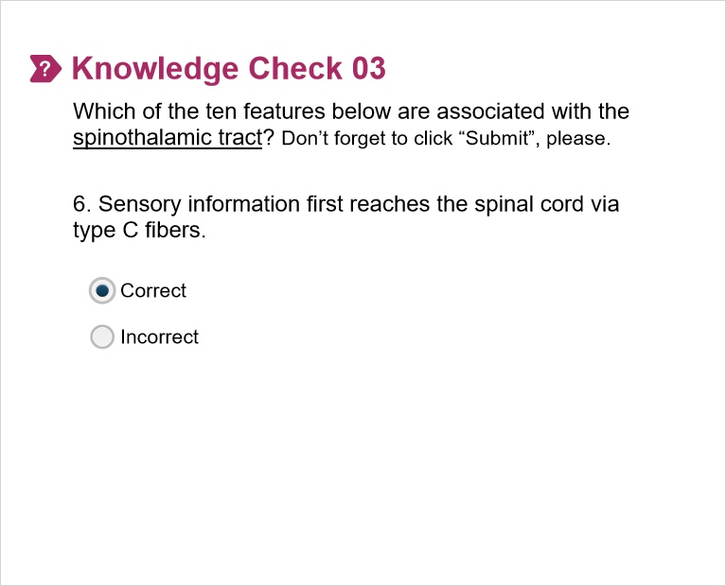
Correct | Choice
X | Correct
 | Incorrect

Feedback when correct:
C fibers are small, unmyelinated axons that conduct slow-burning pain. Another type of pain fiber is the A-delta fiber which are lightly myelinated axons that transmit fast, sharp pain.
Feedback when incorrect:
C fibers are small, unmyelinated axons that conduct slow-burning pain. Another type of pain fiber is the A-delta fiber which are lightly myelinated axons that transmit fast, sharp pain.

Good job! (Slide Layer)
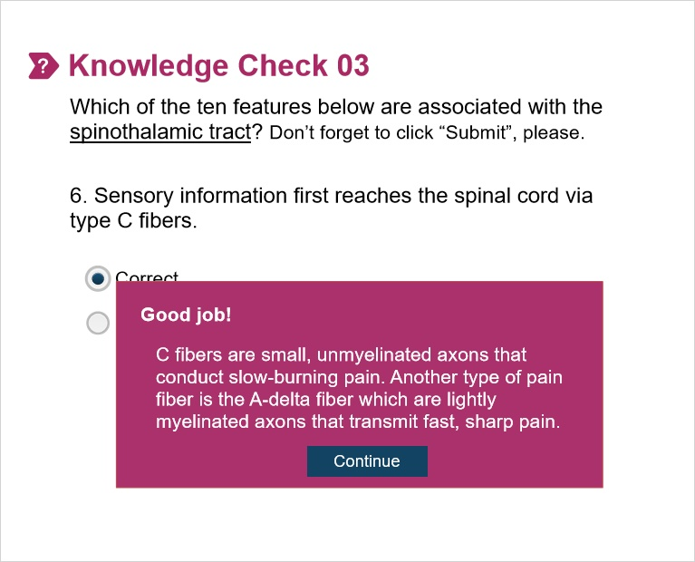

Sorry! (Slide Layer)
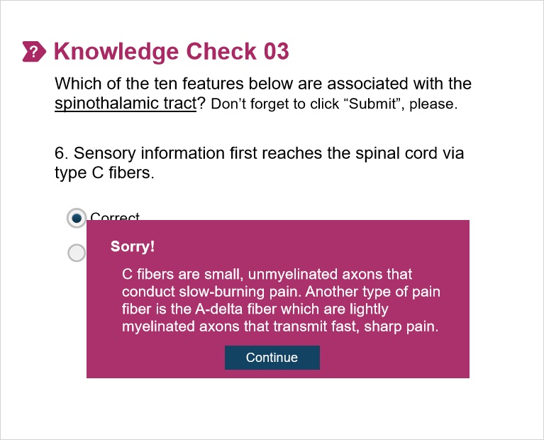

3.8 Knowledge Check 03.07
(Multiple Choice, 10 points, 1 attempt permitted)
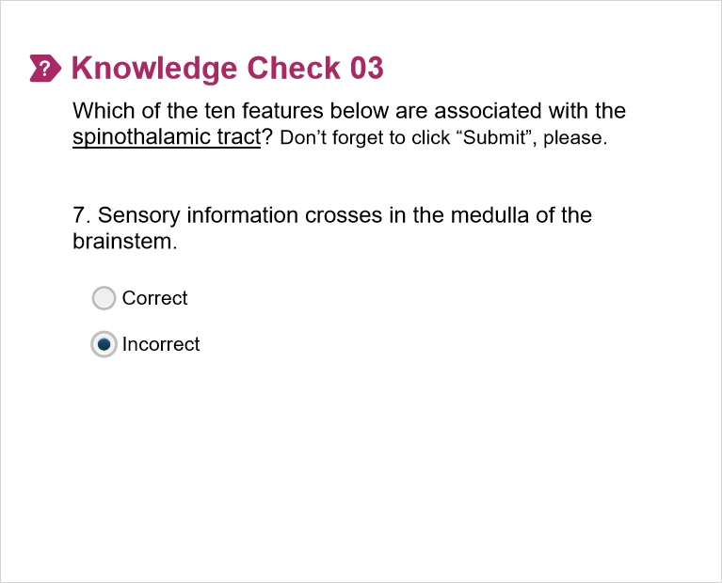
Correct | Choice
 | Correct
X | Incorrect

Feedback when correct:
Sensory information in the spinothalamic tract doesn’t cross (decussate) in the medulla of the brainstem. Rather, it crosses in the anterior white commissure of the spinal cord.
Feedback when incorrect:
Sensory information in the spinothalamic tract doesn’t cross (decussate) in the medulla of the brainstem. Rather, it crosses in the anterior white commissure of the spinal cord.

Good job! (Slide Layer)
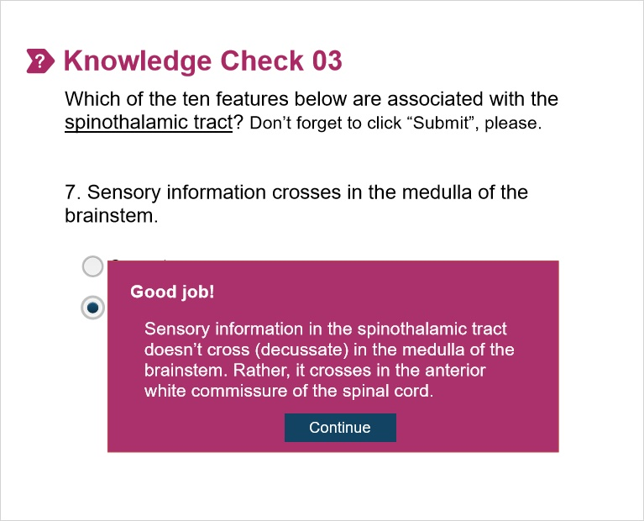

Sorry! (Slide Layer)
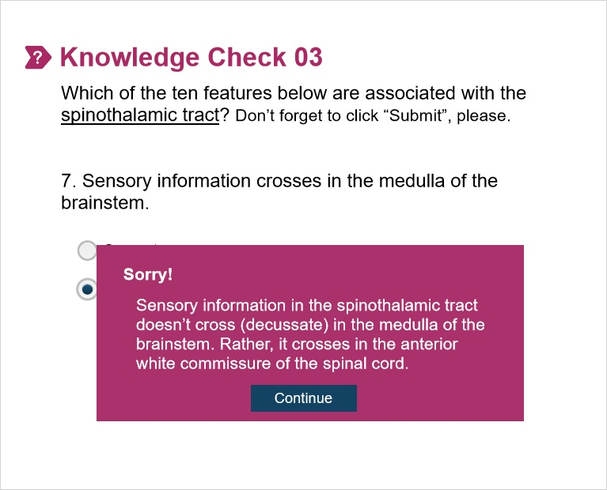

3.9 Knowledge Check 03.08
(Multiple Choice, 10 points, 1 attempt permitted)
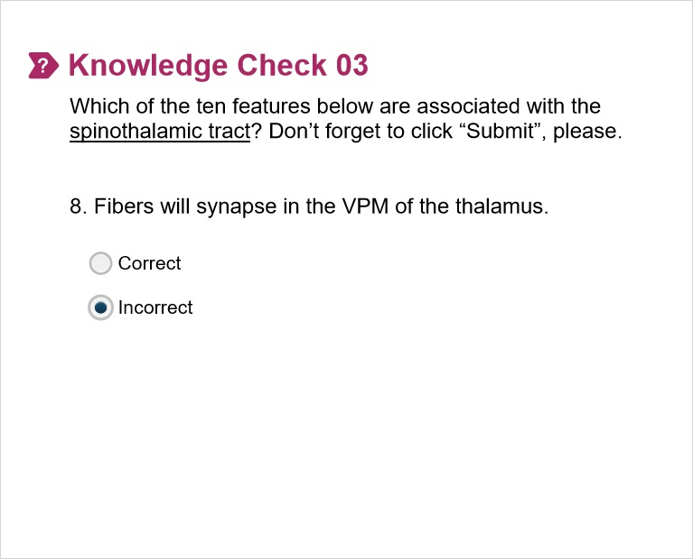
Correct | Choice
 | Correct
X | Incorrect

Feedback when correct:
Sensory information in the spinothalamic tract will synapse in the VPL of the thalamus (amongst other locations like the reticular formation). Information related to sensory processing of the face will synapse in the VPM of the thalamus.
Feedback when incorrect:
Sensory information in the spinothalamic tract will synapse in the VPL of the thalamus (amongst other locations like the reticular formation). Information related to sensory processing of the face will synapse in the VPM of the thalamus.

Good job! (Slide Layer)
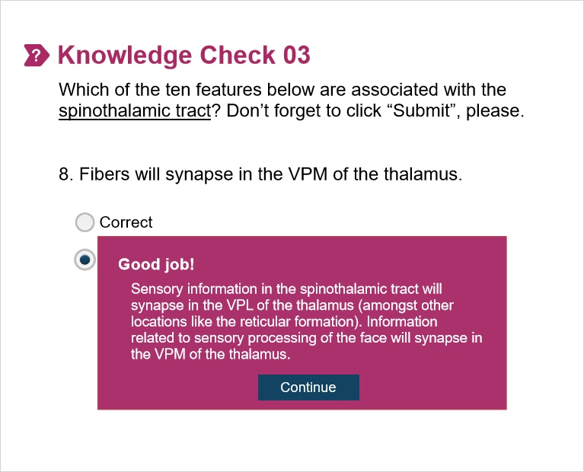

Sorry! (Slide Layer)
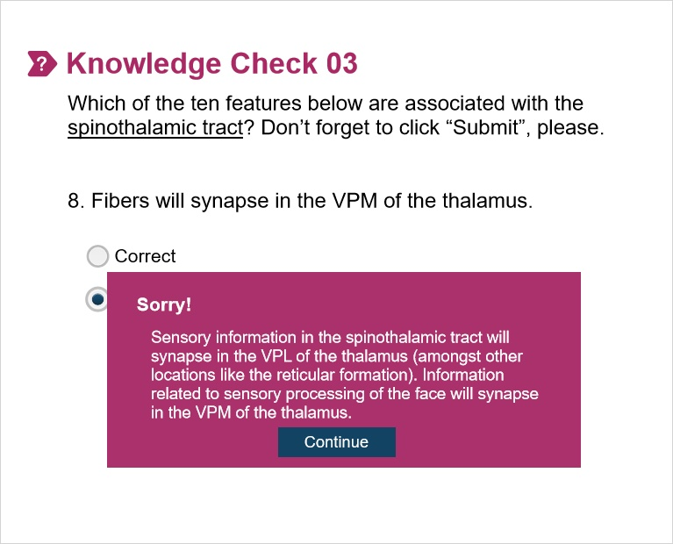

3.10 Knowledge Check 03.09
(Multiple Choice, 10 points, 1 attempt permitted)
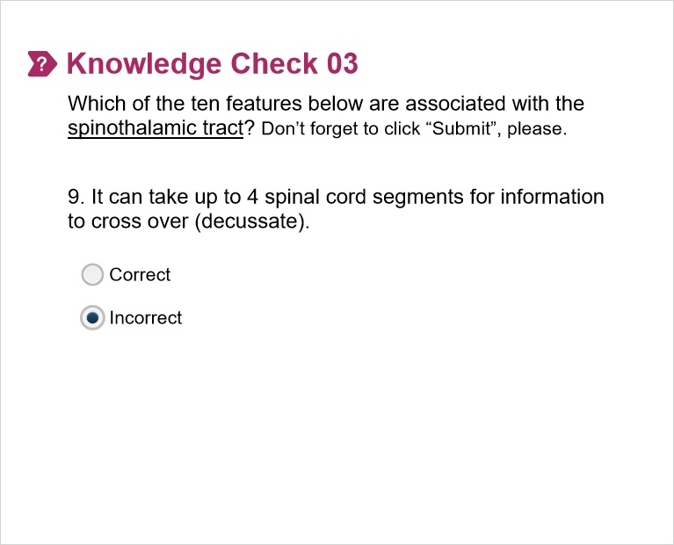
Correct | Choice
 | Correct
X | Incorrect

Feedback when correct:
It generally takes up to two spinal cord segments for fibers to cross prior to entering the spinothalamic tract.
Feedback when incorrect:
It generally takes up to two spinal cord segments for fibers to cross prior to entering the spinothalamic tract.

Good job! (Slide Layer)
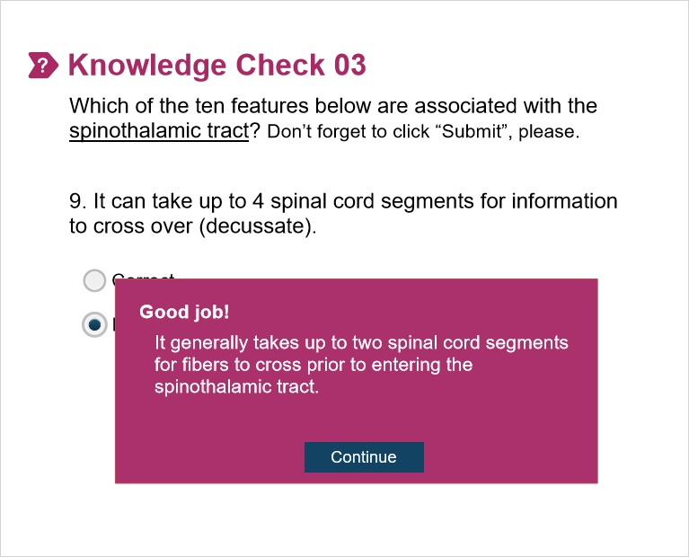

Sorry! (Slide Layer)
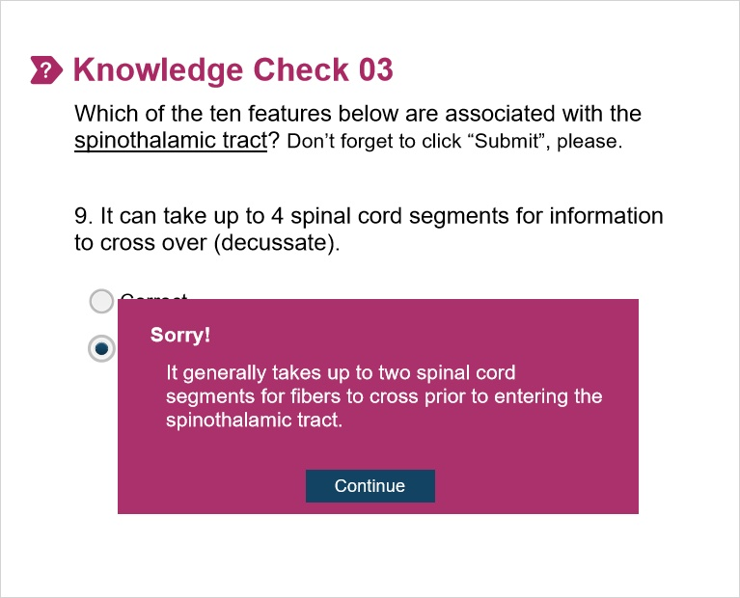

3.11 Knowledge Check 03.10
(Multiple Choice, 10 points, 1 attempt permitted)
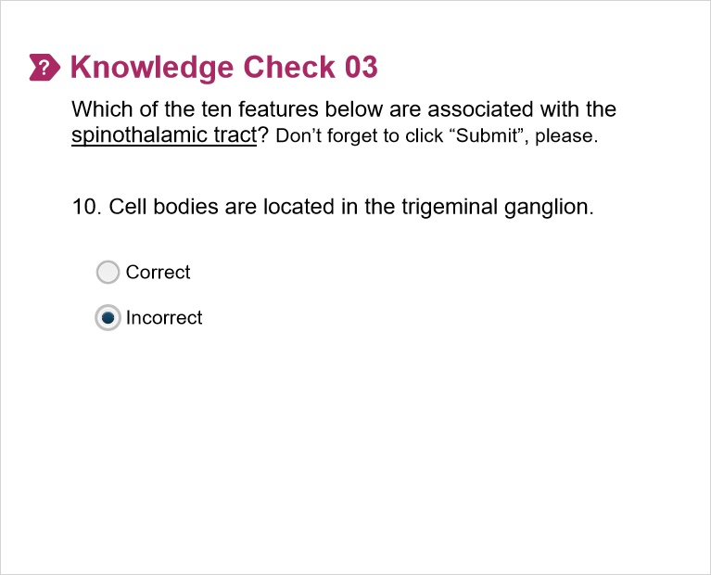
Correct | Choice
 | Correct
X | Incorrect

Feedback when correct:
Cell bodies associated with the transmission of sensory information (pain, thermal, tactile, pressure, etc.) for the face are found in the trigeminal ganglion. Remember from way back in FoCS when we dissected this? All 3 branches of the trigeminal nerve have their cell bodies in the trigeminal ganglion. Cell bodies for transmission of pain/thermal sensory information in the spinothalamic tract are located in the DRG.
Feedback when incorrect:
Cell bodies associated with the transmission of sensory information (pain, thermal, tactile, pressure, etc.) for the face are found in the trigeminal ganglion. Remember from way back in FoCS when we dissected this? All 3 branches of the trigeminal nerve have their cell bodies in the trigeminal ganglion. Cell bodies for transmission of pain/thermal sensory information in the spinothalamic tract are located in the DRG.

Good job! (Slide Layer)
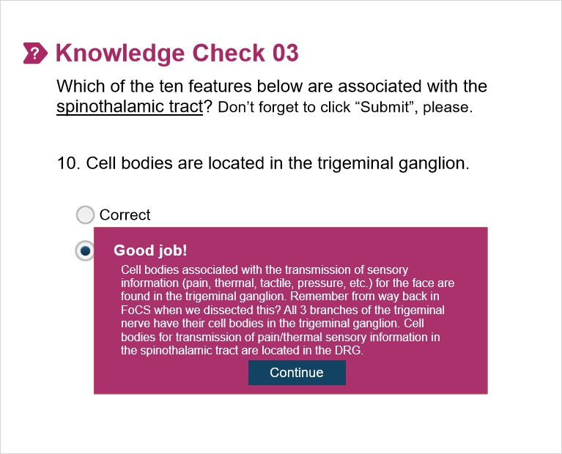

Sorry! (Slide Layer)
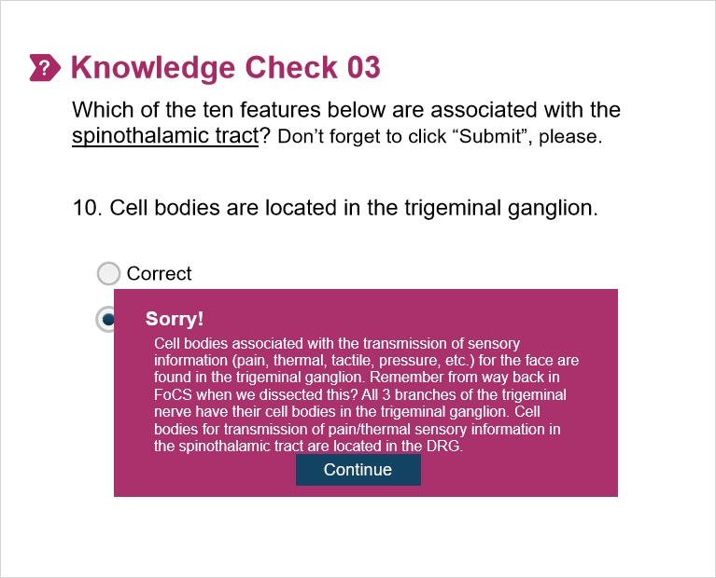

4. Part 04

4.1 Knowledge Check_ Corticospinal Tract
(Multiple Choice, 10 points, 1 attempt permitted)
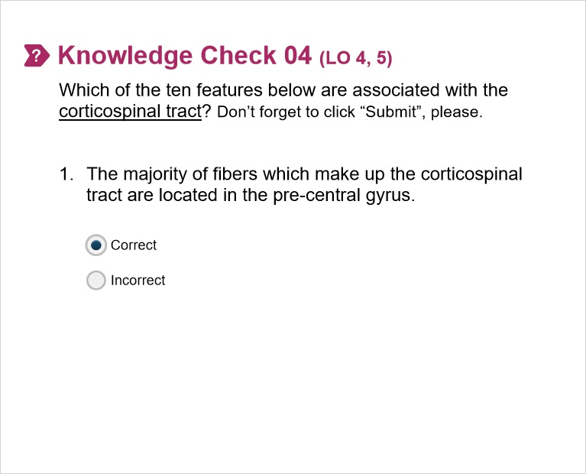
Correct | Choice
X | Correct
 | Incorrect

Feedback when correct:
The majority of the fibers which give rise to the corticospinal tract are located in the primary motor cortex or pre-central gyrus. Other locations include the pre-motor and supplementary motor cortices as well as parts of the somatosensory cortex.
Feedback when incorrect:
The majority of the fibers which give rise to the corticospinal tract are located in the primary motor cortex or pre-central gyrus. Other locations include the pre-motor and supplementary motor cortices as well as parts of the somatosensory cortex.

Notes:

Good job! (Slide Layer)
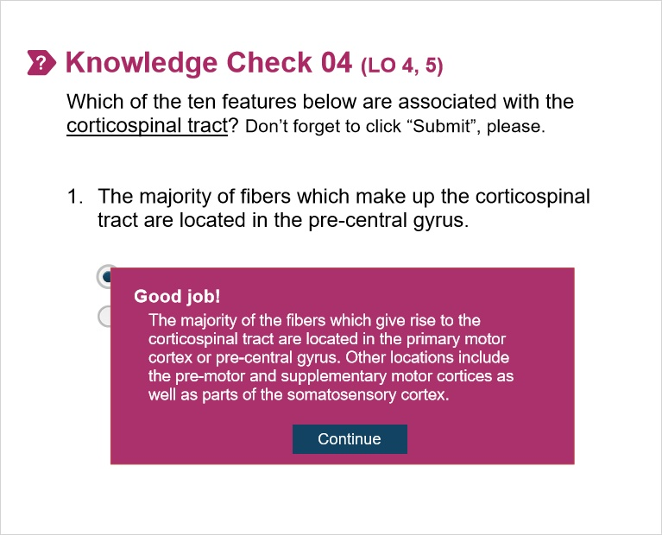

Sorry! (Slide Layer)
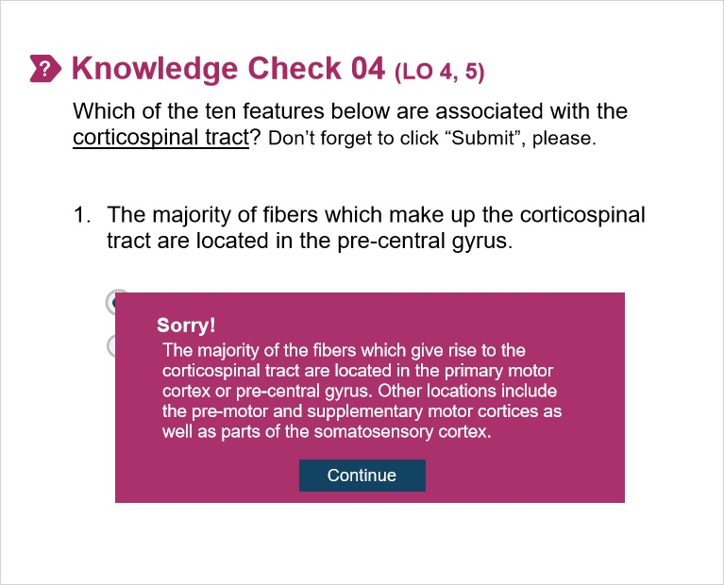

4.2 Knowledge Check 04.02
(Multiple Choice, 10 points, 1 attempt permitted)
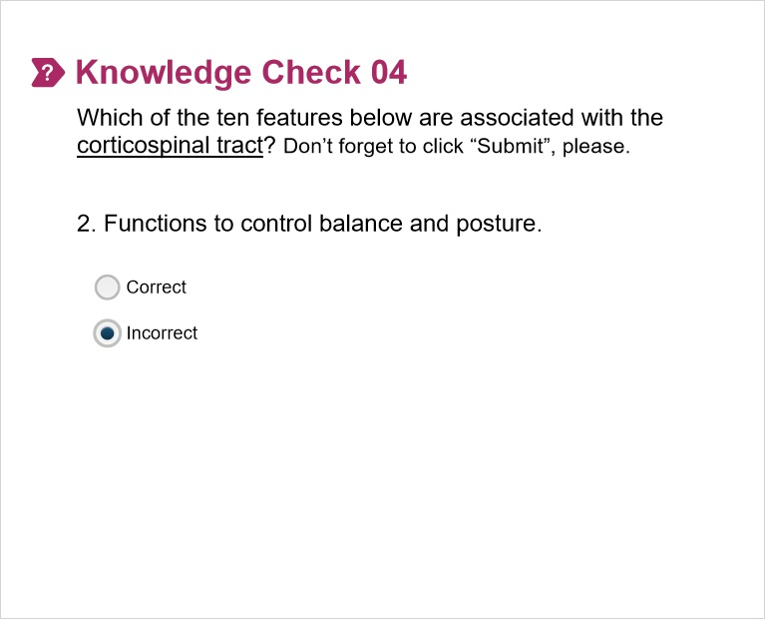
Correct | Choice
 | Correct
X | Incorrect

Feedback when correct:
The corticospinal tract controls movements of the distal and proximal muscles. The reticulospinal and in particular, the vestibulospinal tracts, control posture and balance. Again, we’ll focus the work on the corticospinal tracts as opposed to the other descending tracts.
Feedback when incorrect:
The corticospinal tract controls movements of the distal and proximal muscles. The reticulospinal and in particular, the vestibulospinal tracts, control posture and balance. Again, we’ll focus the work on the corticospinal tracts as opposed to the other descending tracts.

Good job! (Slide Layer)
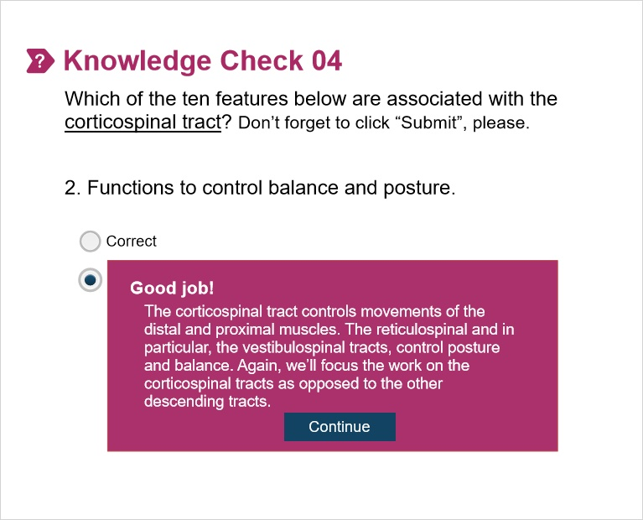

Sorry! (Slide Layer)
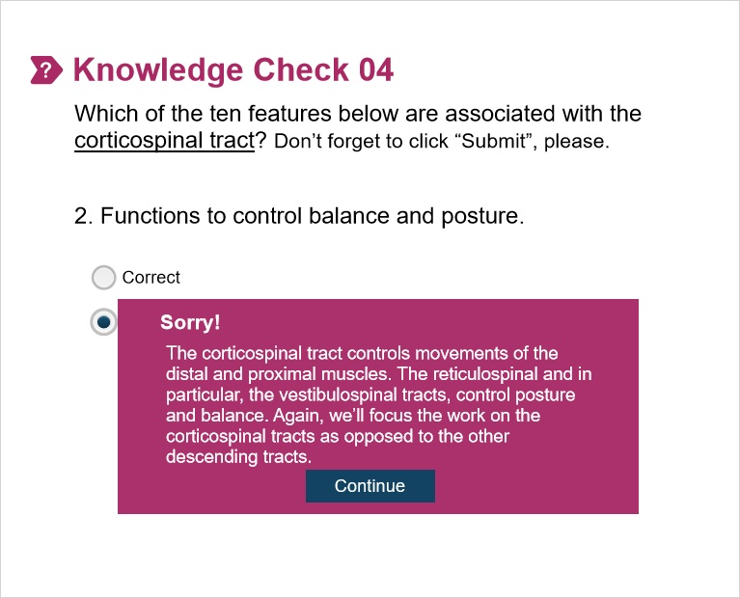

4.3 Knowledge Check 04.03
(Multiple Choice, 10 points, 1 attempt permitted)
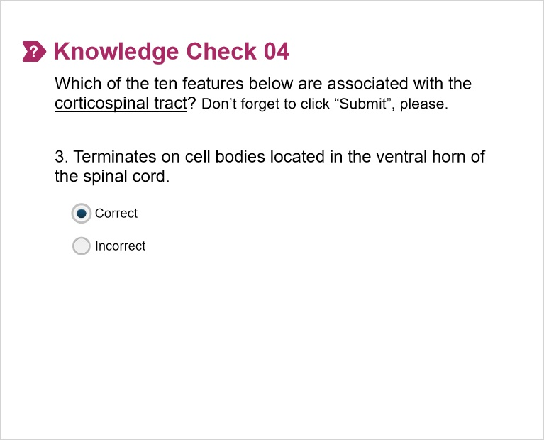
Correct | Choice
X | Correct
 | Incorrect

Feedback when correct:
The corticospinal tract terminates on lower motor neurons (LMN) in the ventral horn of the spinal cord. These include α motor neurons which carry motor commands to extrafusal fibers such as skeletal muscle causing contraction of the muscle. Other LMNs are γ motor neurons which innervate intrafusal fibers such as muscle spindles controlling its sensitivity to stretch, over a wide range of muscle lengths., respectively
Feedback when incorrect:
The corticospinal tract terminates on lower motor neurons (LMN) in the ventral horn of the spinal cord. These include α motor neurons which carry motor commands to extrafusal fibers such as skeletal muscle causing contraction of the muscle. Other LMNs are γ motor neurons which innervate intrafusal fibers such as muscle spindles controlling its sensitivity to stretch, over a wide range of muscle lengths., respectively.

Good job! (Slide Layer)
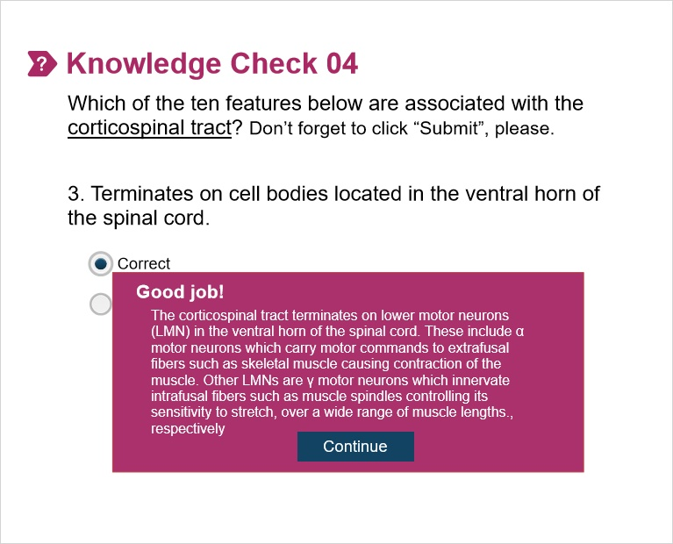

Sorry! (Slide Layer)
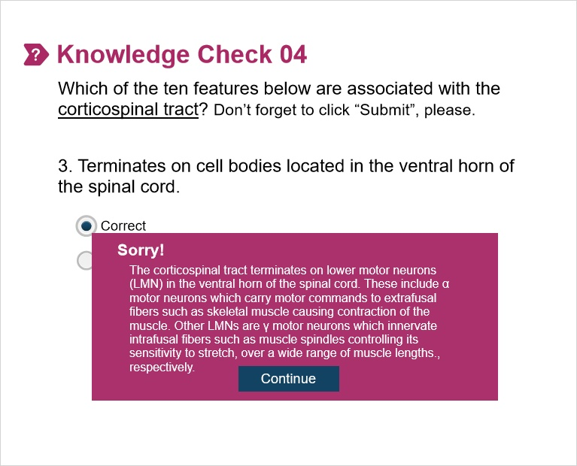

4.4 Knowledge Check 04.04
(Multiple Choice, 10 points, 1 attempt permitted)
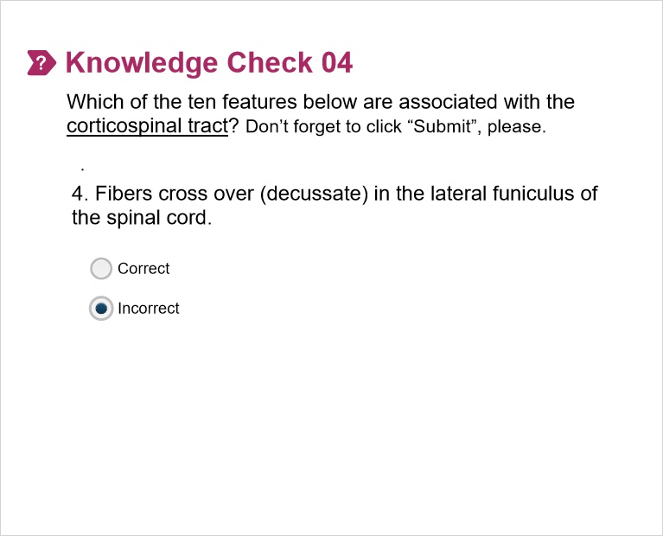
Correct | Choice
 | Correct
X | Incorrect

Feedback when correct:
Fibers of the corticospinal tract don’t cross over (decussate) in the lateral funiculus (column) of the spinal cord. Rather, they cross over at the pyramidal decussation in the caudal medulla.
Feedback when incorrect:
Fibers of the corticospinal tract don’t cross over (decussate) in the lateral funiculus (column) of the spinal cord. Rather, they cross over at the pyramidal decussation in the caudal medulla.

Good job! (Slide Layer)
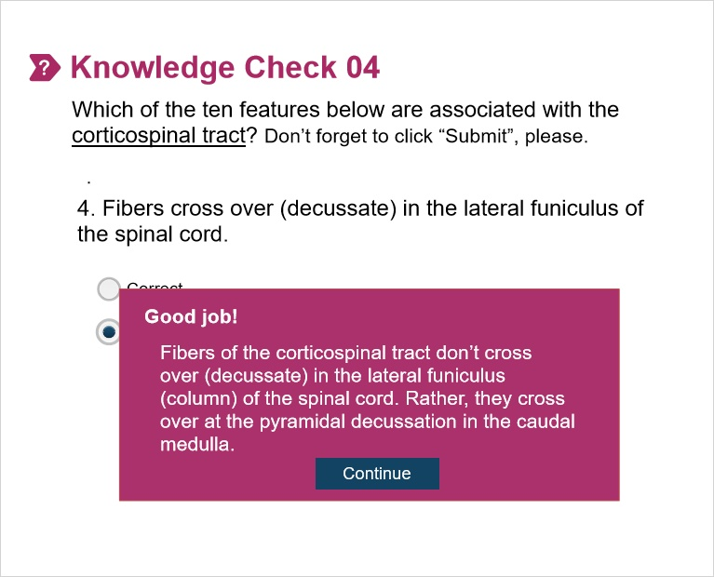

Sorry! (Slide Layer)
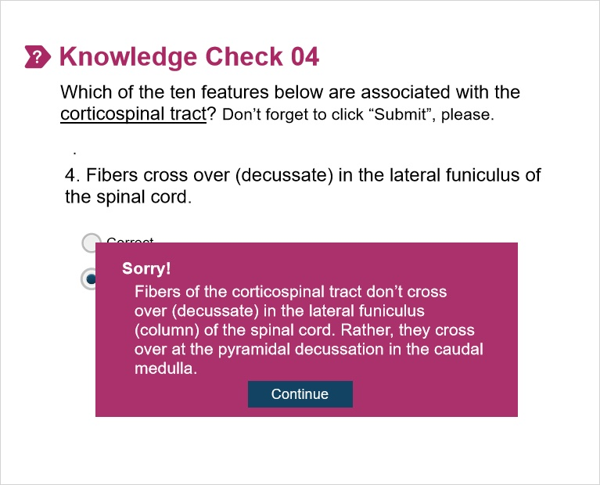

4.5 Knowledge Check 04.05
(Multiple Choice, 10 points, 1 attempt permitted)
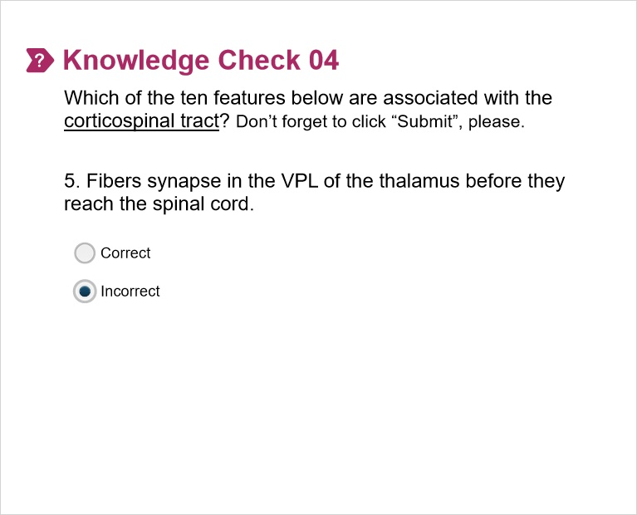
Correct | Choice
 | Correct
X | Incorrect

Feedback when correct:
Fibers of the corticospinal tract don’t synapse in the thalamus. The first synapse takes place in the ventral horn of the spinal cord where the corticospinal tract synapses on α and γ motor neurons.
Feedback when incorrect:
Fibers of the corticospinal tract don’t synapse in the thalamus. The first synapse takes place in the ventral horn of the spinal cord where the corticospinal tract synapses on α and γ motor neurons.

Good job! (Slide Layer)
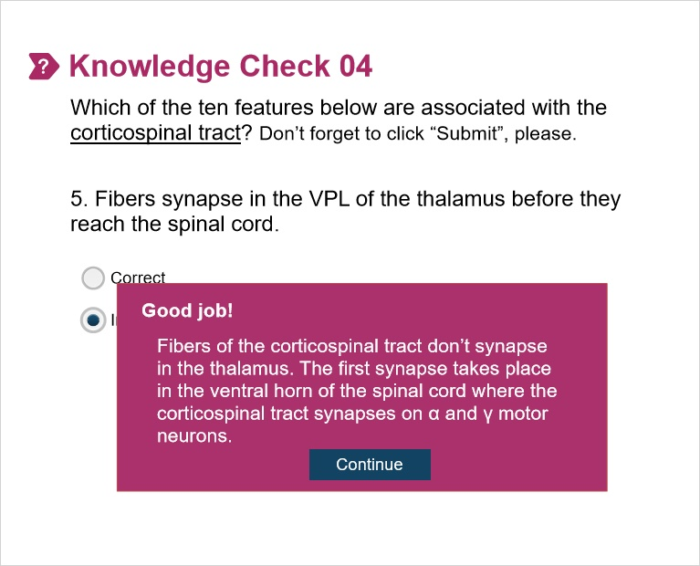

Sorry! (Slide Layer)
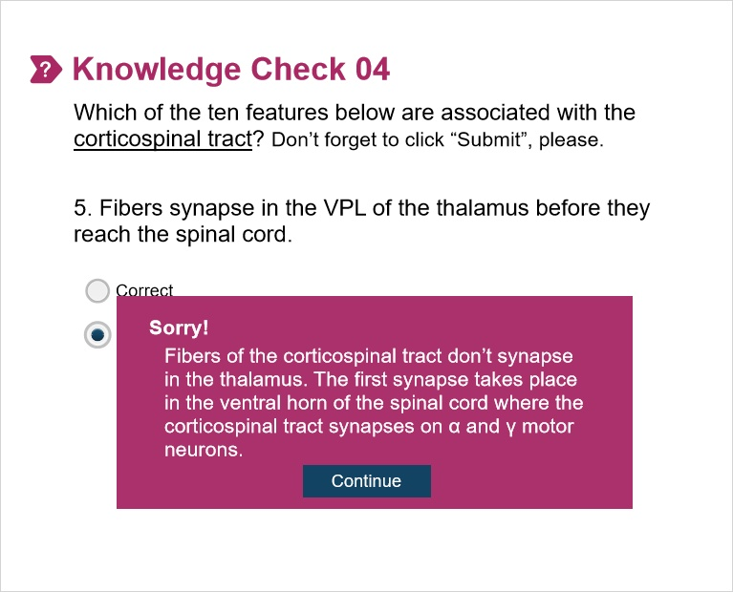

4.6 Knowledge Check 04.06
(Multiple Choice, 10 points, 1 attempt permitted)
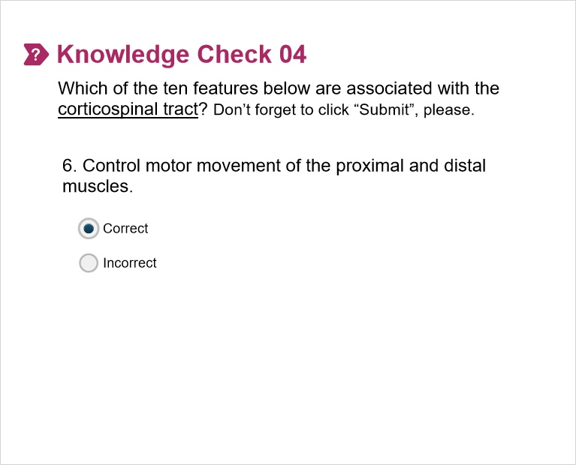
Correct | Choice
X | Correct
 | Incorrect

Feedback when correct:
The corticospinal tract controls the movement of the proximal (closest to the trunk) and distal (farthest from the trunk) muscles.
Feedback when incorrect:
The corticospinal tract controls the movement of the proximal (closest to the trunk) and distal (farthest from the trunk) muscles.

Good job! (Slide Layer)
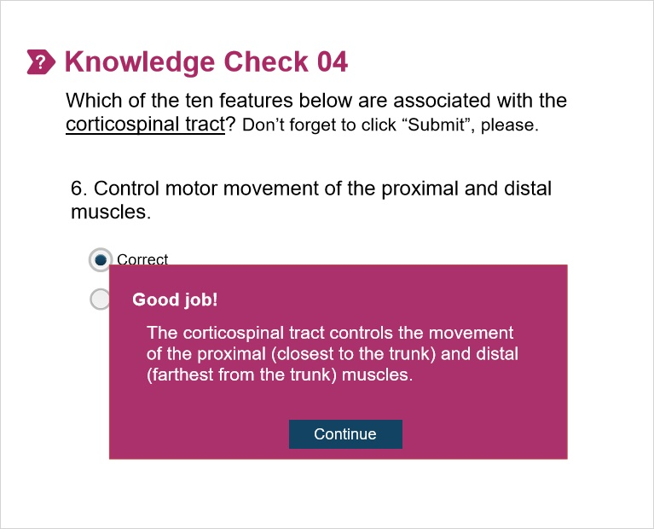

Sorry! (Slide Layer)
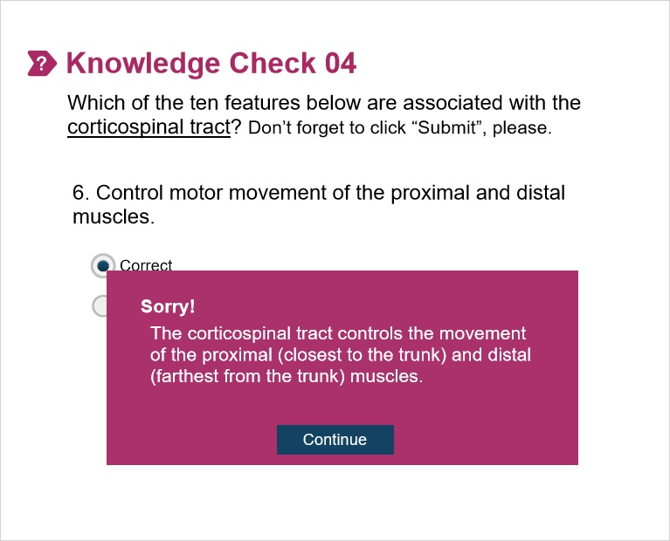

4.7 Knowledge Check 04.07
(Multiple Choice, 10 points, 1 attempt permitted)
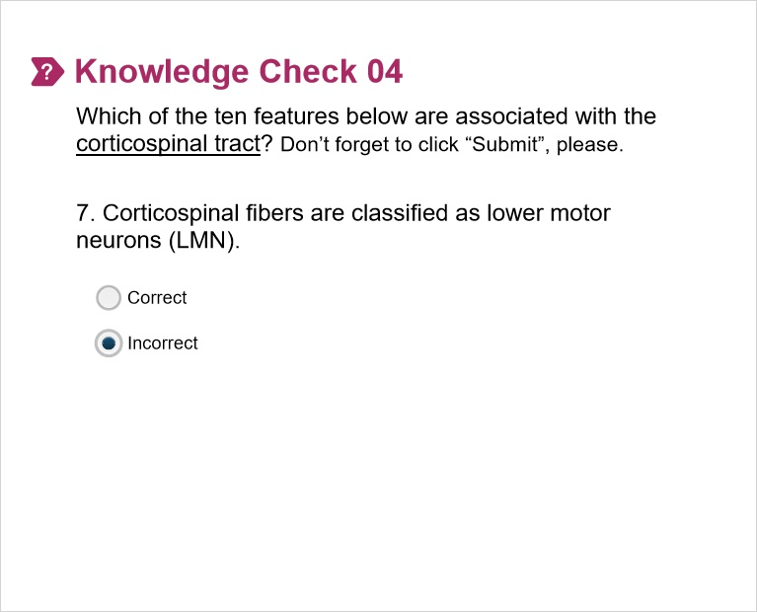
Correct | Choice
 | Correct
X | Incorrect

Feedback when correct:
Fibers of the corticospinal tract are classified as upper motor neurons (UMN). Lower motor neurons (LMNs) are the α and γ motor neurons of the ventral horn of the spinal cord. The axons from these ventral horn motor neurons are also classified as LMN.
Feedback when incorrect:
Fibers of the corticospinal tract are classified as upper motor neurons (UMN). Lower motor neurons (LMNs) are the α and γ motor neurons of the ventral horn of the spinal cord. The axons from these ventral horn motor neurons are also classified as LMN.

Good job! (Slide Layer)
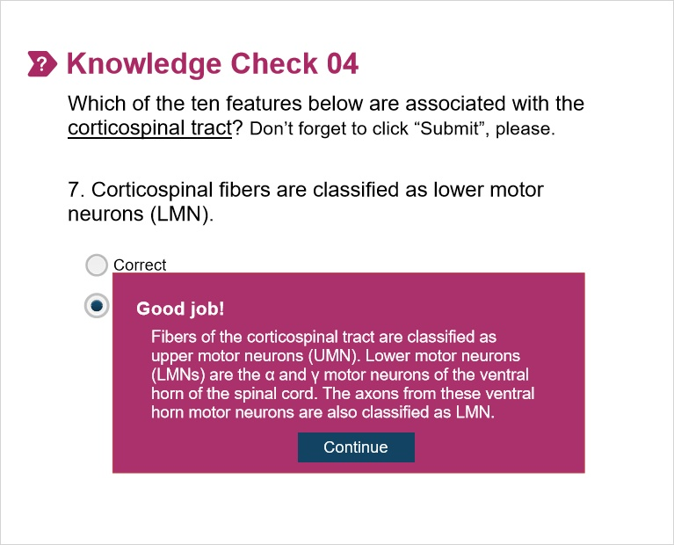

Sorry! (Slide Layer)
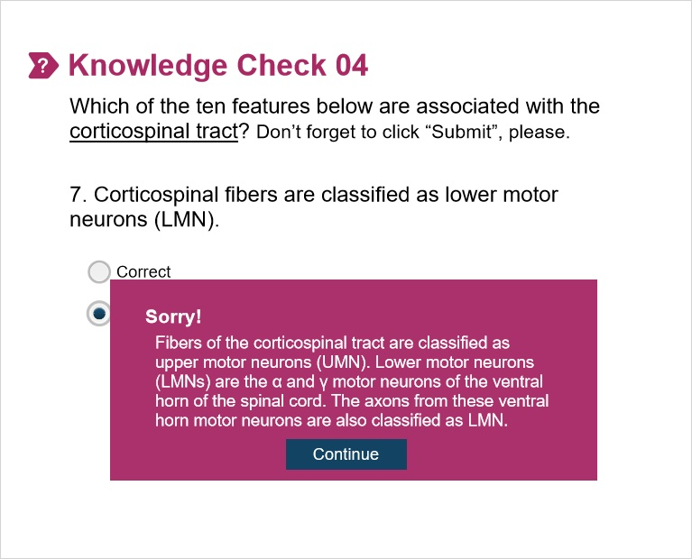

4.8 Knowledge Check 04.08
(Multiple Choice, 10 points, 1 attempt permitted)
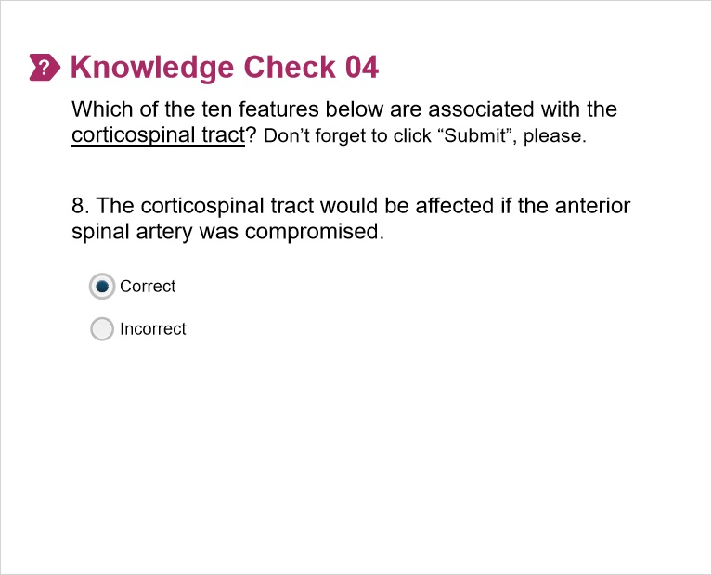
Correct | Choice
X | Correct
 | Incorrect

Feedback when correct:
The corticospinal tract is supplied by the anterior spinal artery. Recall that the anterior spinal artery supplies the ventral 2/3 of the cord while the posterior spinal artery supplies the dorsal 1/3 of the cord and thus the dorsal columns.
Feedback when incorrect:
The corticospinal tract is supplied by the anterior spinal artery. Recall that the anterior spinal artery supplies the ventral 2/3 of the cord while the posterior spinal artery supplies the dorsal 1/3 of the cord and thus the dorsal columns.

Good job! (Slide Layer)
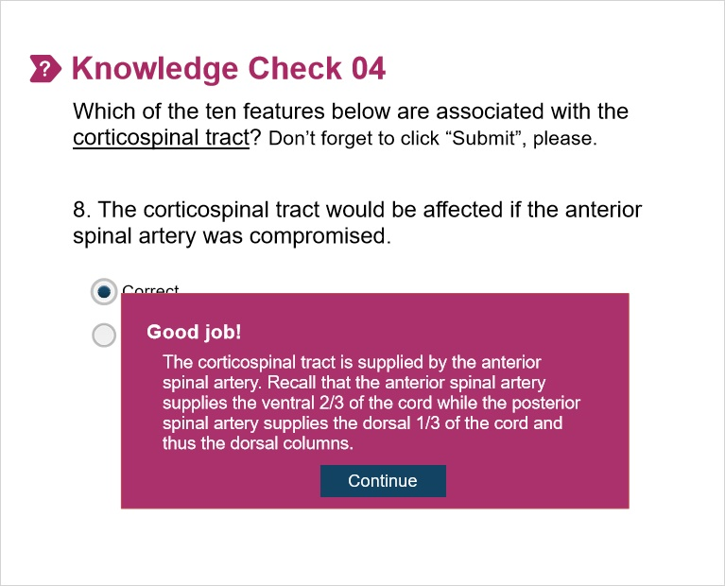

Sorry! (Slide Layer)
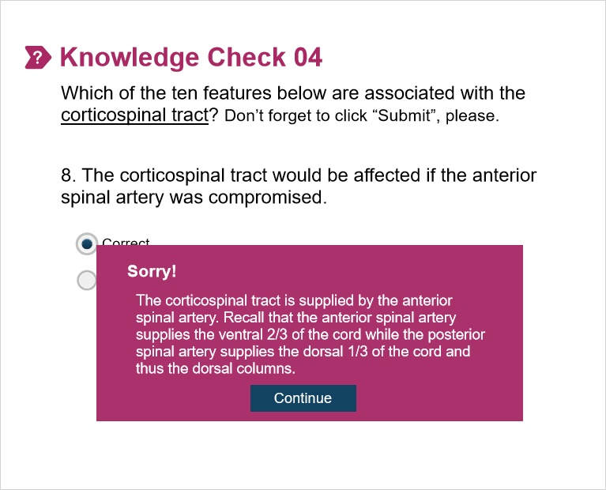

4.9 Knowledge Check 04.09
(Multiple Choice, 10 points, 1 attempt permitted)
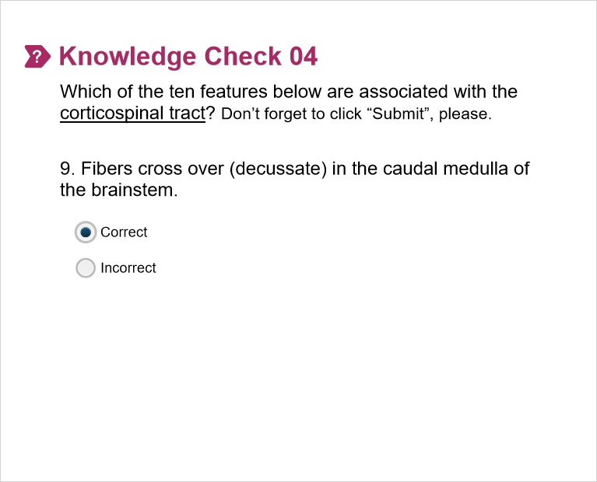
Correct | Choice
X | Correct
 | Incorrect

Feedback when correct:
The corticospinal tract crosses over (decussates) in the pyramidal decussation located in the caudal medulla.
Feedback when incorrect:
The corticospinal tract crosses over (decussates) in the pyramidal decussation located in the caudal medulla.

Good job! (Slide Layer)
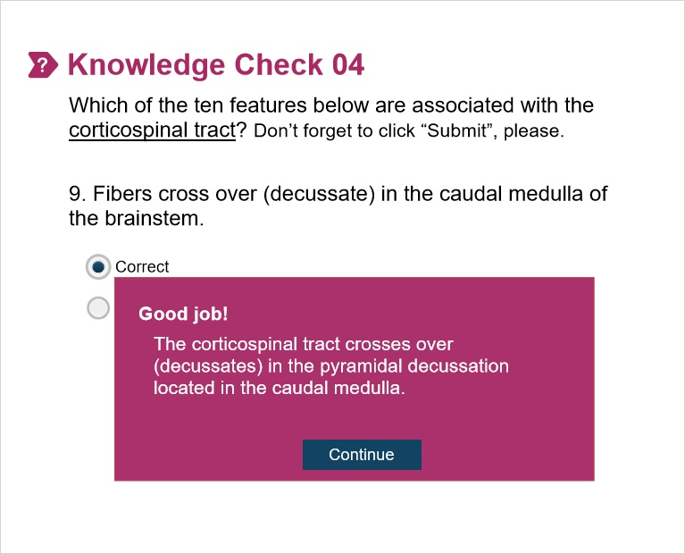

Sorry! (Slide Layer)
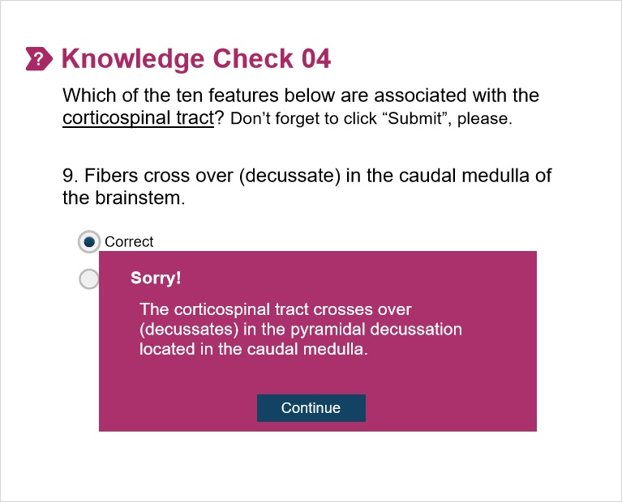

4.10 Knowledge Check 04.10
(Multiple Choice, 10 points, 1 attempt permitted)
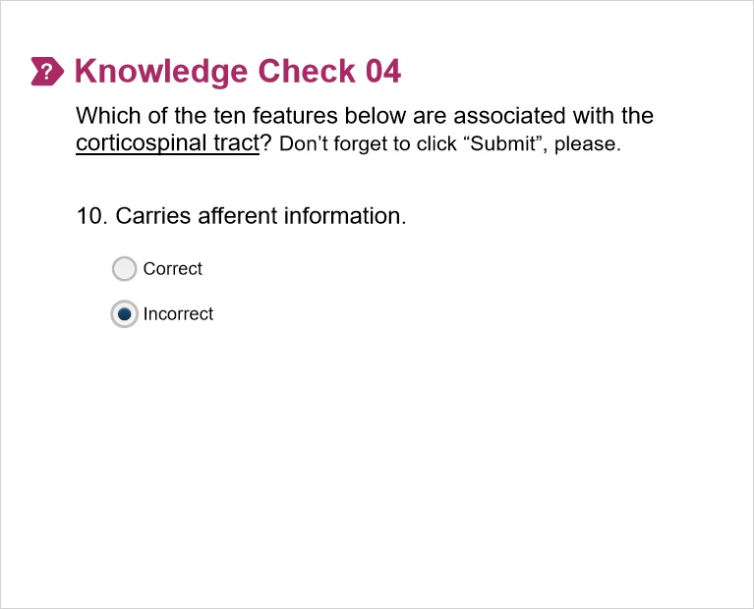
Correct | Choice
 | Correct
X | Incorrect

Feedback when correct:
The corticospinal tract carries efferent (motor) information while the DCML and spinothalamic tracts carry afferent (sensory) information.
Feedback when incorrect:
The corticospinal tract carries efferent (motor) information while the DCML and spinothalamic tracts carry afferent (sensory) information.

Good job! (Slide Layer)
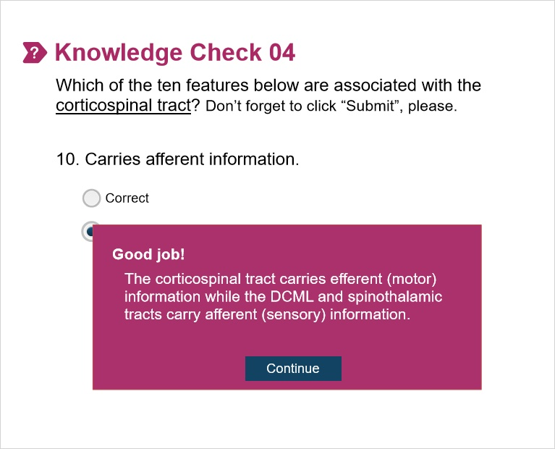

Sorry! (Slide Layer)
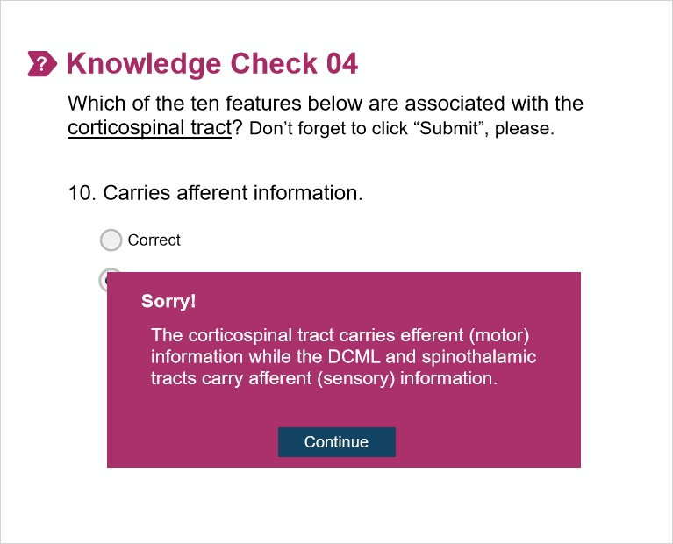

5. Part 05

5.1 Exercise 3 - Instructions
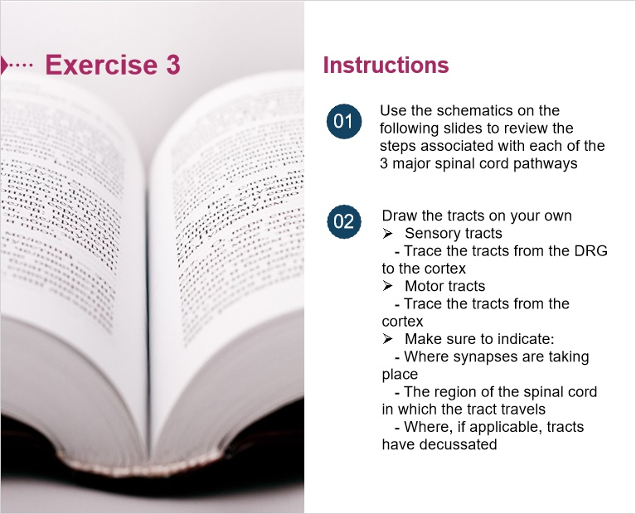

5.2 DCML_Lower Limbs
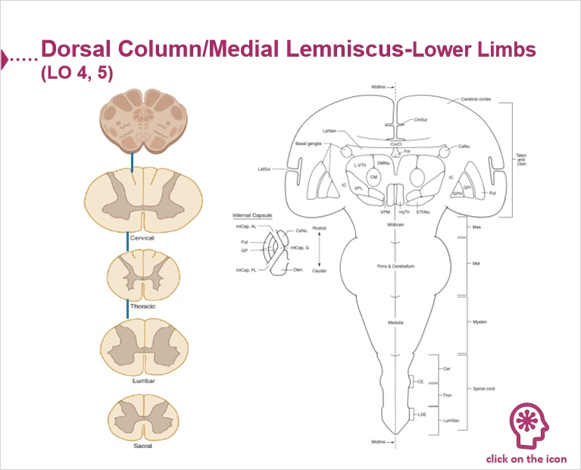

Stretch Reflex 0 (Slide Layer)
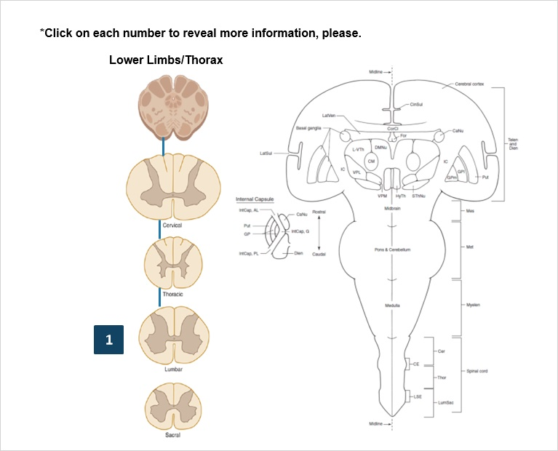

Stretch Reflex 1 (Slide Layer)
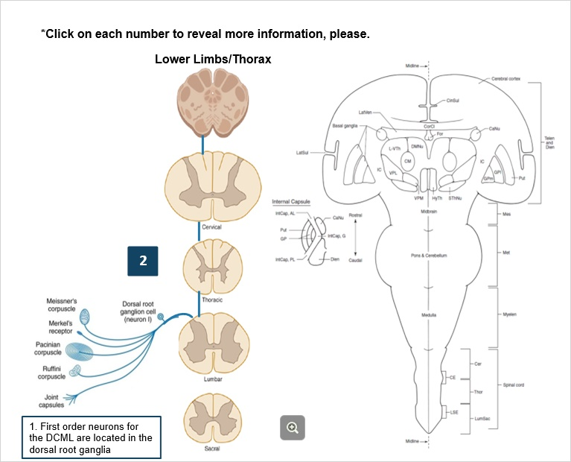

Stretch Reflex 2 (Slide Layer)
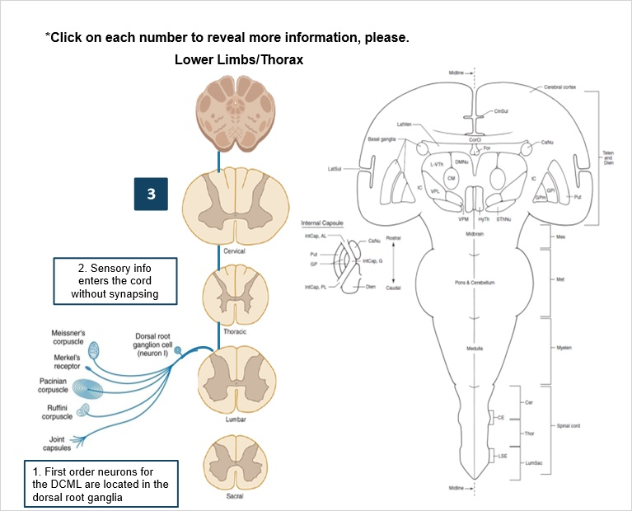

Stretch Reflex 3 (Slide Layer)
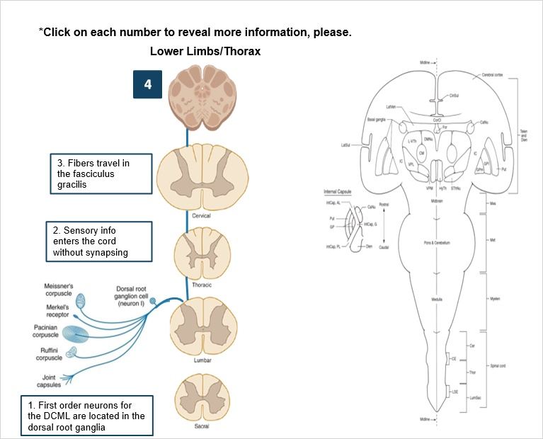

Stretch Reflex 4 (Slide Layer)
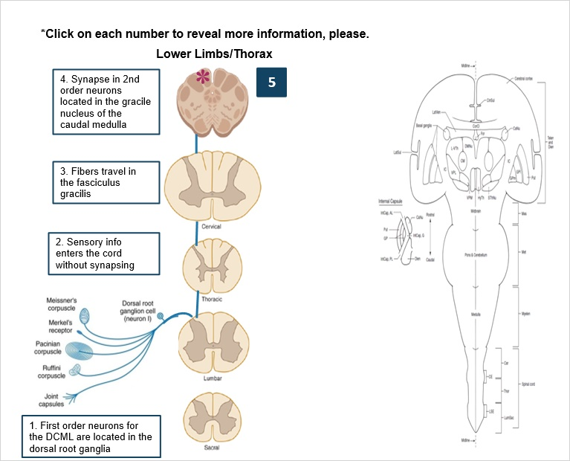

Stretch Reflex 5 (Slide Layer)
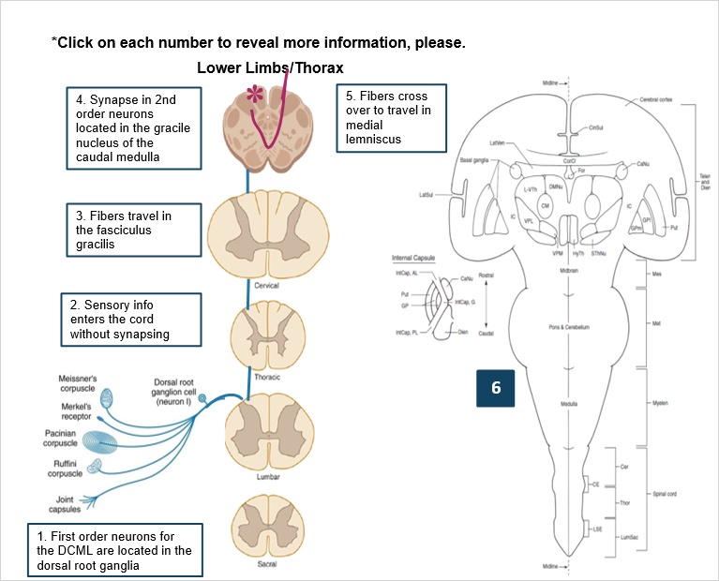

Stretch Reflex 6 (Slide Layer)
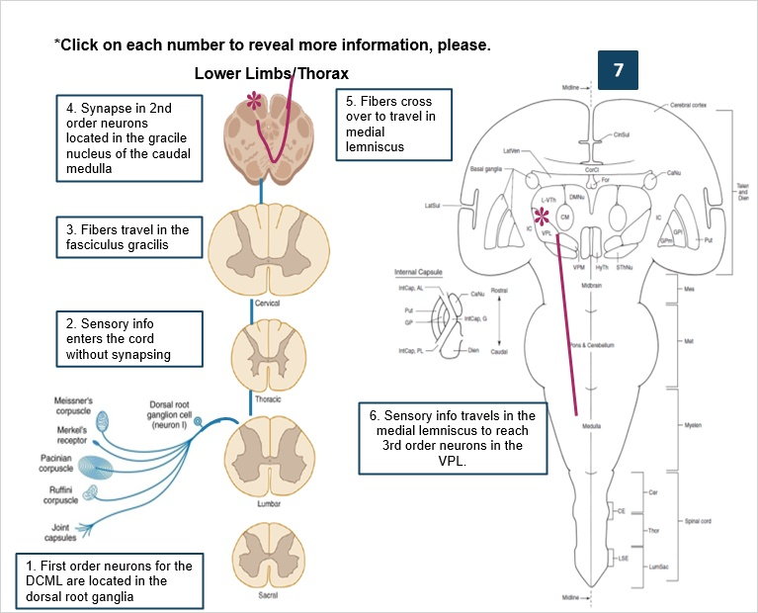

Stretch Reflex 7 (Slide Layer)
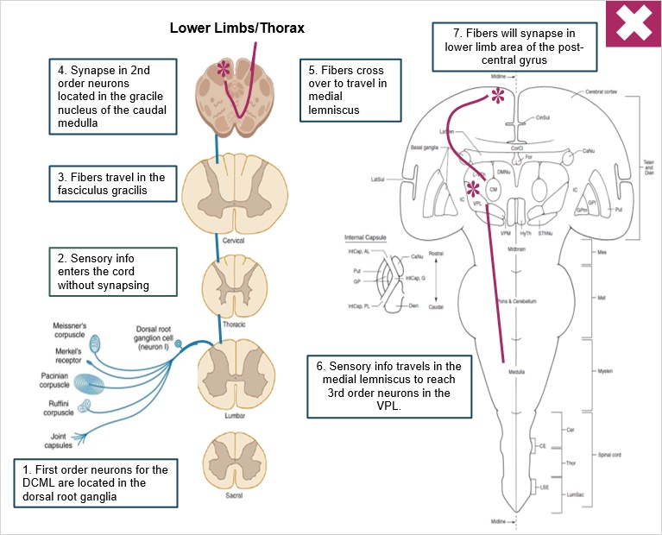

5.3 DCML_Upper Limbs
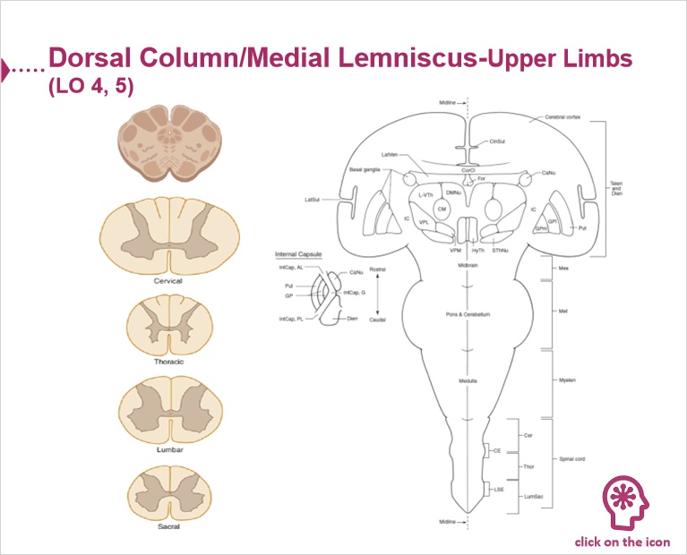

Stretch Reflex 0 (Slide Layer)
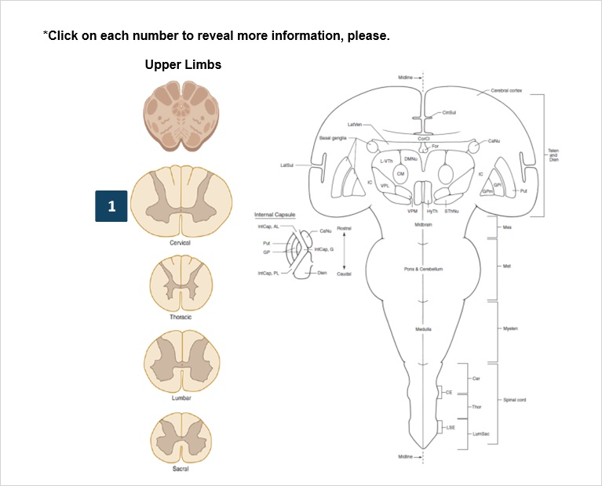

Stretch Reflex 1 (Slide Layer)
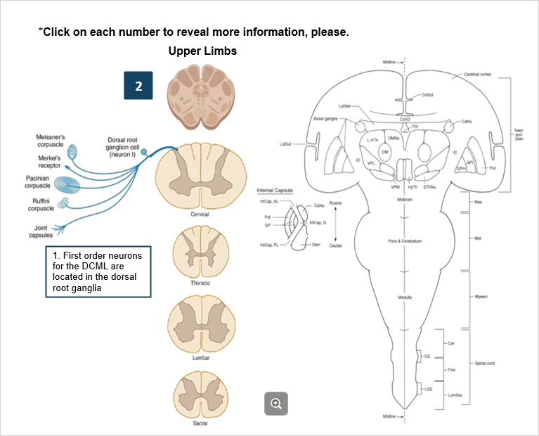

Stretch Reflex 2 (Slide Layer)
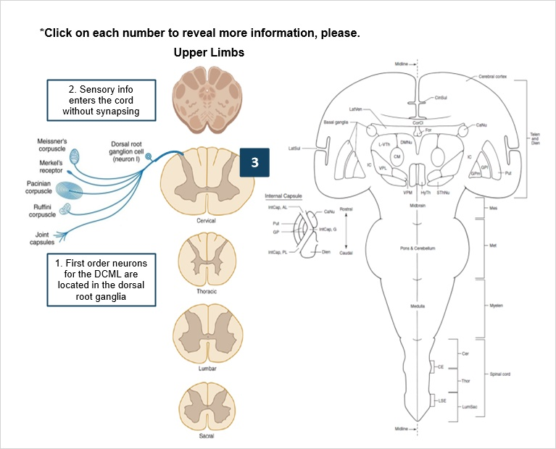

Stretch Reflex 3 (Slide Layer)
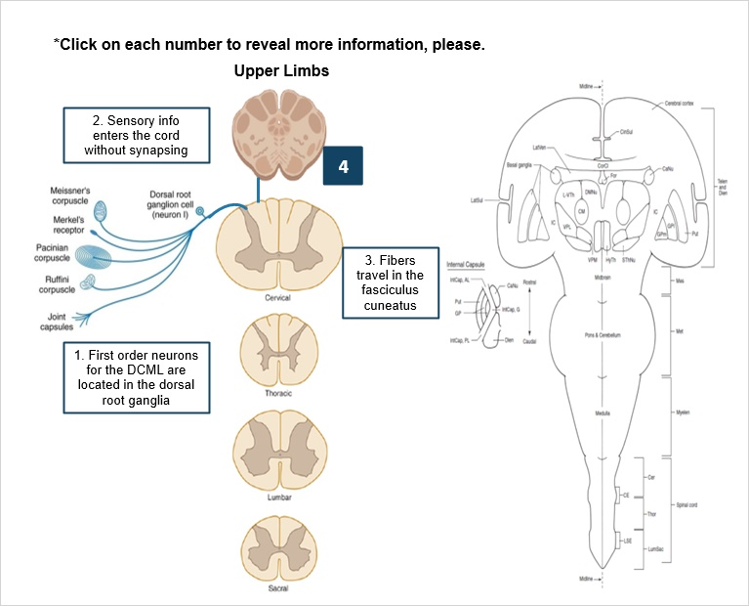

Stretch Reflex 4 (Slide Layer)
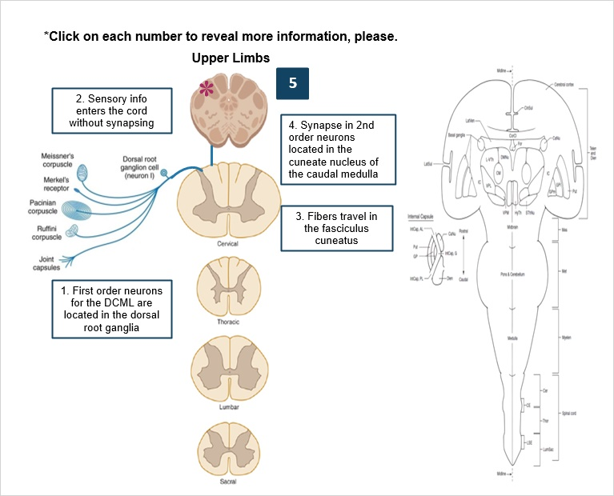

Stretch Reflex 5 (Slide Layer)
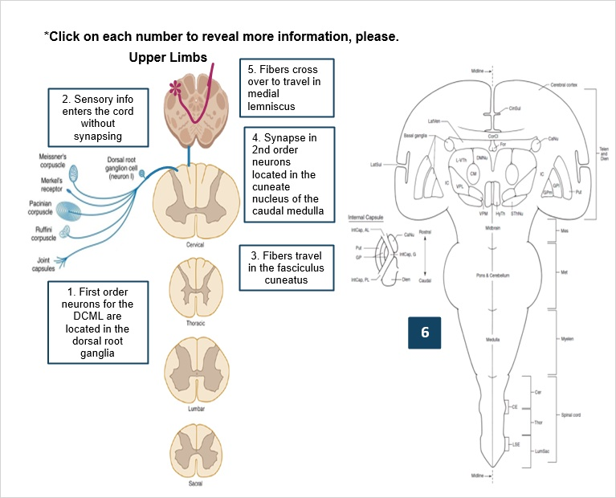

Stretch Reflex 6 (Slide Layer)
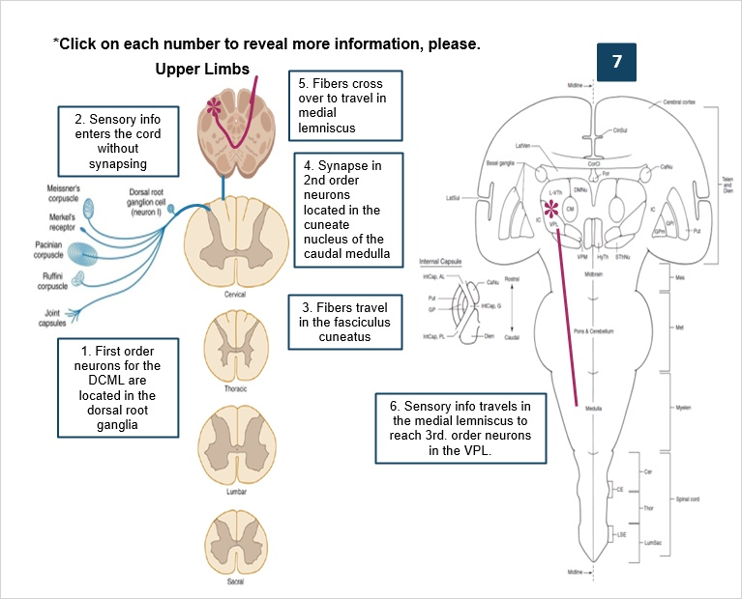

Stretch Reflex 7 (Slide Layer)
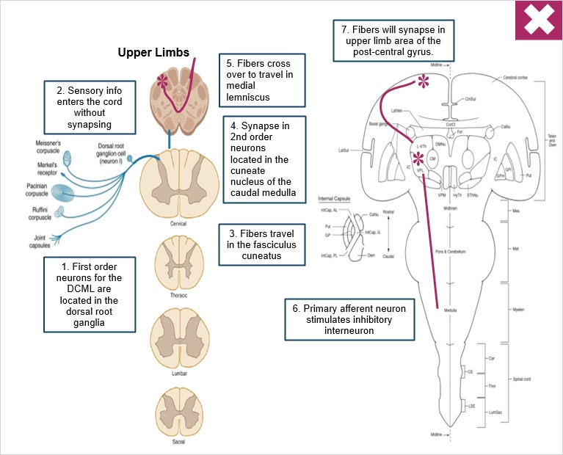

5.4 Spinothalamic Tract
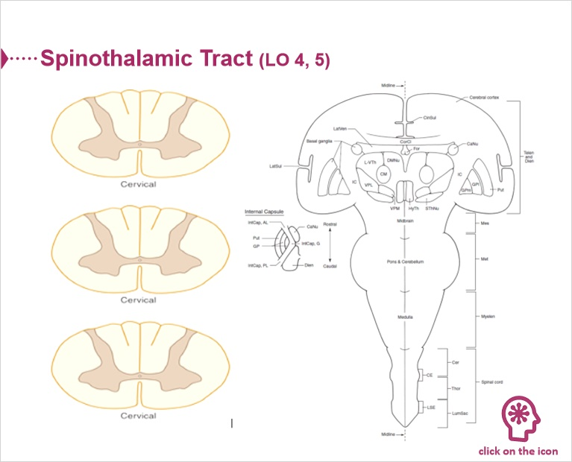

Stretch Reflex 0 (Slide Layer)
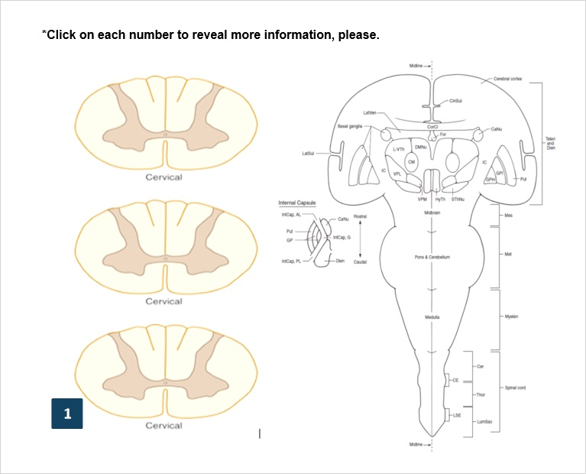

Stretch Reflex 1 (Slide Layer)
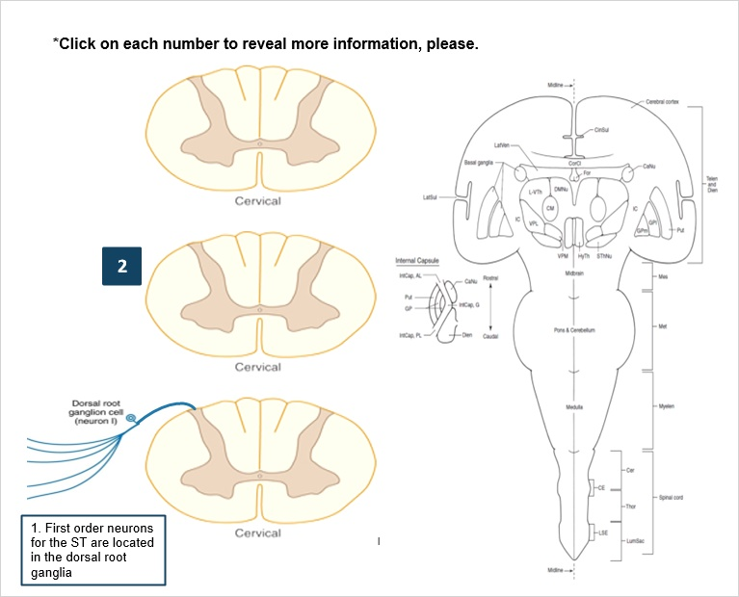

Stretch Reflex 2 (Slide Layer)
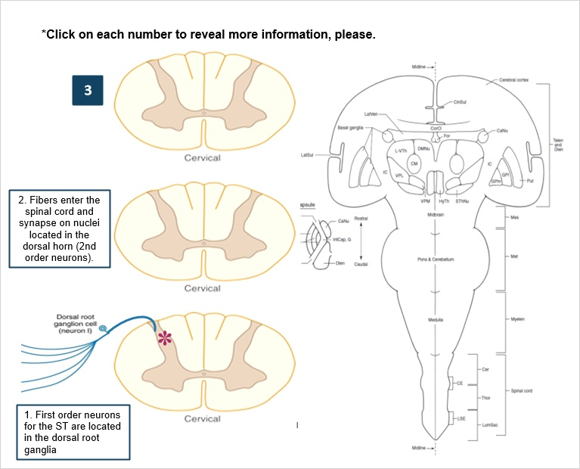

Stretch Reflex 3 (Slide Layer)
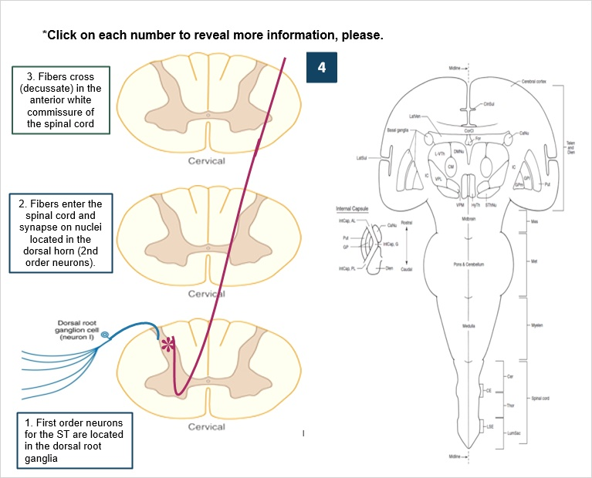

Stretch Reflex 4 (Slide Layer)
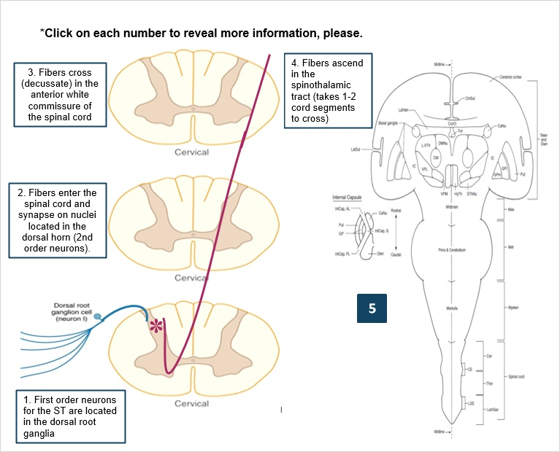

Stretch Reflex 5 (Slide Layer)
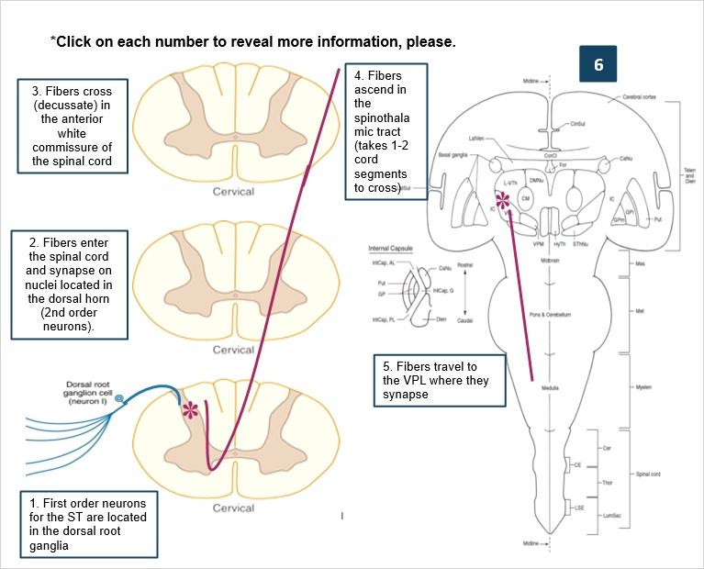

Stretch Reflex 6 (Slide Layer)
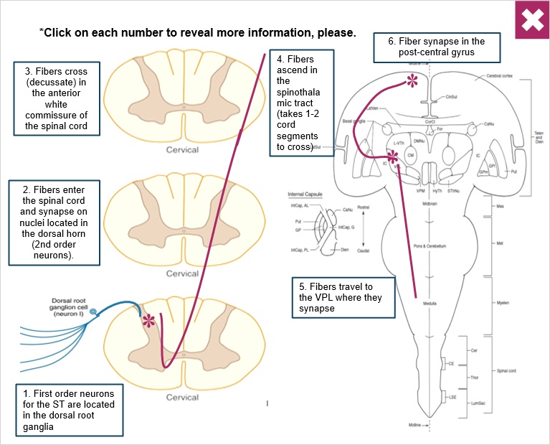

5.5 LO 4-5
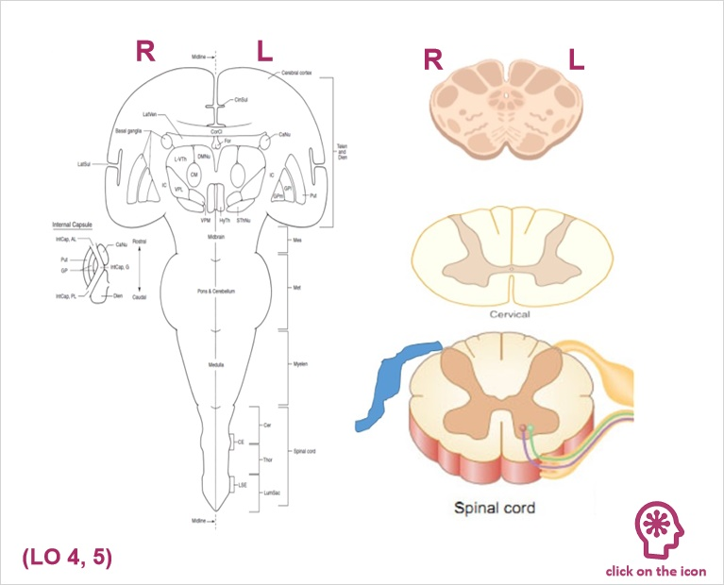

Stretch Reflex 0 (Slide Layer)
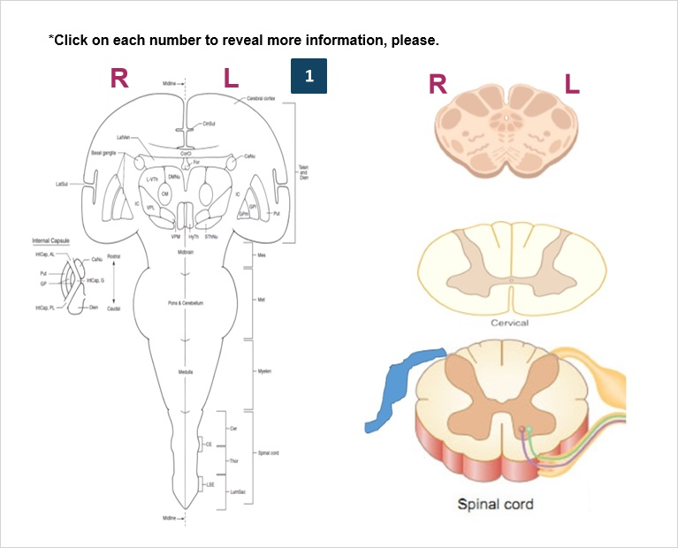

Stretch Reflex 1 (Slide Layer)
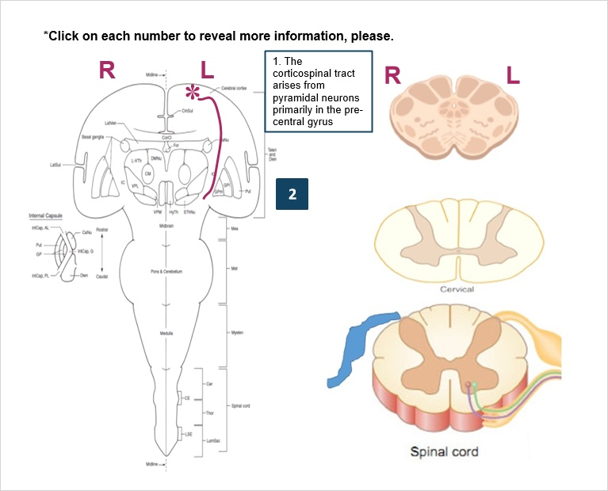

Stretch Reflex 2 (Slide Layer)
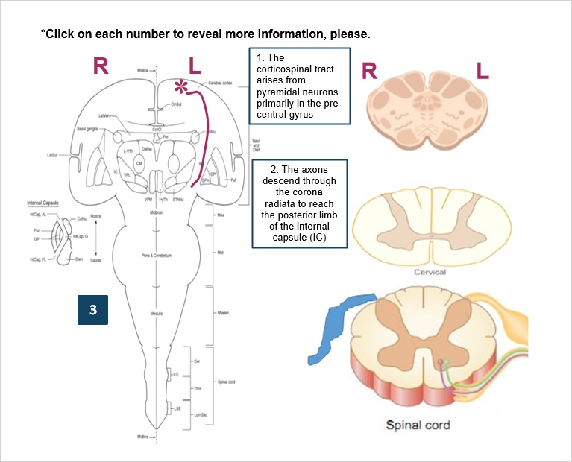

Stretch Reflex 3 (Slide Layer)
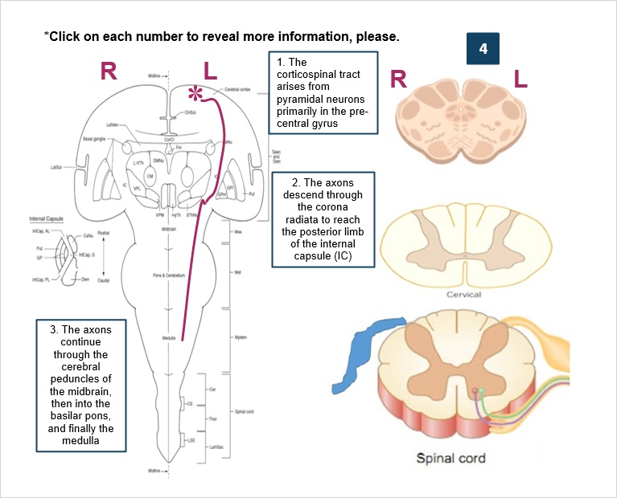

Stretch Reflex 4 (Slide Layer)
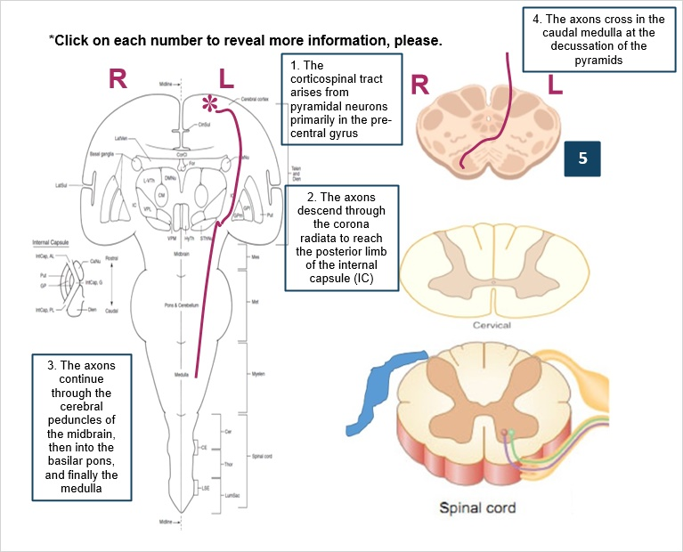

Stretch Reflex 5 (Slide Layer)
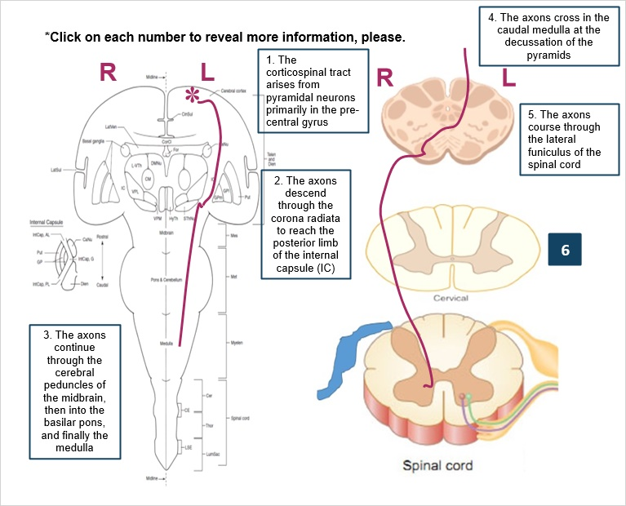

Stretch Reflex 6 (Slide Layer)
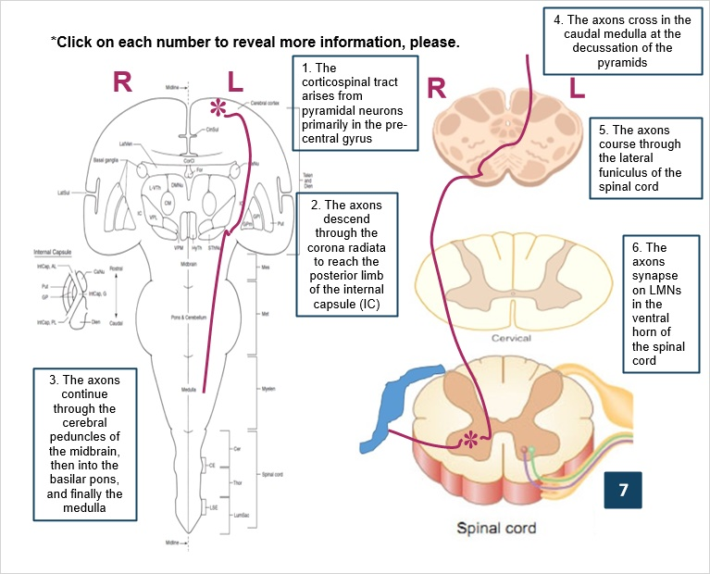

Stretch Reflex 7 (Slide Layer)
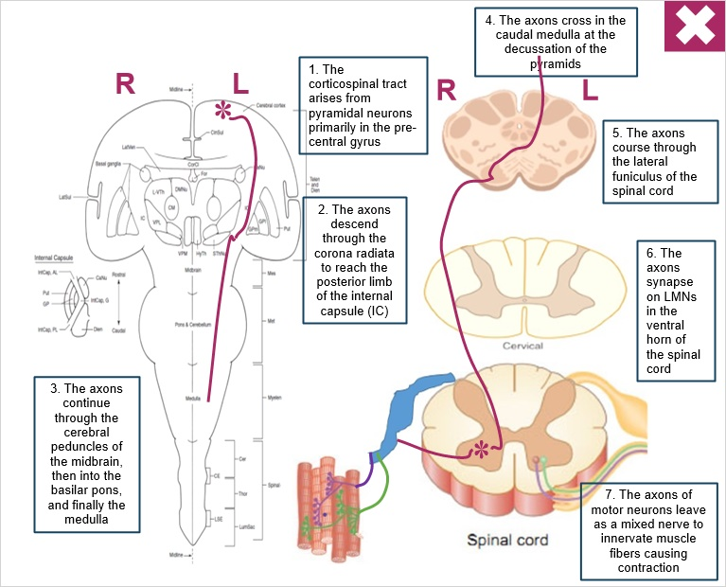

5.6 Corticospinal Tract Brief Introduction to Lesions
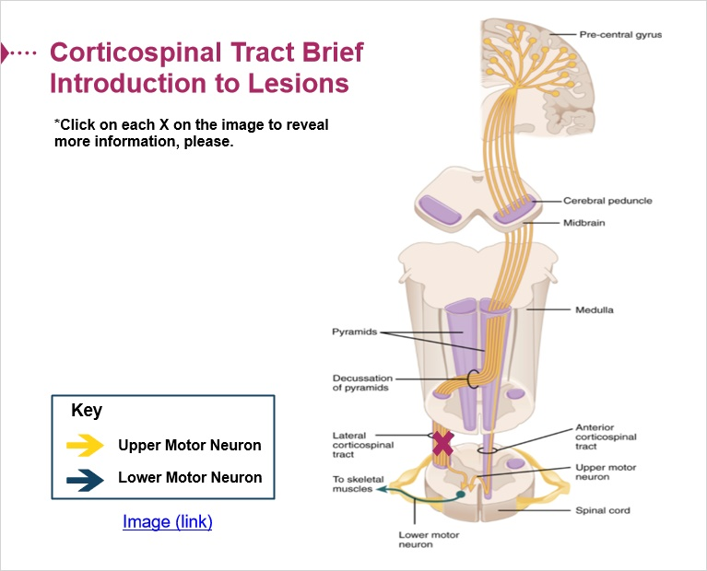

Lesion below puramidal decussation (Slide Layer)
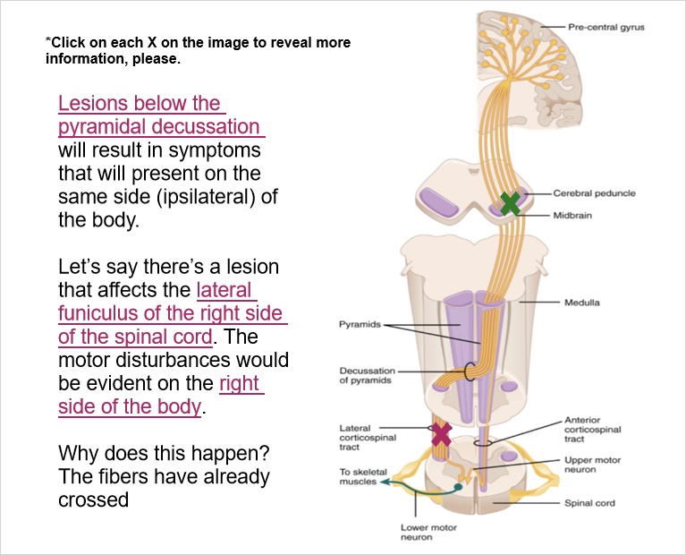

Lessions above ppyramidal decussation (Slide Layer)
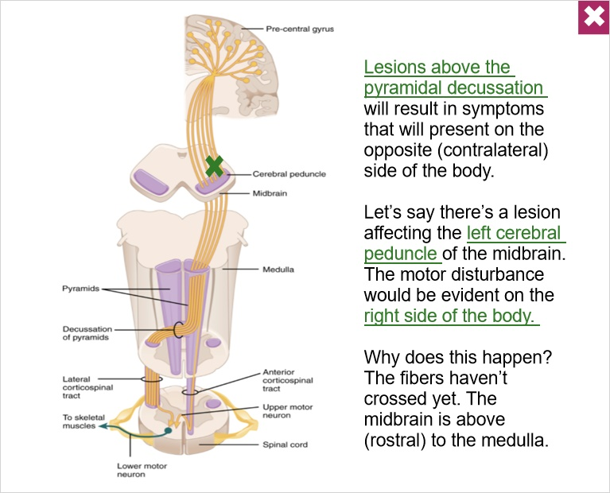

5.7 Dorsal Column_Medial Lemniscus
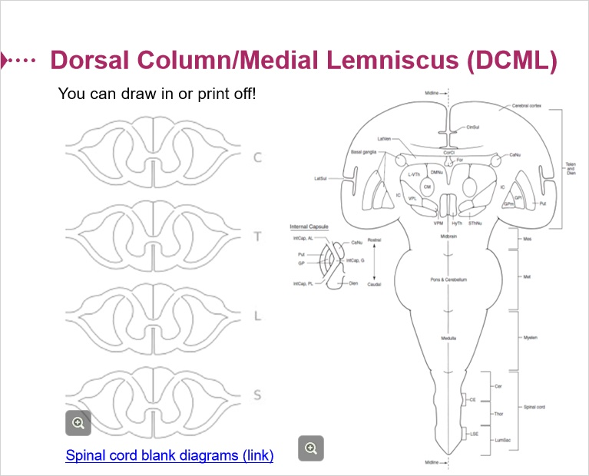

5.8 Spinothalamic Tract
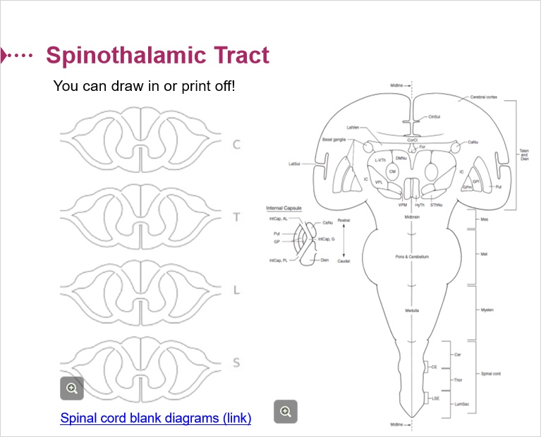

5.9 Corticospinal Tract
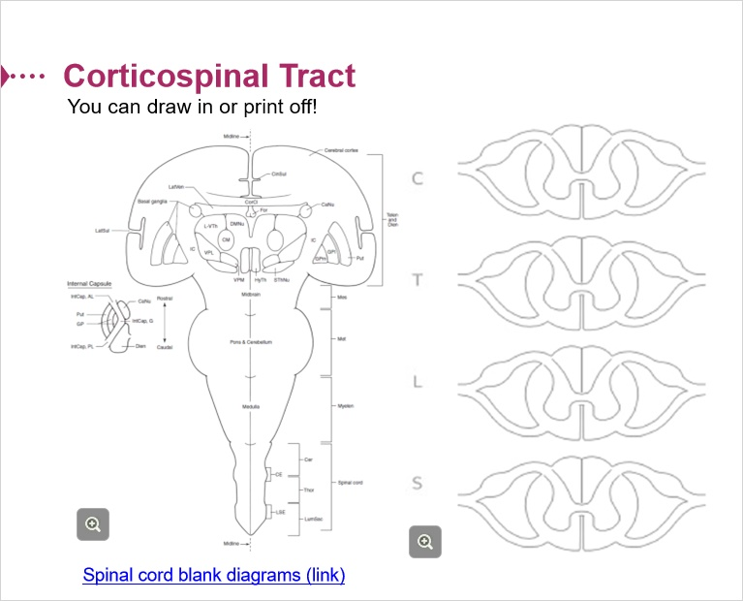

6. Part 06

6.1 Refresher about Motor Neurons
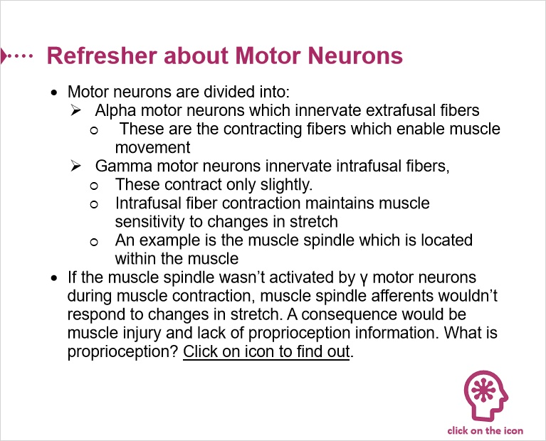

Proprioception (Slide Layer)
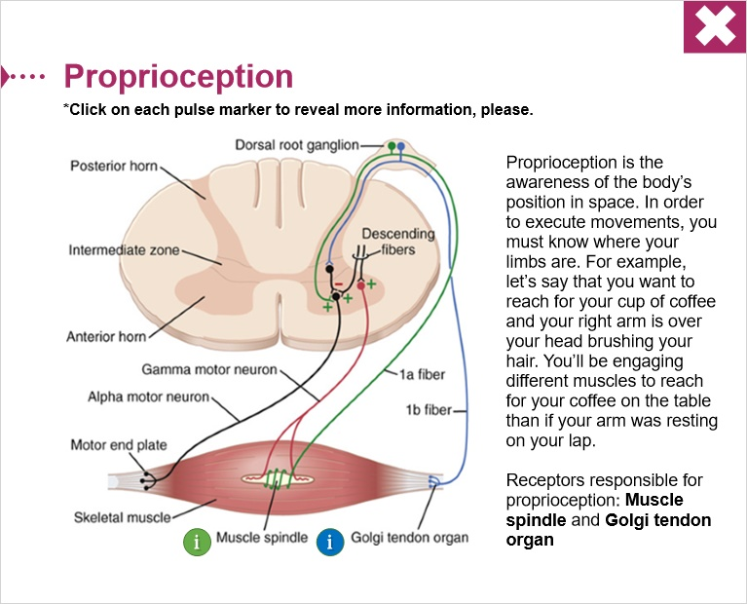

6.2 Information together
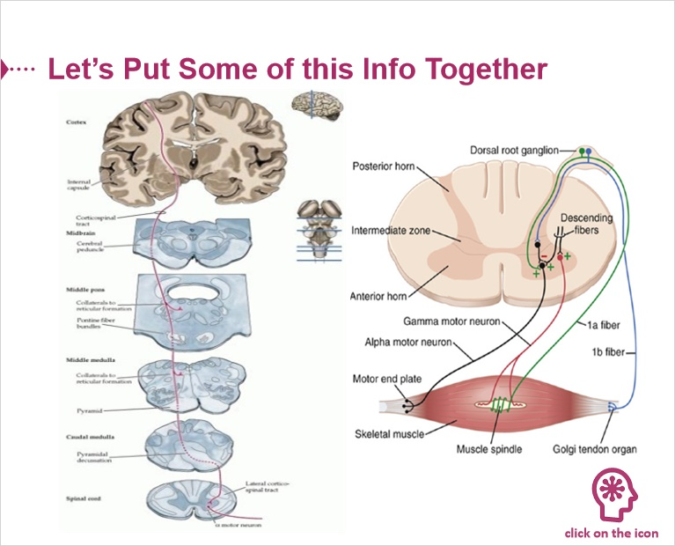

2-neuron circuit (Slide Layer)
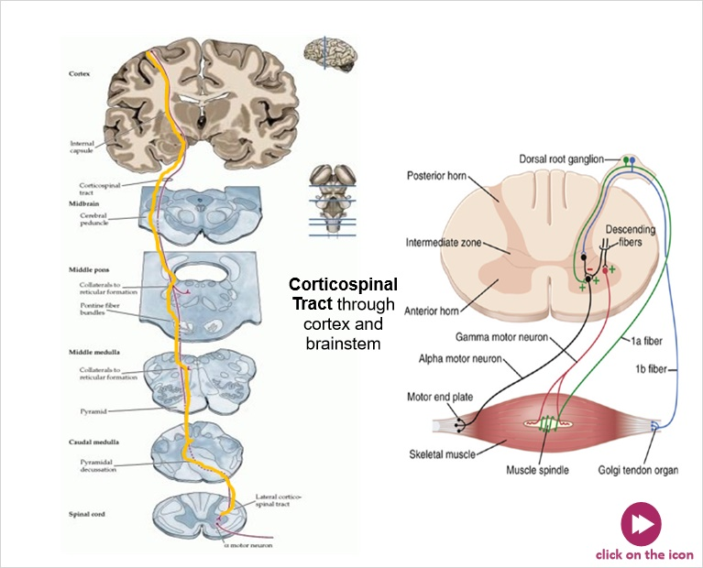

Untitled Layer 3 (Slide Layer)
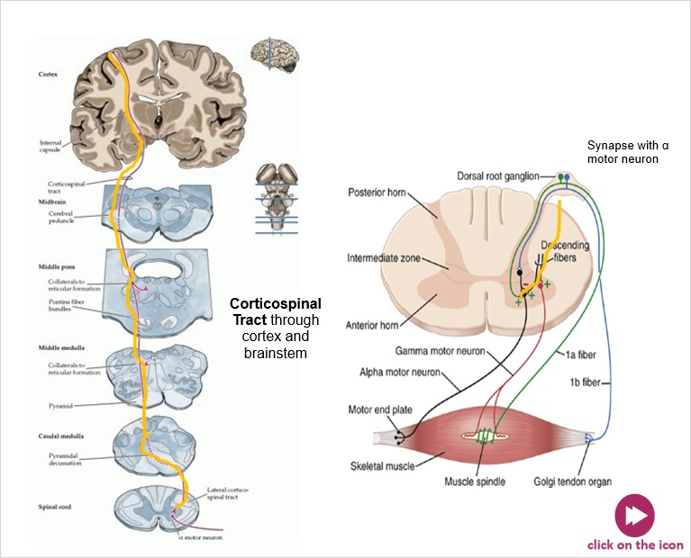

Untitled Layer 4 (Slide Layer)
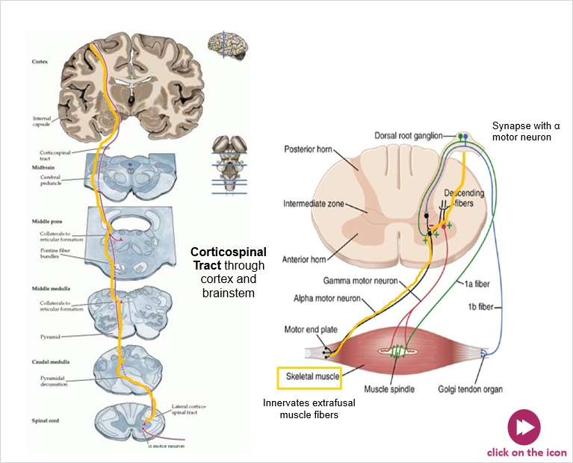

Untitled Layer 5 (Slide Layer)
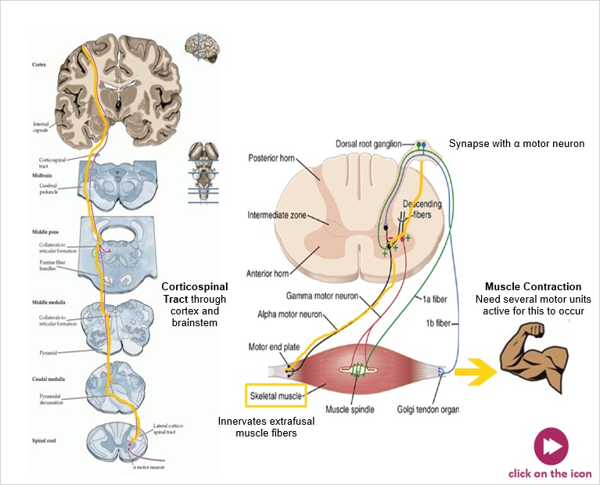

Untitled Layer 6 (Slide Layer)
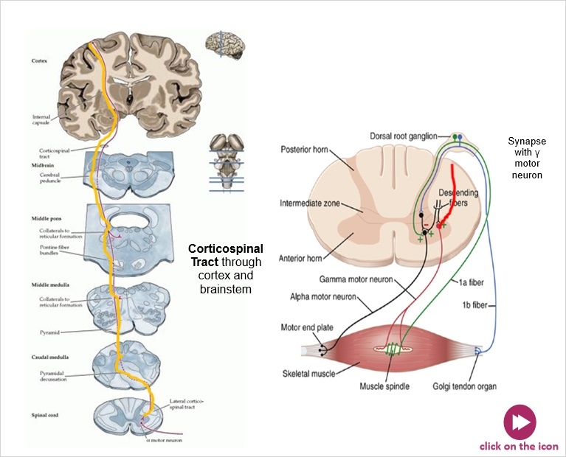

Untitled Layer 7 (Slide Layer)
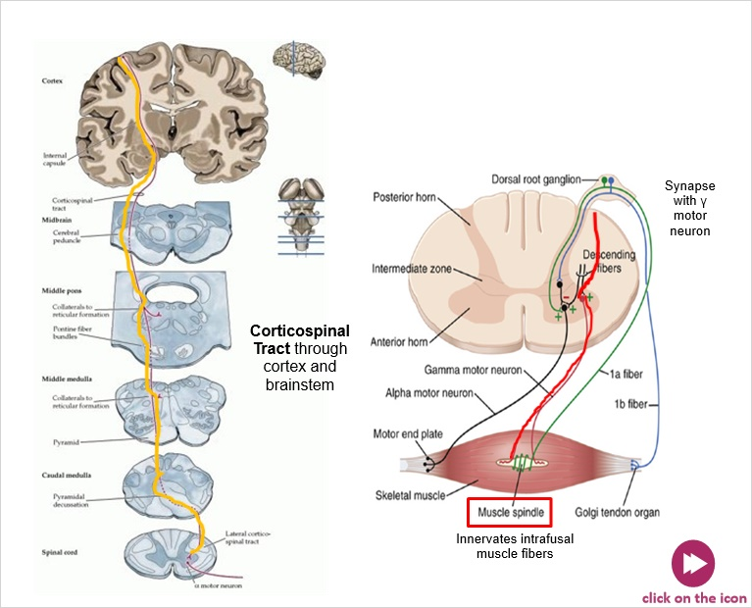

Untitled Layer 8 (Slide Layer)
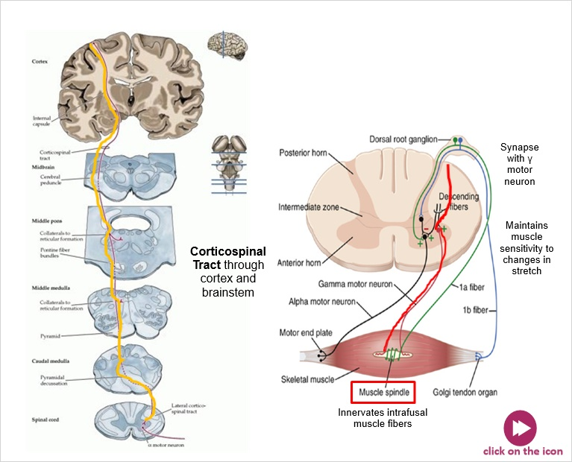

Untitled Layer 9 (Slide Layer)
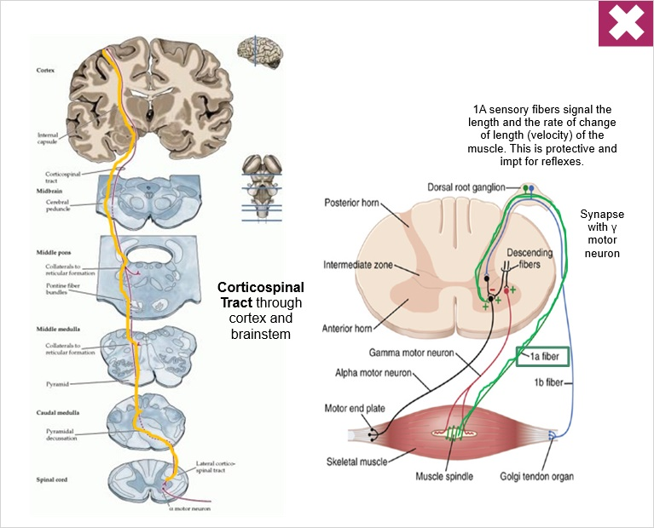

6.3 Integrative Question
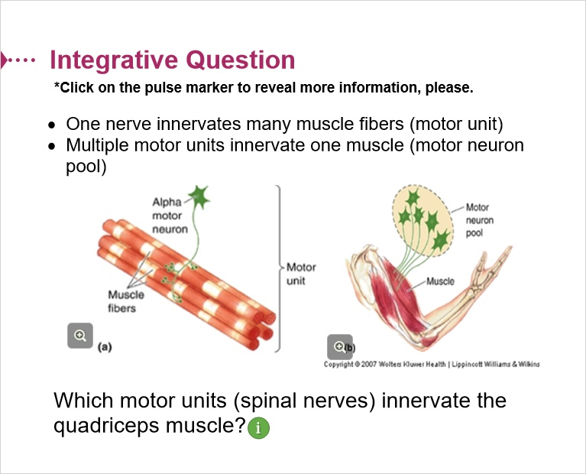
Notes:

6.4 Strerch_Myotactic Reflexes
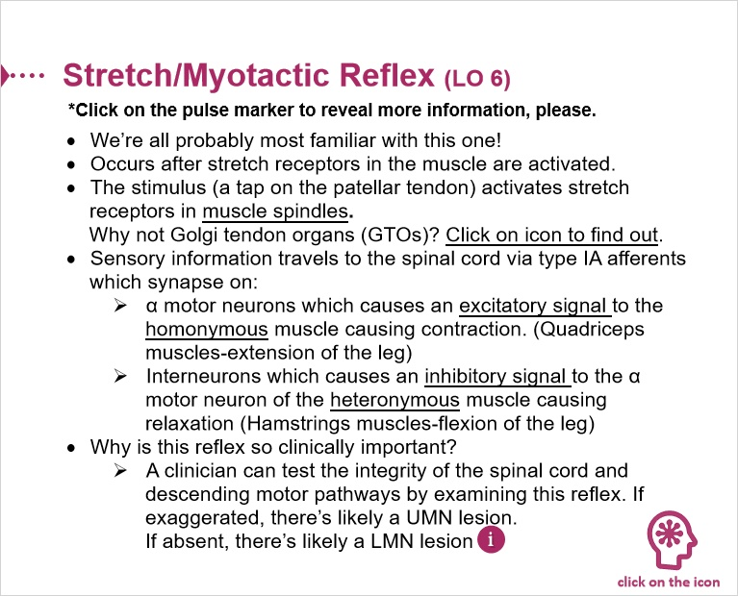

Muscles Spindles Vs GTO Activation (Slide Layer)
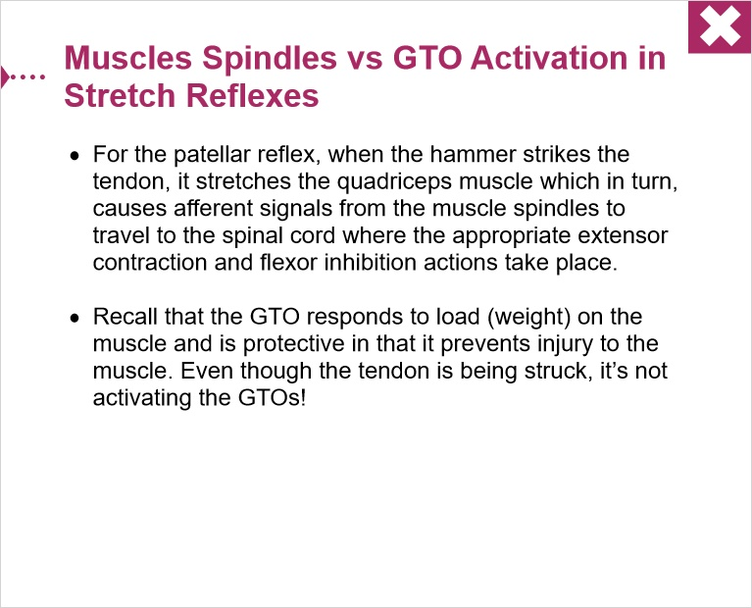

6.5 Stretch Reflex (LO 6)
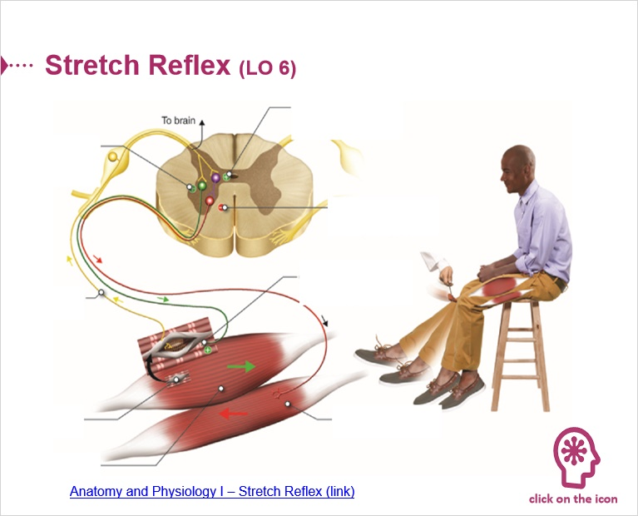

Stretch Reflex 0 (Slide Layer)
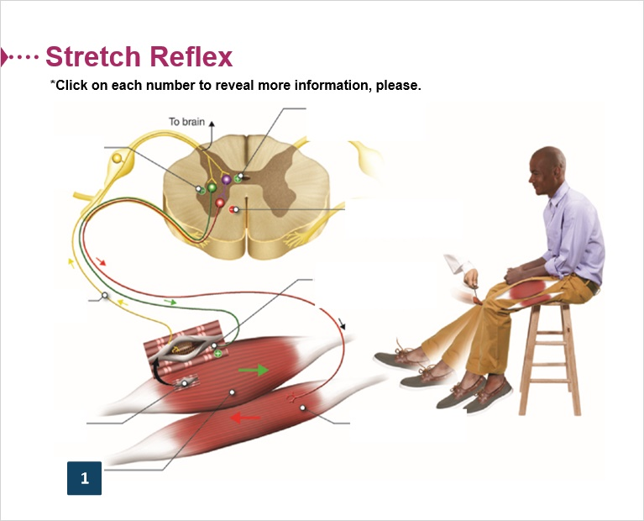

Stretch Reflex 1 (Slide Layer)
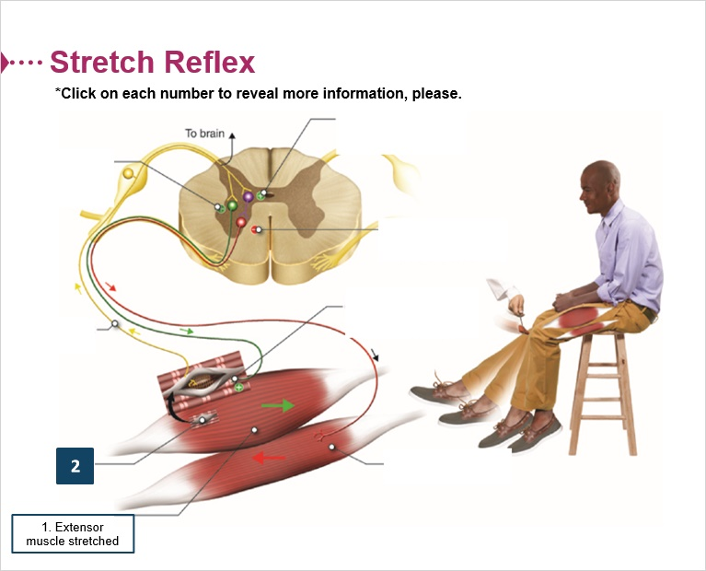

Stretch Reflex 2 (Slide Layer)
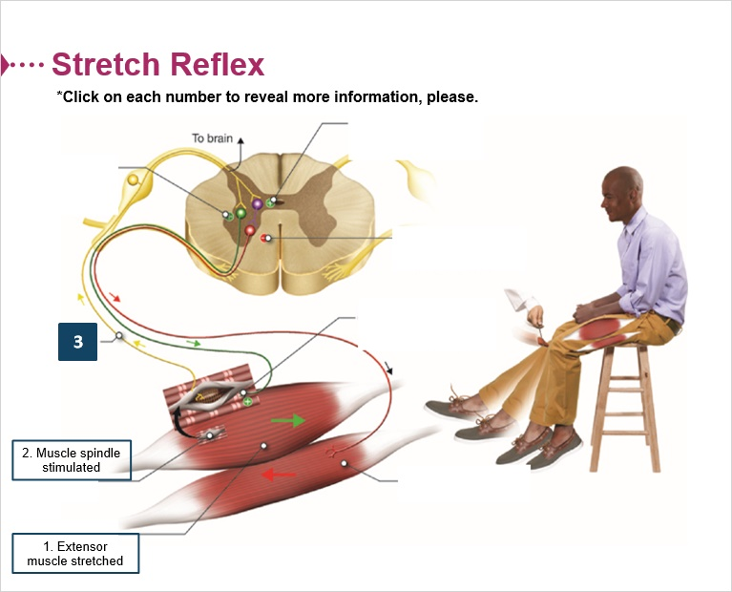

Stretch Reflex 3 (Slide Layer)
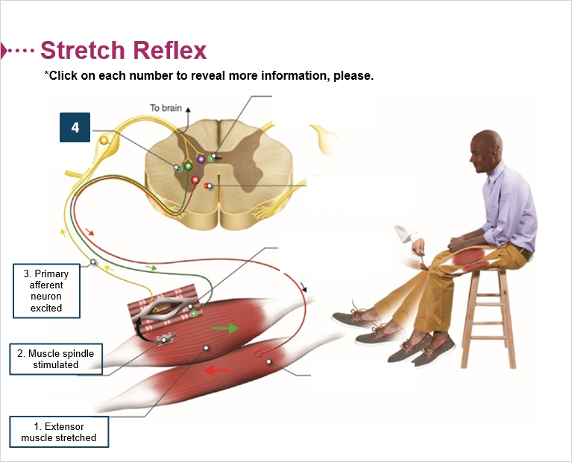

Stretch Reflex 4 (Slide Layer)
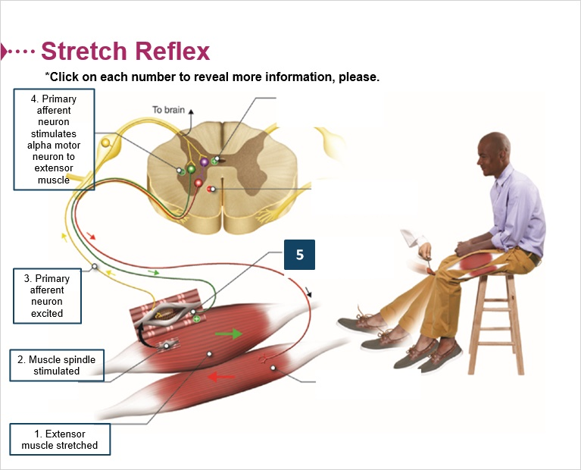

Stretch Reflex 5 (Slide Layer)
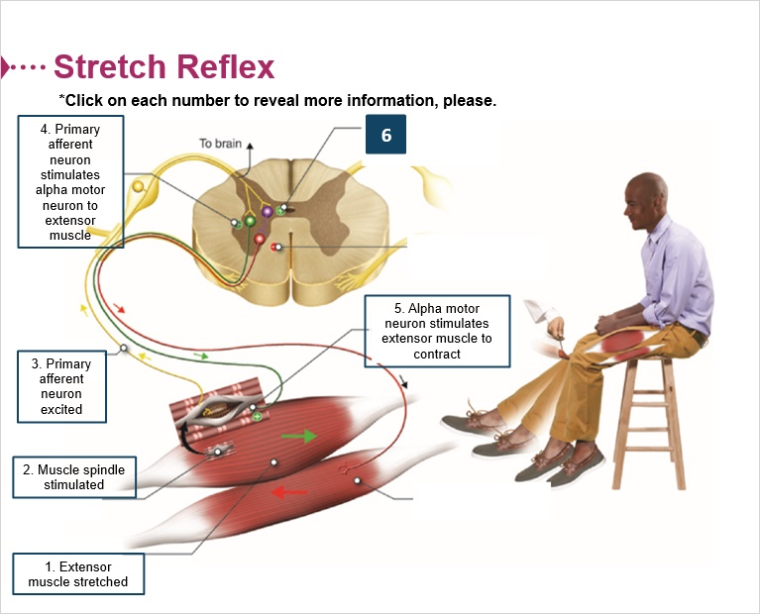

Stretch Reflex 6 (Slide Layer)
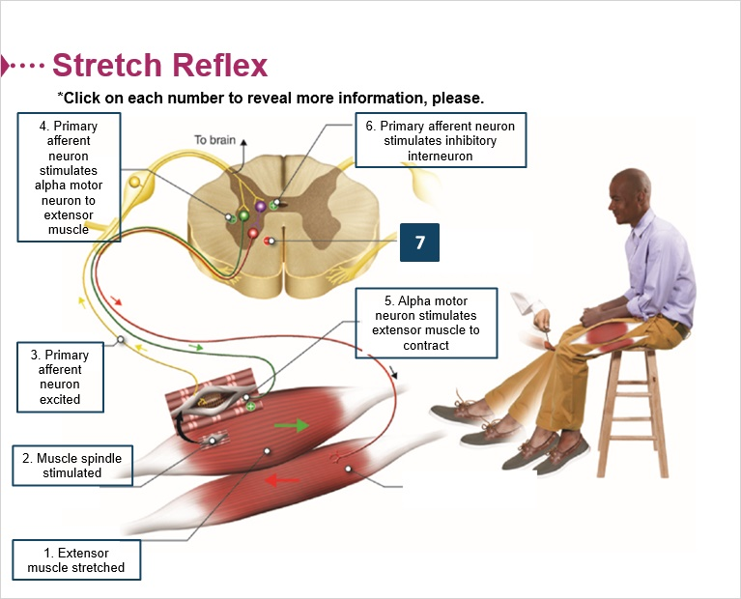

Stretch Reflex 7 (Slide Layer)
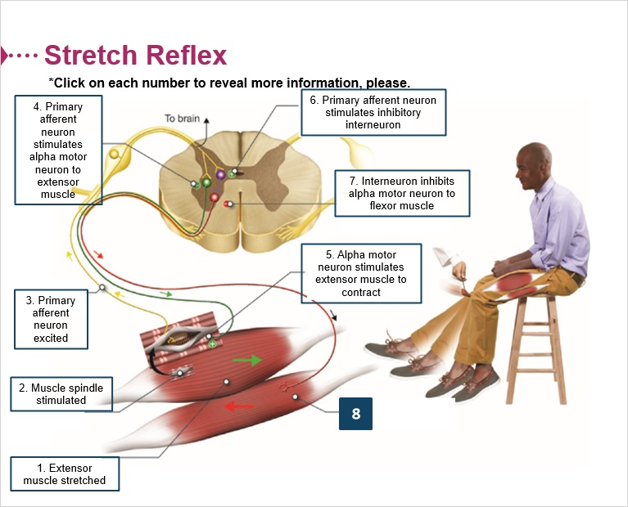

Stretch Reflex 8 (Slide Layer)
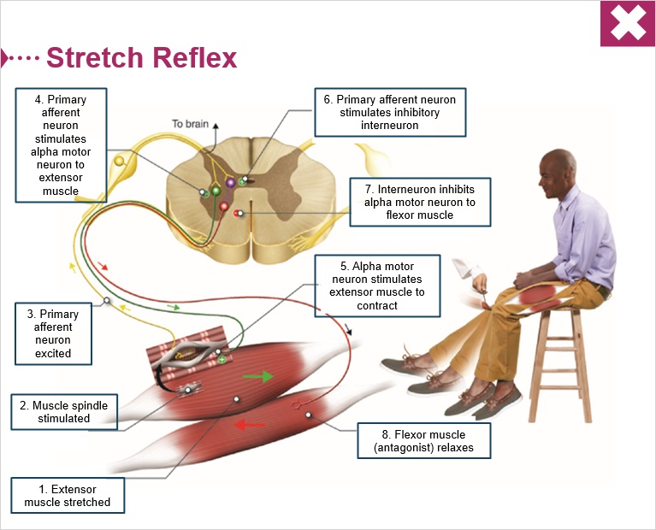

6.6 Descending Pathways Modify Reflexes
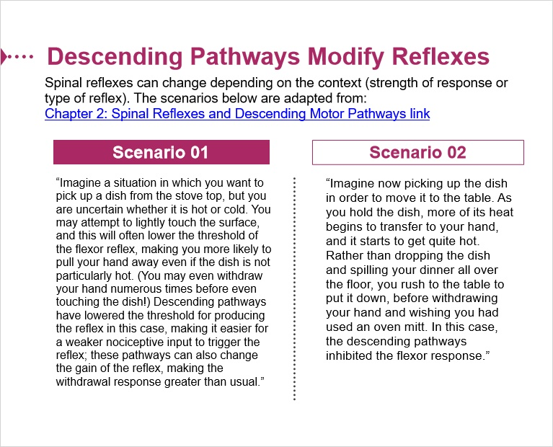

6.7 Anti-Gravity Muscles of the Human Body (Postural Muscles)
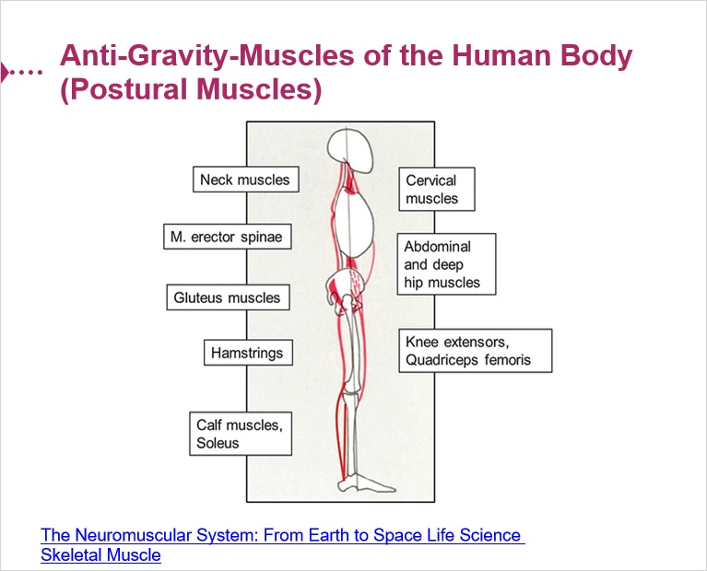

6.8 Proprioception
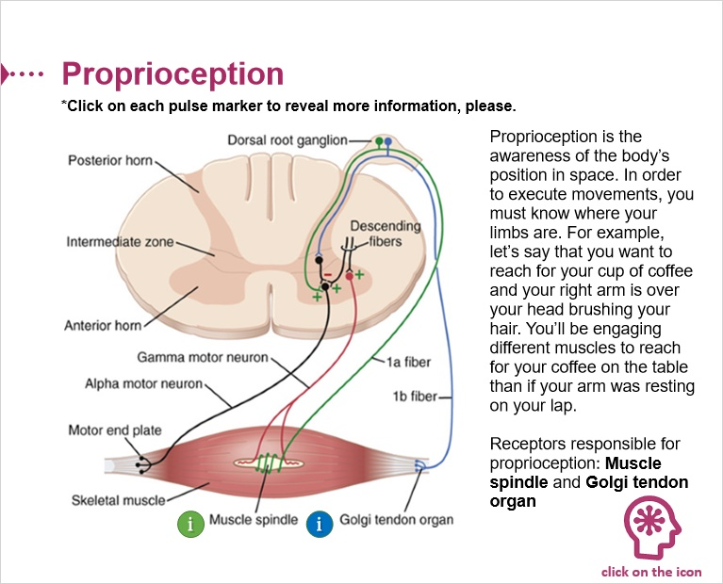

Heavy weight (Slide Layer)
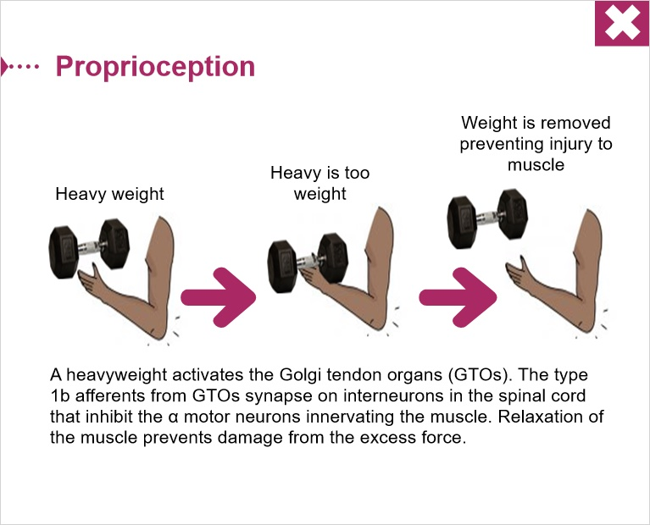

6.9 Muscles Spindles Vs GTO Activation


