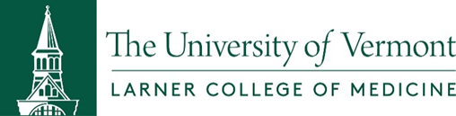

UVM Rural Health Longitudinal Integrated Curriculum
Hudson Headwaters Health Network, Queensbury, New York

APPLICATION for AY 2019-2020
Application Deadline: September 6, 2018

Name: Date:
Email: Phone:

Please answer each the following questions in <200 words.

- What are your expectations of the UVM’s Longitudinal Integrated Clerkship (LIC)? Given the goals of the LIC, provide at least two concrete examples of how the LIC would help fulfill your career goals.

- Participating in the program requires a great deal of autonomy and flexibility. Please provide examples of when you demonstrated independent skills and flexibility while working in a group setting.

- Tell us about a project or activity in which you were a key member. What was your role? What aspects of the process did you enjoy the most? What about the process was the most challenging?

Other Requirements

The provided LIC housing at HHHN is in two-bedroom apartments with shared common space for two students.

Other comments:

If accepted into the LIC program, this information will be used in public relations communications with the LIC community.

Additional documentation requested
- A CV or brief biography of yourself.
- As part of your application, we require a signed release to view your medical school application. Please complete the signed release to authorize.
- Signed release of photo for public relations (attached).
- Ask a faculty member to complete the online letter of recommendation.
For questions regarding the LIC program at HHHN, please contact:
HHHN LIC Site Director Dr. Colleen Quinn: cquinn@hhhn.org
HHHN LIC Site Coordinator Jane Morrissey: jdmorrissey@hhhn.org

