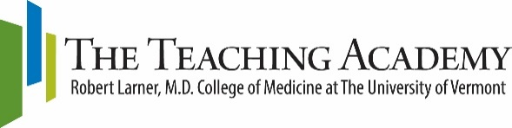

Snow Season Education Retreat - Thursday, January 20, 2022
Poster Session - Thursday, January 20, 2022

Poster Abstract Submission Form
*All abstracts are due Monday, November 15, 2021.
Final Posters in PDF form are due Monday, January 10, 2022.

Title:

Category:
If your abstract is selected for the retreat, you have the option for your poster to be peer-reviewed and to receive confidential feedback. Please indicate if you wish for your poster to be reviewed during the Snow Season Education Retreat. Your poster will receive two independent, single-blinded reviews and feedback will be provided to the first author for sharing with co-authors. | No | Yes *

Author/Presenter Name | School | Department/Program/Section | Email Address
Poster Abstract
Abstract must be no more than 300 words. Please address each element listed below, as appropriate to your work. Abstracts will be published in the Snow Season Program, so please be sure to proofread carefully.
Topics must have an education focus or be related to educational scholarship.

Replace the text in this box with your abstract.
- Background (e.g., rationale or theoretical framework, opportunity or problem addressed, including brief review of relevant literature)
- Description of project/program/innovation
- Methods (as applicable) – What did you do?
- Results
- Discussion/Conclusions/Lessons Learned (including implications and/or next steps)
- IRB Determination (if obtained)
- Please list any previous dissemination (e.g., poster, abstract, demonstration, article), if applicable
- Disclosures
NOTE: In some cases, your abstract might consist of the existing or planned text on your poster. In addition, you may include 1-2 graphics, including tables or graphics, to provide further context (this is not required).

Read and check box (To check, double click box, select “Checked” and then “OK.”):
The first author/presenter must check this box to confirm that each collaborator listed above has contributed sufficiently to the work for inclusion as a co-author/co-presenter and has approved this proposal submission. Checking this box also confirms that, at a minimum, the first author will be at the Teaching Academy Snow Season Poster Session to share this work with colleagues.

Two posters will be selected for oral presentation on Thursday, January 20, 2022. Each presentation will be 15 minutes.
Check this box if you agree to participate if selected.

First authors should send this submission form as an email attachment (Word) to Teaching.Academy@med.uvm.edu by Monday, November 15, 2021. You will be expected to submit a PDF of your poster for online viewing by Monday, January 10, 2022. Abstracts and virtual posters will be available for viewing on the Teaching Academy website. A virtual Poster Session will take place during the Snow Season Education Retreat; you will be expected to give a 1-minute elevator pitch for your poster. If you request a peer-review for your poster, you must be available during the Snow Season Poster Session for Reviewers.

