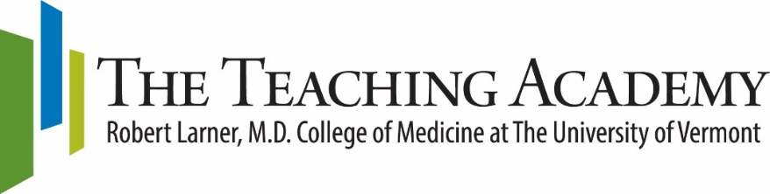

2021-2022 Medical Education Fellowship Program Information

The Medical Education Fellowship Program is a monthly, cohort-style program for Larner College of Medicine faculty who seek additional preparation for teaching and educational scholarship across the medical education continuum. Participants will review principles of learning and development, discuss teaching and learning issues with colleagues, and develop instructional, assessment, and program evaluation strategies. Participation in the program will also include mentorship for a scholarly project in education suitable for presentation and publication. The program consists of interactive, seminar-style sessions and readings. An active learning approach will be used, i.e., materials will be available in advance of each session and participants will be expected to draw upon and apply the materials during the sessions. Participants will also have the opportunity to observe teaching sessions and receive feedback on their own teaching.

Approximately 8-10 faculty members will be selected for participation in the Medical Education Fellowship Program. While designed for early to mid-career faculty members, faculty with teaching experience who are interested in expanding their teaching skills and scholarship may also apply. Participants are expected to undertake a curriculum development initiative or other teaching-related project suitable for presentation and publication. The primary facilitator is Katie Huggett, Ph.D., Director of the LCOM Teaching Academy. Additional faculty and staff will co-facilitate or share resources and expertise at individual sessions.

Prerequisite: Applicants without previous preparation for teaching (e.g., course offered by a specialty society) must complete the Essentials of Teaching and Assessment certificate course on the afternoon of September 30 and the morning of October 1, 2021.

Location: Dana Medical Library Classroom
Schedule: Monthly sessions, 9:00-11:00 AM on Friday morning. Additional consultation time may be available following monthly sessions, from 11 AM - 12 PM
Dates: October 22, November 12, December 10, January 20*, February 11, March 11, April 8, May 13, June 17
*January’s session will be on Thursday to coincide with the Snow Season Education Retreat
**You may have no more than 1 excused absence.

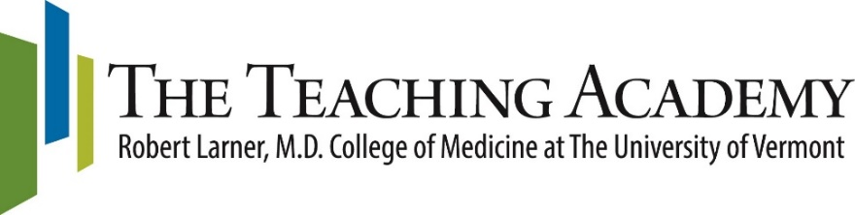

2021-2022 Medical Education Fellowship Program Schedule

September 30 & October 1 | Essentials of Teaching and Assessment Certificate Course
October 22 | Session 1 A: Introductions and brief project presentations  Instructor: Katie Huggett, PhD  Session 1 B: Developing Curricula and Educational Experiences  Instructor: Bridget Marroquin, MD
November 12 | Session 2 A: Science of Learning and Instruction  Instructor: Jesse Moore, MD  Session 2 B: Dana Medical Library Resources for Educators  Instructor: Alice Stokes, MLIS
December 10 | Session 3 A: Conceptual Frameworks and Theories in Health Professions Research  Instructor: Katie Huggett, PhD  Session 3 B: Project Peer Review Session
January 20* | Session 4: Snow Season Education Retreat
February 11 | Session 5: Using Assessment Data to Improve Teaching  Instructor: Leigh Ann Holterman, PhD
March 11 | Session 6: Design Thinking for Medical Education  Instructor: Mitchell Tsai, MD
April 8 | Session 7: Program Evaluation in Medical Education  Instructor: Lisa Grefe, MSc
May 13 | Session 8: Career Development for Educators  Instructor: Charlie Irvin, PhD
June 17 | Session 9: Wrap–up and Scholarly Project Presentations  Instructor: Tom Delaney, PhD

2021-2022 Medical Education Fellowship Program Application

Name: | Position:
Department: | Primary Phone:
Email:

Approximately 8-10 faculty members will be selected for participation in the Medical Education Fellowship Program. While designed for early to mid-career faculty members, faculty with teaching experience who are interested in expanding their teaching skills and scholarship may also apply. Participants are expected to undertake a curriculum or assessment project, or other teaching-related project suitable for presentation and publication. Scholarly project presentations will occur at the final session.

Applicants to the Medical Education Fellowship Program should submit the following:
- This Application Form page with contact information.
- Cover letter expressing your interest in the program. Please address the following questions: Why are you interested in the Medical Education Fellowship Program? What will you contribute to the experience? How do you envision participation in the program will improve your teaching?
- One-page proposal for a scholarly project you will undertake during the program. Project examples include a plan to develop a new course/curriculum; a proposal for a teaching or assessment innovation; or a small-scale research study related to some aspect of your teaching.
- Copy of your CV.
- Letter of support from your Department or Program Chair.

Important Dates:
- Application Deadline: July 12, 2021
- Participants will be notified on or before July 30, 2021

Location: Dana Medical Library Classroom
Schedule: Monthly sessions, 9:00-11:00 AM on Friday morning. Additional consultation time may be available following monthly sessions, from 11 AM - 12 PM.
Dates: October 22, November 12, December 10, January 20*, February 11, March 11, April 8, May 13, June 17
*January’s session will be on Thursday to coincide with the Snow Season Education Retreat
**You may have no more than 1 excused absence.

Please email or send this completed application to: Amanda Broder via teaching.academy@med.uvm.edu
Questions about the Program? Contact Katie Huggett, PhD Kathryn.huggett@med.uvm.edu

